Olympic Rescue

Build Instructions:
- Gather all materials
- Cut (2) 2x4 boards down the middle to create (4) boards 1.5” x 1.75” x 96”. 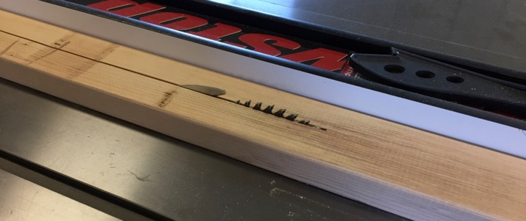
- From (2) of the 1.5” x 1.75” x 96” boards cut (3) boards at 45”. Creating (3) boards 1.5” x 1.75” x 45”
- Cut (1) of the 1.5” x 1.75” x 96” boards in half. Creating (2) boards 1.5” x 1.75” x 48”
- Cut the 4’ x 8’ sheet of luan in half. Creating (2) sheets 48” x 48”.
- Assemble the support structure for the course as show on Sheet A of the Drawing.
  - Note: We used screws and glue for this task. We also had to pre-drill the holes so we didn’t split the boards

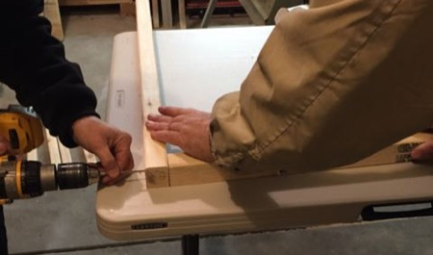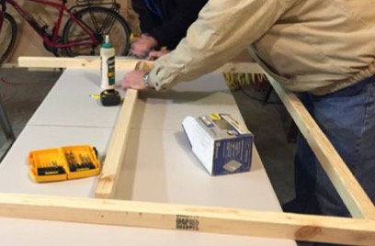
- Apply the skin to the support structure as shown on Sheet B of the Drawing. We used glue and nails for this step.
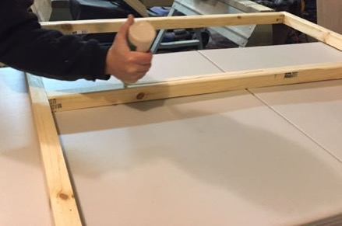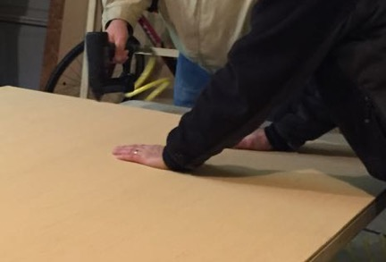
- Cut the 1” x 6” board for the sides of the Ski Slope as shown on Sheet C of the Drawing.
- From the remaining luan material cut the ramp and top portions of the Ski Slope. This is shown on Sheet C of the Drawing, but measure to cut your pieces to fit your side pieces. The ramp is 12” wide.
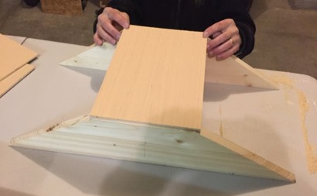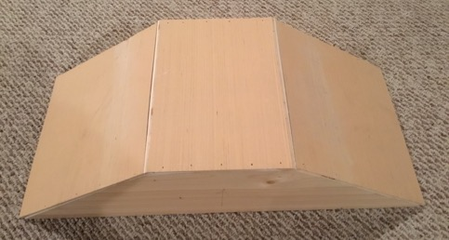
- From the remaining 1” x 6” board, cut (2) 2.5” x 9” fence panels and one support wedge as shown on Sheet D of the Drawing.
- Assemble the snow fence (1 panel and the wedge) as shown on Sheet D of the Drawing.
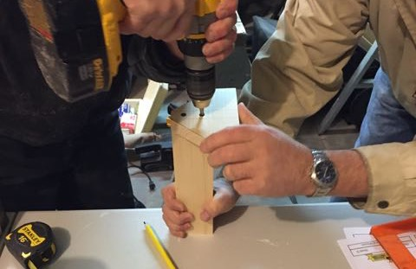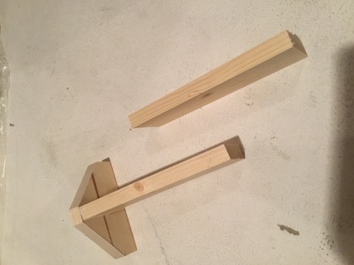
- From the remaining 1.5” x 1.75” boards, cut (4) Slalom Poles 1.5” x 1.75” x 4”
- From the ¼” Dowel, cut (8) 6” sticks
- Install the Dowel sticks on the course as shown on Sheet F of the Drawing. We just glued these in place.
- Paint the course, ski slope, fences, slalom poles, and rescue area. Dimensions for the course colors can be found on Sheet F of the Drawing.
  - Note: The injured Skier pick-up area was marked by drawing around a nickel with a Sharpie.
  - Note: The tape used to mask the paint areas peels more cleanly if removed before the paint has fully dried.
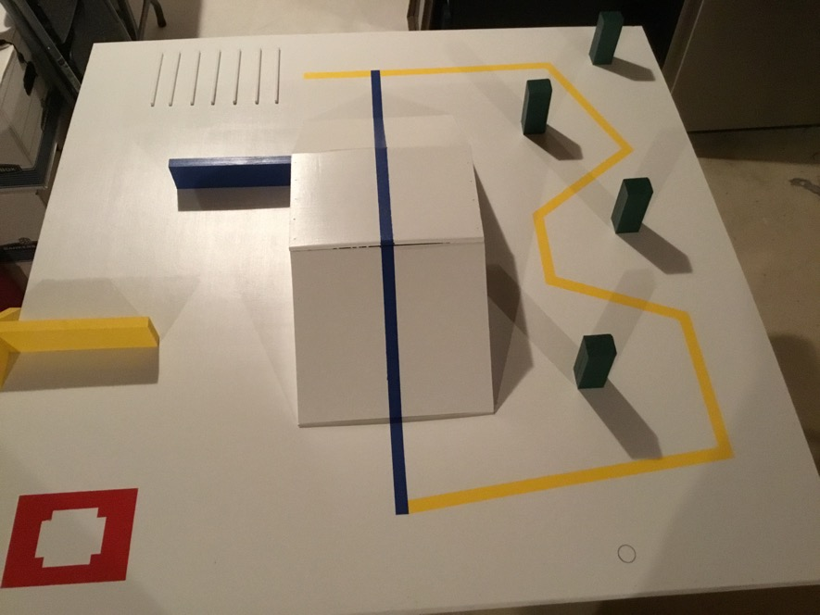
- Install the ski slope, fences, and slalom poles using Velcro as shown on Sheet E of the Drawing.
