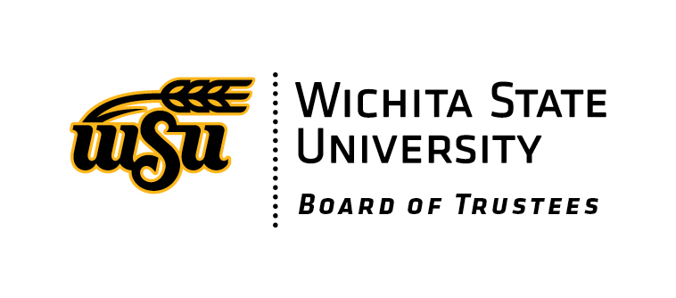
AGENDA
Board of Trustees Meeting
Thursday, November 9, 2023, 1:15 pm meeting
Zoom

KDFA REVENUE BONDS for STADIUM PROJECT. The Board previously agreed to commit $11,800,000 from its 1.5 Mill Tax Levy revenue (“Special Tax Levy”) toward construction and renovation costs of the University’s stadium project. The Board has been asked by bond counsel to approve the following documents related to the project:

  - Resolution. Approval of the financing and bonding process and authorization to execute of Financing Documents.
  - Tax Distribution Agreement. Procedure for collection and distribution of the Special Tax Levy. County collects the Special Tax Levy and pays it to the bond trustee.
  - Tax Compliance Agreement. Sets out representations, facts, expectations, terms and conditions relating to use and investment of bond proceeds.
  - Continuing Disclosure Undertaking. Agreement for Board to provide annual financial reports and other information with respect to the bonds.
  - Preliminary Official Statement. Disclosure requirements regarding the project and means of financing.
  - Indemnification Agreement. Commitment of the University to indemnify the Board for certain liabilities arising from the project.

Upcoming BOT Meeting Dates:
Thursday, January 11, 2024 8-10:30 am John Bardo Center, Rm 164
Thursday, April 11, 2024 8-10:30 am John Bardo Center, Rm 164
Thursday, July 11, 2024 8-10:30 am John Bardo Center, Rm 164
Thursday, September 12, 2024 8-10:30 am John Bardo Center, Rm 164

Additional Events:
December 1, 2023 – Board of Trustees Holiday Party 5:30-7 pm, Social Tap

