“SEE MY COLOR, Acknowledge my trauma, help me heal” | Crystal Bennett, LMSW  crystal@crystalthryves.com

What are the underlying messages communicated by racial colorblindness?
NOTES: Click or tap here to enter text.

VIDEO: “Baby Doll Test”
What does this video tell us about implicit bias and the development of internalized oppression?
Click or tap here to enter text.

MICROAGGRESSIONS
NOTES: Click or tap here to enter text.

- MICROASSAULTS

- MICROINSULTS

- MICROINVALIDATIONS

INEQUITIES
NOTES : Click or tap here to enter text.

IMPACT
NOTES: Click or tap here to enter text.

HEALING

HOW DO YOU CREATE SAFETY? : Click or tap here to enter text.

NOTES : Click or tap here to enter text.

Color-Blind Racial Attitudes Scale SCORING INFORMATION
Neville, H. A., Lilly, R. L, Duran, G., Lee, R. M., Browne, L. (2000). Construction and
Initial Validation of the Color-Blind Racial Attitudes Scale (CoBRAS). Journal of Counseling Psychology, 47, 59-70.

Directions. Below is a set of questions that deal with social issues in the United States (U.S.). Using the 6-point scale, please give your honest rating about the degree to which you personally agree or disagree with each statement. Please be as open and honest as you can; there are no right or wrong answers. Record your response to the left of each item.

1 2 3 4 5 6
Strongly Strongly
Disagree Agree

1. ____ Everyone who works hard, no matter what race they are, has an equal chance to become rich.
2. ____ Race plays a major role in the type of social services (such as type of health care or day care)
that people receive in the U.S.
3. ____ It is important that people begin to think of themselves as American and not African American,
Mexican American or Italian American.
4. ____ Due to racial discrimination, programs such as affirmative action are necessary to help create equality.

5. ____ Racism is a major problem in the U.S.
6. ____ Race is very important in determining who is successful and who is not.
7. ____ Racism may have been a problem in the past, but it is not an important problem today.
8. ____ Racial and ethnic minorities do not have the same opportunities as White people in the U.S.
9. ____ White people in the U.S. are discriminated against because of the color their skin.
10. ____ Talking about racial issues causes unnecessary tension.
11. ____ It is important for political leaders to talk about racism to help work through or solve society’s problems.
12. ____ White people in the U.S. have certain advantages because of the color of their skin.
13. ____ Immigrants should try to fit into the culture and adopt the values of the U.S.
14. ____ English should be the only official language in the U.S.
15. ____ White people are more to blame for racial discrimination in the U.S. than racial and ethnic minorities.
16. ____ Social policies, such as affirmative action, discriminate unfairly against White people.
17. ____ It is important for public schools to teach about the history and contributions of racial and ethnic minorities.
18. ____ Racial and ethnic minorities in the U.S. have certain advantages because of the color of their skin.
19. ____ Racial problems in the U.S. are rare, isolated situations.
20. ____ Race plays an important role in who gets sent to prison.

The following items (which are bolded above) are reversed score (such that 6 = 1, 5 = 2, 4 = 3, 3 = 4, 2 = 5, 1 = 6): item #2, 4, 5, 6, 8, 11, 12, 15, 17, 20. Higher scores should greater levels of “blindness”, denial, or unawareness.

Factor 1: Unawareness of Racial Privilege consists of the following 7 items: 1, 2, 6, 8, 12, 15, 20
Factor 2: Unawareness of Institutional Discrimination consists of the following 7 items: 3, 4, 9, 13, 14, 16, 18
Factor 3: Unawareness to Blatant Racial Issues consists of the following 6 items: 5, 7, 10, 11, 17, 19

Results from Neville et al. (2000) suggest that higher scores on each of the CoBRAS factors and the total score are related to greater: (a) global belief in a just world; (b) sociopolitical dimensions of a belief in a just world, (c) racial and gender intolerance, and (d) racial prejudice. For information on the scale, please contact Helen Neville (hneville@uiuc.edu).

YOUR IDENTITY, POWER & PRIVILEGE

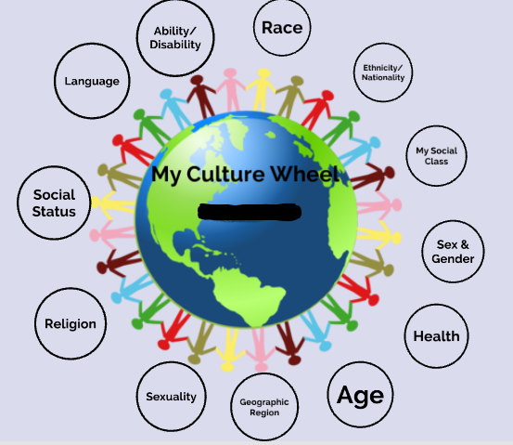

REFLECTION

- Which identities were easier for you to name at first? Which took more time?

- What identities have changed over time?

- Of the various dimensions of yourself, where have experienced subjugation or oppression? Where have you experienced privilege?

- How have these experiences shaped you and impacted your worldview?

- How might the various dimensions of yourself impact your interactions with others and/or the way they perceive you?

RECOGNIZING & MITIGATING POWER
Click or tap here to enter text.

INSTITUTIONAL ACCOUNTABILITY
What challenges have you or are you currently encountering when trying to integrate cultural humility into practice settings?
Click or tap here to enter text.

What are 2-3 action steps that you are committing to over the next 60 days to move towards becoming antiracist?

Click or tap here to enter text.

ADDITIONAL NOTES/RESOURCES
Click or tap here to enter text.

