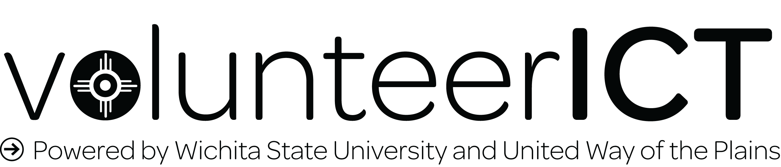
First Semester Report
volunteerICT is Wichita State University’s volunteering partnership with the United Way of the Plains. In fall 2017 more than 860 members of the WSU community logged in to this website. Of this group, 395 community members used the website to track about 2,400 service hours during this time.
- Site Usage
volunteerICT was also connected to this site to provide insight about user behaviors. The following is a summary of information gathered between August 21 and December 12, 2017.
The most popular time for users to be on this site was Tuesday between 11 and 12 p.m., CST. High traffic times varied each week. The item on the right is a sample of prime use times during another week.
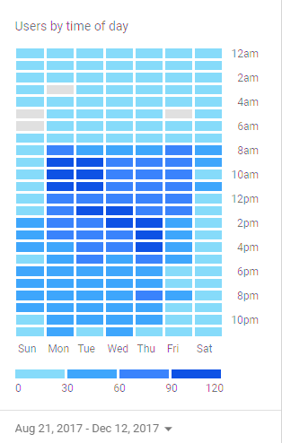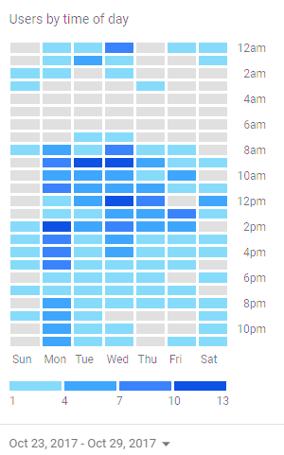

When aggregated, the total number of users on this site during the semester was highest on Mondays, Thursdays, and Tuesdays.
Day | Number of Users
Monday | 911
Tuesday | 893
Wednesday | 840
Thursday | 899
Friday | 677
Saturday | 361
Sunday | 371

While computers were the preferred method of access for many users, 35.8% of sessions occurred on a mobile device. On average, users accessed the site 2.29 times during this timeframe.
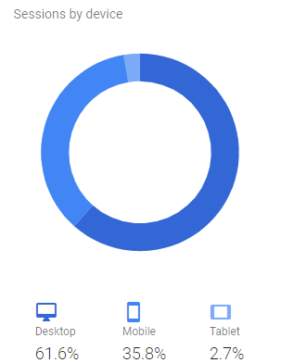

- User Demographics
The largest portion of users was undergraduate students (685). Graduate students accounted for an additional 46 users. Faculty, staff, and employees of the University combined accounted for about the same number of users. There are limits to the usefulness of this information because users self-reported their demographic information as they set up their account for the first time. Some users did not provide certain information on their accounts. For example, about 35% of users did not provide their college affiliation, which is much higher than the number of staff for whom this category would not apply.

College | Hours (for 2017) | Users | Average Hours/User
Fairmount College of Liberal Arts and Sciences | 581 | 168 | 3.458333333
College of Health Professions | 522 | 125 | 4.176
College of Engineering | 429 | 166 | 2.584337349
W. Frank Barton School of Business | 213 | 74 | 2.878378378
College of Education | 204 | 78 | 2.615384615
Combined Other (less than 20 users each) | 156 | 38 | 4.105263158

Users were asked to identify a few interests as they created their accounts. These interests were used to send users notifications of new opportunities in customized weekly digest emails.

- Service Hours
Community Service Board Hours account for 2,064.59 hours tracked on volunteerICT during this semester. 174.5 hours of service that took place during this semester were tracked as independent activities (not through an opportunity listed on volunteerICT), while 152 hours were tracked through agencies other than Community Service Board. Trees for Life is the community partner where users conducted the largest portion of these hours (45).

- Responses
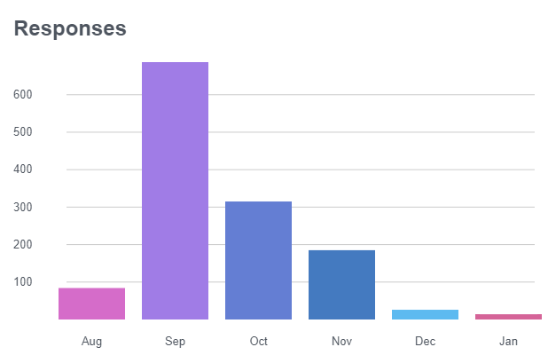
There were 1,309 individual responses made by 523 users throughout the semester. The majority of opportunity responses in this semester occurred in September.

Of all users who responded to an opportunity, 61.4 percent responded to only one opportunity. The average responses per user was 2.5 (median=1). Twenty one percent of users responded to more than one opportunity, while about 18 percent of users did not respond to any opportunities during this time. However, of users who responded to more than 1 opportunity, the average number of responses was 5.18.

Of users who responded to any opportunity during this semester, 221 unique users only responded to the Wu’s Big Event VII opportunity. Among users who responded to opportunities that were not Wu’s Big Event, 55.93 percent responded to more than one opportunity. Users who attended Wu’s Big event and an additional opportunity would respond to an average of 7.01 opportunities by the end of the semester (n=75).
 | One Opportunity | More than One Opportunity | Total
With Wu’s Big Event | 335 | 188 | 523
 | 64.05% | 35.95% | 100%
Without Wu’s Big Event | 130 | 165 | 295
 | 44.07% | 55.93% | 100%

While the number of hours with outside agencies is low, there were 235 responses (by 129 unique users) to opportunities with outside organizations.
- Community Service Board Interactions
Volunteer opportunities that the Community Service Board (CSB) facilitated were housed on volunteerICT. CSB also used this website to track meeting attendance and volunteering at CSB-led events such as tabling outreaches and special events. These meetings accounted for 605 service hours tracked through the website. Volunteers at Community Service Board opportunities accounted for 1,456.09 hours.
Volunteers were checked in to almost all CSB events using the agency check-in feature. Only one event, Gingerbread Village, did not use this arrangement. Of the 30 users who responded to this need, only 6 took the step of tracking their hours. If it was not possible to check in users at a site, the Site Manager added these hours for users who were marked as attending by the service site leader.
With the addition of this software, the registration-to-participation rate increased from an average of 51.3% in spring 2017 to 78.6% in fall 2017.
- Service-Learning*
In fall 2017 two courses piloted the Service-Learning Module (SLM) on volunteerICT. Eighteen students completed 212.95 hours of service as part of their courses. Additionally, two internship opportunities were also hosted through volunteerICT’s Service-Learning Module. These opportunities accounted for more than 320 volunteer hours.
Due to the fact that volunteerICT is a connected site with the United Way of the Plains’ Volunteer Center, agencies who partnered with Service-Learning courses will need to create a second account on volunteerICT. In this semester, volunteerICT staff created and managed “shell” organizations that allowed students to interact with the site as if they were connecting with an outside organization. Instructors were able to approve hours and communicate with students. Community Partners were also able to receive email notifications when a student “signed up” for an opportunity.
*Users, responses, and hours entered through the Service-Learning Module are not included in other metrics in this report.

VII. Future Directions
- Increase the response-to-tracking rate
- Reduce the number of users who have only their myWSU ID associated with their accounts.

Blog version (posted on 12/15)
The first semester of volunteerICT at Wichita State University is over and we're so excited to share the outcomes. During this semester, WSU students tracked more than 2,430 hours of service. If one person did all that, they would be working around the clock for 101 days! Almost every hour of this work happened right here in the Greater Wichita area, meaning that students, faculty, and staff contributed about $51,433.62 worth of people-hours into this city.
None of this would be possible without the 100+ community partners who coordinated opportunities and managed volunteers. Thank you for opening your doors and sharing your time with us!
What these numbers don’t tell you is the human impact. WSU volunteers sometimes work directly with community members by providing services, or they stay behind the scenes doing things like building weekend food bags at the Kansas Food Bank or sorting through resources at Trees for Life. These jobs aren’t always glamorous, so we want to take a moment at the end of this season to say thank you to the Shockers and community partners who make this possible!
A humongous final thank you goes out to the United Way of the Plains and their commitment to the community. WSU’s volunteerICT is synced with the United Way Volunteer Center and we are so thankful for this partnership!
To see a live dashboard of volunteerICT’s impact, go to wichita.galaxydigital.com/landing

WSU Today/Shocker Blast Version
The first semester of volunteerICT at Wichita State University is over and Civic Engagement is excited to share the outcomes. During this semester, WSU students tracked more than 2,430 hours of service. If one person did all that, they would be working full time for 1.15 years! Almost every hour of this work happened right here in the Greater Wichita area, meaning that students, faculty, and staff contributed about $51,433.62 worth of people-hours into this city.
Shockers also bring it home by representing their colleges as they volunteer. Fairmount Liberal Arts and Sciences students themselves accounted for 581 hours this year! (Although the College of Health professions deserves a shout out for having the highest ratio of hours per student!) How does your college stack up?
To see volunteerICT’s live impact page, go to https://wichita.galaxydigital.com/portal/landing/
These jobs are not always glamorous, so we want to take a moment at to say thank you to the Shockers and community partners who make this possible!
None of this would be possible without the 100+ community partners who coordinated opportunities and managed volunteers. Thank you for opening your doors and sharing your time with us!
A humongous final thank you goes out to the United Way of the Plains and their commitment to the community. The United Way Volunteer Center is the hub of all activity on volunteerICT and we are so thankful for this partnership!

