
Spring 2018 Semester and Annual Report
VolunteerICT is Wichita State University’s volunteering partnership with the United Way of the Plains. During the 2017-18 academic year WSU students tracked more than 6,600 hours of service, with most of that work happening right here in the Wichita area. To accomplish the same, 11.4 full-time employees would need to work throughout the year without any time off! From medical interpreting to painting fences, Shockers made an impact in many areas of our community.
VolunteerICT also made the volunteer experience more meaningful for volunteers and community partners. Eighty-nine percent of users were able to find a volunteer opportunity within two weeks of joining the site! Additionally, VolunteerICT users were 19 percent more likely to follow through to attending a volunteer opportunity compared to last year.
The most important parts of this website are the community partners who make this happen! A huge thank you goes out to the 140 community agencies who invited WSU students and the community to get involved and make a difference this year. The United Way of the Plains has been a driving force in this innovative partnership that provides experiential learning opportunities for Shockers and supports the Greater Wichita community.

- Site Usage
The most popular time for users to be on volunteerICT was Monday between 11 and 12 p.m., CST. High traffic times varied each week. The image on the right is a sample of the month of April, which shows high traffic times on Friday as well as Monday and Tuesday. Although it is difficult to generalize trends from this information, it is clear that most users accessed volunteerICT between 7 a.m. and 9 p.m. on weekdays.
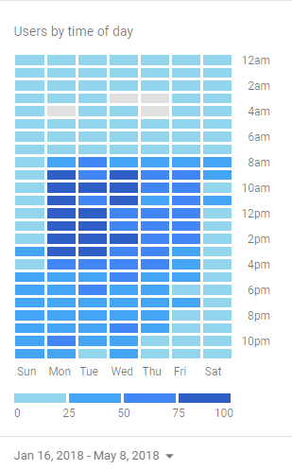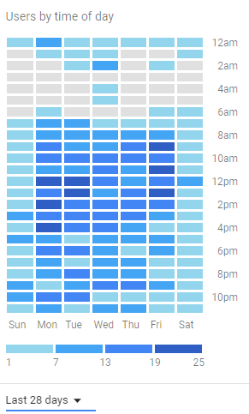
According to Google Analytics, this site saw an average of 91 visitors each week. Throughout the academic year, users accessed an average of 10.56 pages per visit. Since its launch, 26.2 percent of visits to this site were through links on the webs.wichita.edu or wichita.edu domains. 5.2 percent of users accessed this site through the CAS portal or links on the myWSU homepage. The largest portion of users came from direct page visits and organic searches, totalling about 56 percent of users on these dates. In the spring semester, 3.68 percent of site visits came directly from Blackboard links.
While computers were the preferred method of access for many users, 40 percent of sessions occurred on a mobile device.

- User Demographics
The largest portion of users was undergraduate students with more than 1,000 users belonging to this group, which represented about 9.91 percent of undergraduate students enrolled at the same time. Graduate students accounted for an additional 108 users. There are 15 accounts belonging to faculty members and 49 that belong to staff of the University. In spring of 2018, there was also the introduction of a “community member” role for community partners, alumni, friends/family of students and others who wish to volunteer with WSU community members or have access to Community Service Board events. There are 34 users with this designation active on volunteerICT.
In the spring of 2018 there was also the addition of a “secondary college” affiliation. This became a required component of new user profiles and returning users were prompted to complete this question when they updated their profiles. However, it should be noted that information regarding hours and users will sum to more than 100 percent since the same information is used for both primary and secondary affiliation. The main reason for including a secondary college affiliation is to include information for colleges whose main student affiliations are not academic majors (i.e. Honors College and Graduate School). If a user listed the same primary and secondary affiliation, they were not included in the secondary college affiliation.

Users were asked to identify a few interests as they created their accounts. These interests were used to send users notifications of new opportunities in customized weekly digest emails.

- Service Hours
These were the interest groups in which users tracked hours between August 21, 2017 and May 8, 2018.

Of this group, 756 community members used the website to track about 6,630 service hours during the 2017-18 academic year. Between the freeze date for the previous report and the end of the spring semester, 995.41 hours were tracked “independent” of opportunities listed on this site. During this period 142.55 hours were tracked through agencies other than Community Service Board. Civic Engagement operated another agency called “Service-Learning at WSU” that operated in-class service-learning orientations and one opportunity for a service-learning class. This agency accounted for 291.5 hours of service tracked through this website. The outside agency with the most service hours tracked through the site formally is International Rescue Committee with 15 hours. However, 96 hours were also tracked through Medical Mission at Home (although the actual WSU contribution to this event was around 400 hours). Community Service Board Hours account for 965.5 hours tracked on volunteerICT during the spring semester.
WSU students, faculty, and staff tracked at least 15 hours with these community partners:
Community Service Board | Horace Mann Dual Language Magnet School
Service-Learning at WSU | The Lord's Diner
Medical Mission at Home | Douglas Design District Lupoli Mural
NEHNA | International Rescue Committee in Wichita
Wesley Medical Center | NCAA Booths
Exploration Place (and special events) | Wichita State University
Wichita Family Crisis Center | Andover High School Younglife

College Affiliation | Hours by Primary Users to Date | Primary Users Fall 2017 | Primary Users Spring 2018 | Average Hours*  /User Fall 2017*** | Average Hours/User Spring 2018 (primary) | Average hours/user to date**
Fairmount College of Liberal Arts and Sciences | 1669.77 | 168 | 269 | 9.1006 | 10.2457 | 11.51
College of Health Professions | 1726.79 | 125 | 245 | 9.1014 | 8.8972 | 9.87
College of Engineering | 773.42 | 166 | 228 | 4.5925 | 8.2262 | 6.04
W. Frank Barton School of Business | 697.75 | 74 | 126 | 7.5465 | 7.7287 | 8.72
College of Education | 554.03 | 78 | 110 | 9.2264 | 7.651 | 10.65
College of Fine Arts | 169.61 | (not available) | 24 | 7.2 | 8.6342 | 11.31
Graduate School | 108.06 | (not available) | 32 | 2.7143 | 11.1325 | 7.72
Honors College | 40.5 | (not available) | 7 | 12.5 | 7.75 | 13.5

*it should be noted that this information is highly dynamic as users are able to retroactively track activities that took place in previous semesters or years. These service hours are included in this report by the date they took place, rather than the date the logging occurred.
**average hours per user to date includes activities that took place between semesters, which accounts for the difference between the averages.
***In previous reports, the average hours per user in 2017 was calculated by dividing the total hours for that college by the number of users who identified that affiliation. This included users who had zero hours tracked on the site but who had identified a primary college affiliation (a required step at registration). However, in spring 2018 a new report was added that allowed site administrators to see an individual user’s affiliation and hour entries during a certain period. This report has been updated to only include users who created hour entries during that academic time period.

*The “secondary affiliation” field was ignored for users who indicated the same college for primary and secondary affiliation. For example, if a user indicated “College of Education” as both their primary and secondary affiliation, they were not included in the secondary affiliation analysis.

- Responses
There were 2,197 individual responses made by 847 users since the launch of this website. In the spring semester there were 927 responses submitted by 445 individuals. The majority of these responses occurred in January, but September 2016 remains the most active month for this site.

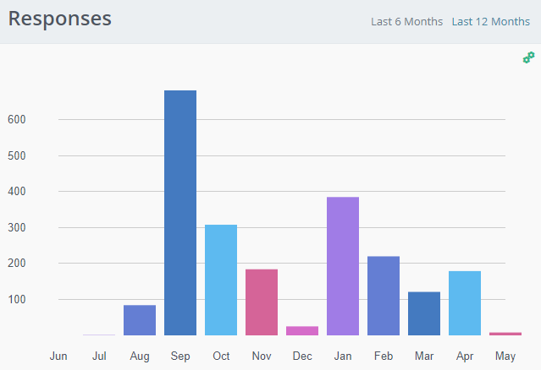
During the active semesters, the site saw an average of 8.995 responses per day. During spring 2018, of all users who responded to an opportunity the average user responded to 2.1 opportunities. Among users who responded to more than one opportunity in spring 2018, the average was 4.41 opportunity responses. Among users who submitted an opportunity response, 89.4 percent of users had submitted the response within 14 days of joining the website.

Of all users on the site, 62 percent have submitted a response to any opportunity at any time. Of users who joined in the spring semester, only 60.3 percent (290 individuals) have submitted a response by the end of the semester. However, about 45 percent of those who joined the site in spring 2018 (221 individuals) tracked hours in the spring semester. During the fall semester 51.4 percent of users who joined in that semester tracked hours in the same semester, and 64.1 percent of users who joined the site in the fall submitted a response in that semester. By the end of the spring semester, 68 percent of users who had joined in the fall had submitted a response to a volunteer opportunity. In total, 55.5 percent of users on the site had tracked service hours at any point during these semesters.

 | Fall 2017 join cohort | Spring 2018 join cohort | All users
Responded to an opportunity fall 2017 | 64.1
Tracked hours fall 2017 | 51.2
Responded to an opportunity spring 2018 | 68 | 60.3
Tracked hours spring 2018 | 16.8 | 45
Responded to an opportunity anytime | 68.5 | - | 62.6
Tracked hours anytime | 56.23 | - | 55.5

In addition to responding to opportunities, many users search for community organizations’ contact information using this website. These are the most popular agencies viewed on volunteerICT between August 21, 2017 and May 8, 2018:

- Community Service Board Interactions
Volunteer opportunities that the Community Service Board (CSB) facilitated were housed on volunteerICT. CSB also used this website to track meeting attendance and volunteering at CSB-led events such as tabling outreaches and special events. These meetings accounted for 260.5 service hours tracked through the website. Volunteers at Community Service Board opportunities accounted for 965.5 hours tracked on the site.
Volunteers were checked in to almost all CSB events using the agency check-in feature. Only Beanies for Babies, a weekly event in which students crocheted hats for children, did not utilize this feature.
With the addition of this software, CSB events saw an overall increase of 19.4 percent in the registration-to-participation rates between AY2016-17 and AY2017-18 with a 38 percent increase in engagement during this time. Although there are many factors that influence the registration and retention of volunteers, these programs are comparable because events occurred with a similar frequency in all semesters, with the exception of Food Bank Friday, which had only 4 offerings in spring 2018.

 | Fall 16 | Spring 17 | Fall 17 | Spring 18 | Change fall-to-fall | Change spring-to-spring
Food Bank Friday | 0.57 | 0.57 | 0.77352 | 0.693712 | -0.2035201 | -0.1237118
Tutoring Thursday | 0.73 | 0.866667
Mentoring Monday |  |  | 0.63 | 0.625 | 0.1 | 0.24166666
Wednesday at the Diner | 0.27 | 0.53 | 0.781984 | 0.705357 | -0.511984127 | -0.17535714
Senior Saturday | no data | no data | 0.675284 | 0.622475
Wu's Big Event | no data | no data | 0.85 | 0.75
Overall Average | 0.529469 | 0.513083 | 0.786625 | 0.643032 | -0.257156425 | -0.12994889
Series Programs Change |  |  |  |  | -0.20516809 | -0.01913410
*although Tutoring Thursday and Mentoring Monday programs each took place in separate academic years, these programs had a similar focus and took place in the same “after school” time window. They are compared by semester above.

- Service-Learning
In fall 2017 two courses piloted the Service-Learning Module (SLM) on volunteerICT. Twenty seven students completed 225.7 hours of service as part of their courses. Additionally, two internship opportunities were also hosted through volunteerICT’s Service-Learning Module. These opportunities accounted for more than 320 volunteer hours. In fall 2018, one hundred percent of users who took an end-of-year survey were “extremely satisfied” with tracking their hours through the service-learning module.
In the second pilot semester (spring 2018), 113 students were enrolled in six courses in the service-learning module. Together they completed more than 770 hours of service with more than 18 community partners. In addition to the service-learning module, many students used volunteerICT to find service related to courses that did not utilize the service-learning module. One hundred and sixty five responses were associated with WSU course requirements during the spring semester.

Table 1: Student Headcount and full-time-equivalent (fte) on Spring Census. (2018). Student Enrollment Factbook for Spring Census Day. Office of Planning and Analysis at Wichita State University. Retrieved on May 31, 2018. http://webs.wichita.edu/depttools/depttoolsmemberfiles/opa/BIPM/Enrollment_Spring_Census_OPAweb.pdf

