Advisor Instructions – Banner
(Updated 07-29-16)

In order to see if a course has previously been evaluated you may check in Banner.

- Type in SHATATR and press enter.
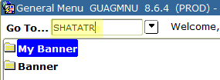

- In the upper left corner of the SHATATR screen click on the drop down arrow beside Institution to find the college code (if you know the college code, type it in and press enter - go to #7).
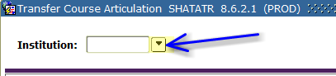

- On the Option List choose Source Background Form (SOISBGI)
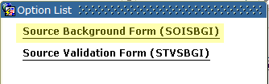

- Click on the circle below College and type in the name of the institution you are searching for.
  - Please note that the form needs exact input to find the Institution as it is typed into Banner (many names are abbreviated). Therefore, it usually works better if you use 1 or 2 letters and % for your search.

  - Examples:
Use But% to search for Butler Community College
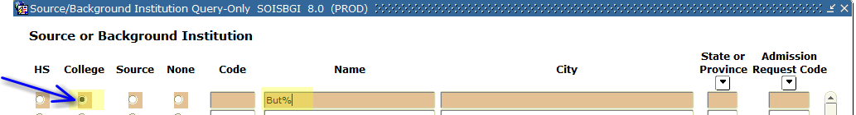

Use U% S% Car% to search for University of South Carolina
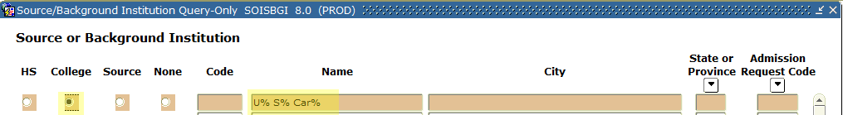

- Press F8 or click Query Execute.
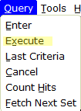

  - The output you receive may include several institutions. Please note that if an institution shows (Inactive) do not use it
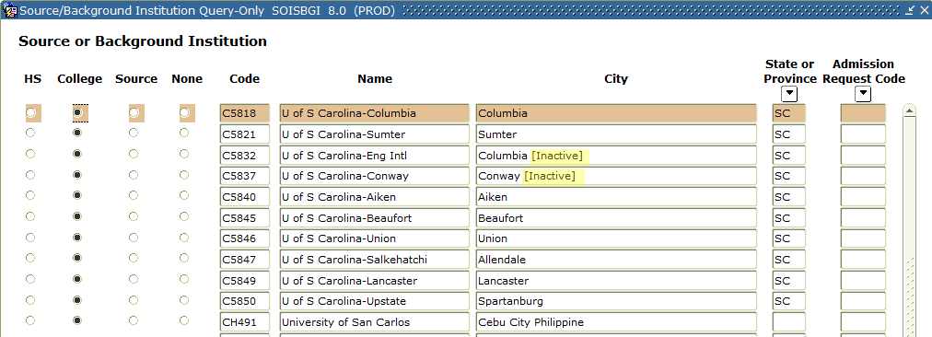

- Double click on the Code of the institution to take you back to SHATATR.
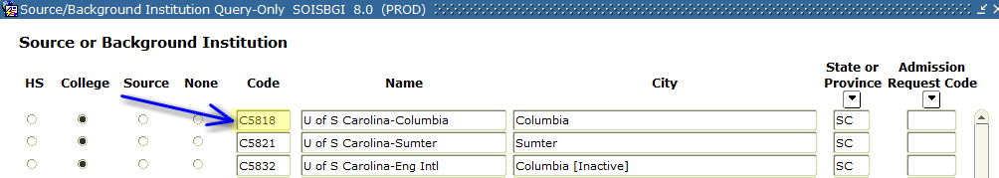

- Press Ctrl + Page Down or click Next Block to bring up all the courses for that Institution. (The courses that are in Groups will always appear first and then the Terms will appear in order (000000 represents “beginning of time”).

You may use the up and down arrows on your keyboard to scroll through all courses, or you may use the drop down arrow on the right side of the screen.
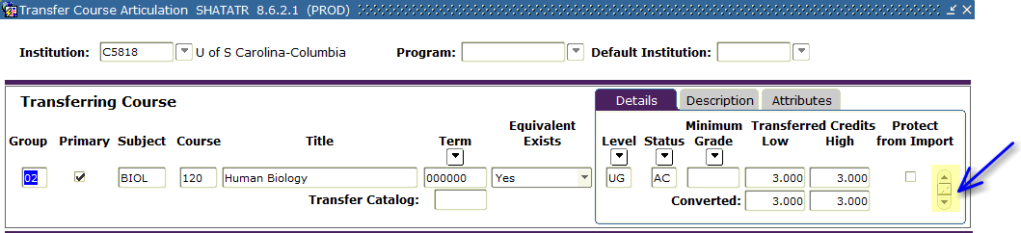

Please note narrowing your search may provide a better option (see instructions on next page).

Search for a single course in SHATATR:

Make sure you have entered the Institution code and have brought up all the courses for that Institution by using
Ctrl + Page Down or Next Block.

- Press F7 or click Query Enter. This will clear the screen.
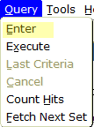

- Under Subject type in the course code and under Course type in the course number.
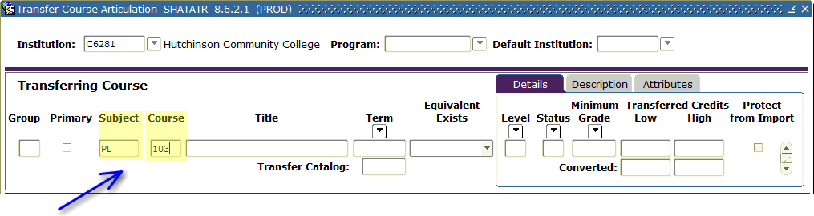

- Press F8 or click Query Execute.

- Use the up and down arrows on your keyboard to scroll through the terms for this course, or use the drop down arrow on the right side of the screen.
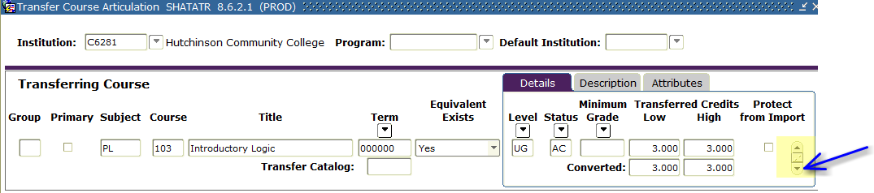

- The output will show you the Equivalent Course, Attributes and Comments for each term:
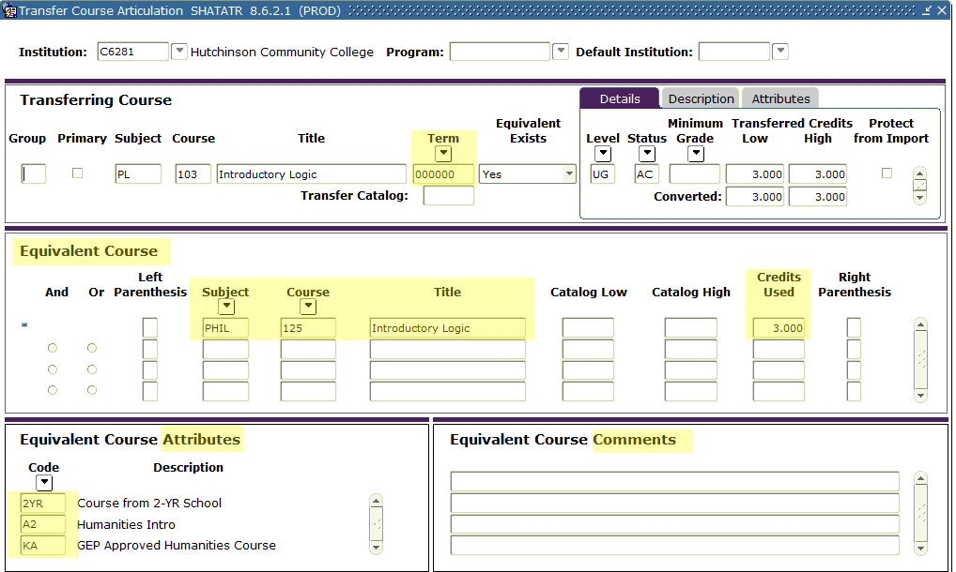
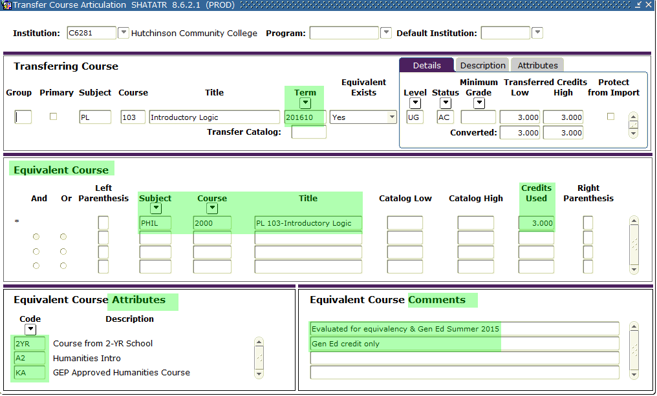
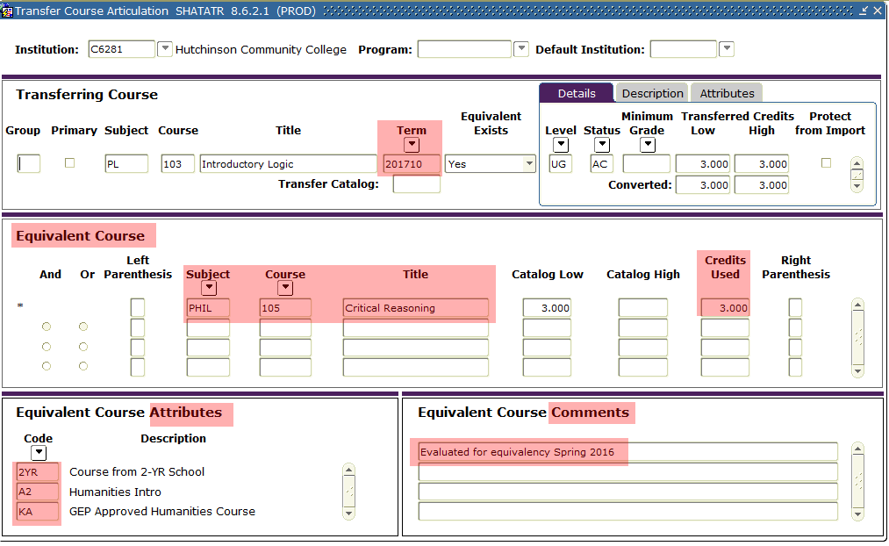

- In the bottom left corner of the Banner screen there is a Record count that will tell you how many records are available for the course.

Remember: The courses that are in Groups will always appear first and then the Terms will appear in order (000000 representing “beginning of time”). It is very possible that a Group may be the most recent term, so do not make the assumption that the last record is the most recent term.

If you do not receive any course information, the course is not in SHATATR and an email should be sent to transfer.eval@wichita.edu requesting the course to be evaluated.

