Advisor Instructions – Transfer Equivalency website
(Updated 07-28-16)

In order to see if a course has previously been evaluated you may check the Transfer Equivalency website http://webapps.wichita.edu/TransferEquiv/.

- Use the drop down arrows to choose:
  - State
  - Institution
  - Subject (*All Subjects* is an available option)
  - Course (*All Courses* is an available option)

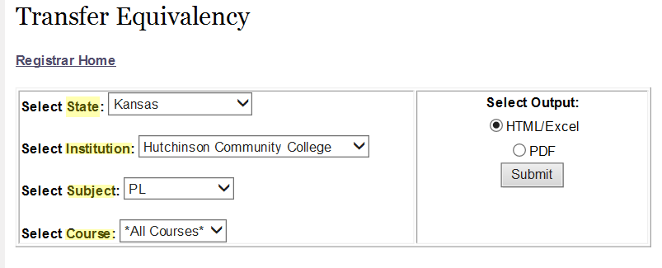

  - You may choose the output of HTML/Excel or PDF before you Submit

- Look for the following information:
  - Transfer Course
  - WSU Course Equivalent
  - Credit Hrs
  - Effective Term (see explanation below)
  - Notes (see explanation below)
  - Attributes (explanation on website)

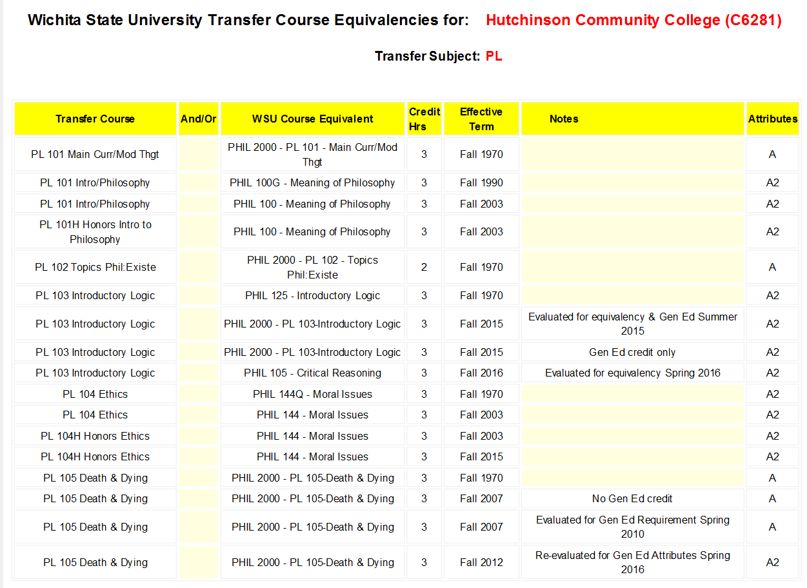

EFFECTIVE TERM:
This is a very important column!
As you see in the above example, PL 101 has 3 separate lines with 3 separate effective terms. The first line shows the course transferred to WSU as PHIL 2000 (elective) effective term Fall 1970 (this is our “beginning of time”). The second line shows the course transferred to WSU as PHIL 100G effective term Fall 1990. And, the third line shows the course transferred to WSU as PHIL 100 effective term Fall 2003.

This means:
PL 101 transferred between Fall 1970 and Summer 1990 will receive the WSU equivalency of PHIL 2000 (elective).
PL 101 transferred between Fall 1990 and Summer 2003 will receive the WSU equivalency of PHIL 100G.
PL 101 transferred between Fall 2003 and Current will receive the WSU equivalency of PHIL 100.

Please note that different attributes are associated with these effective terms also!

*At this time, you may notice more than one line for an effective term. This is due to updates that are currently being worked on to enhance the website. The information is accurate on both lines. Please take both lines into consideration as you look at the course.

NOTES:
The note column will give you information about when a course was last evaluated.
As you see in the above example, PL 103 has two notes for effective term Fall 2015 (take both into consideration as mentioned above). The first note for Fall 2015 states “Evaluated for equivalency & Gen Ed Summer 2015” The second note for Fall 2015 states “Gen Ed credit only.”

This means:
PL 103 was evaluated in the Summer of 2015 for effective term Fall 2015. Beginning Fall 2015, PL 103 is no longer equivalent to PHIL 125. Because it shows the equivalency as PHIL 2000, it is an elective. However, it is considered a General Education course because it shows the attribute A2.

ATTRIBUTES:
Explanation on website:
