WSU Change of Major
STAFF Request Instructions

Two web apps have been developed to facilitate online requests for changes to majors, minors, concentrations, etc. One app is for student use, the other is for specific authorized staff. The staff app will be used to request changes to student majors, minors and/or concentrations only when it is a request the Student cannot submit. This would include changes to majors for which the student does not meet the minimum required GPA or for which a separate applicant and/or approval process is required.

Below are some basic rules of thumb regarding the staff change request app:

- Staff can only change TO majors within their own college.

- Staff will use this system to change pre-majors to majors. Examples: Student is Pre-Major in Nursing and has been approved for Nursing; student is Pre-Social Work and has met requirements to be moved to Social Work.

- Staff can also use this system to clarify when a student wants a DMAC, double major or double degree.

- Staff should use the system to submit a catalog year change for a student; this information should be put in the comment box on the final page before clicking ‘Submit.’ Navigate to the final page without making any other changes by clicking the ‘Continue’ button.

- Do not make changes to major, minor or concentration if a student has completed an AFD.
If the student has filed an AFD and needs to change their major, the AFD must be disabled before the student can use the system to change their major, minor or concentration. Contact the Graduation Coordinator to make changes.

Other important information to keep in mind:
- There is a limit of 4 minors, 4 majors and 4 concentrations on each student record.

- Students may change their major, minor or concentration using this system for a total of 3 times per semester. Staff can submit change requests as needed for students who have used their 3 submissions.

- Certain staff in college advising units have been identified as those needing access to submit requests using the staff request app. Department personnel needing changes must route those changes through these authorized individuals to submit the request via the online process.

The online request form will be access via a link in myWSU portal. (Faculty/Staff Tab > Major Change Admin)

Once you have successfully logged in, you will enter the ID of the student in question and be presented with that student’s academic profile and photo. :

If this is the student you wish to update, click Continue.

Step 1: Make changes to your current academic profile. Note current program listed under Program 1.

Change current program using the scroll bar to find the new major, click the radio button to select new major, and click Continue once selected.

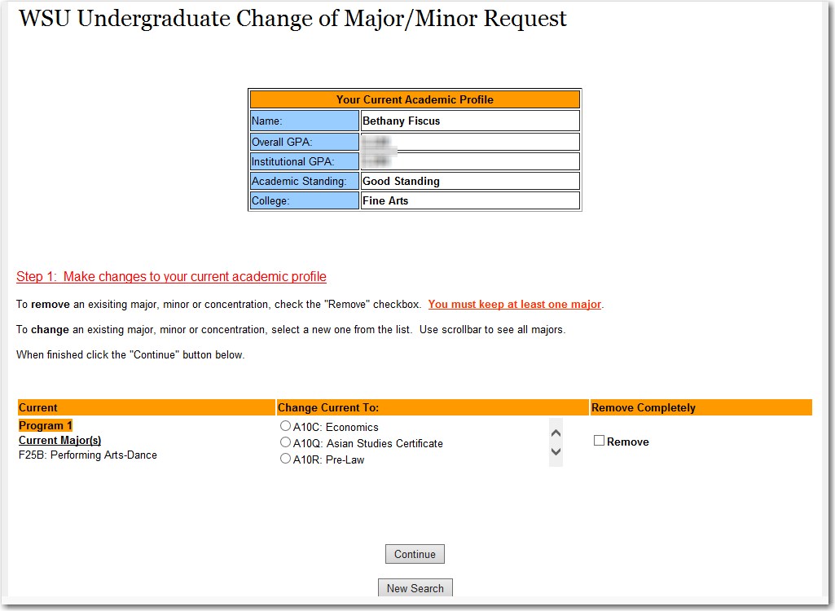

Step 2: Add an additional major, minor or concentration

Click the button for the new additional item to be added and then select the appropriate code. When completed, select Continue. If adding more than one major or minor, click the button each time to add additional items.

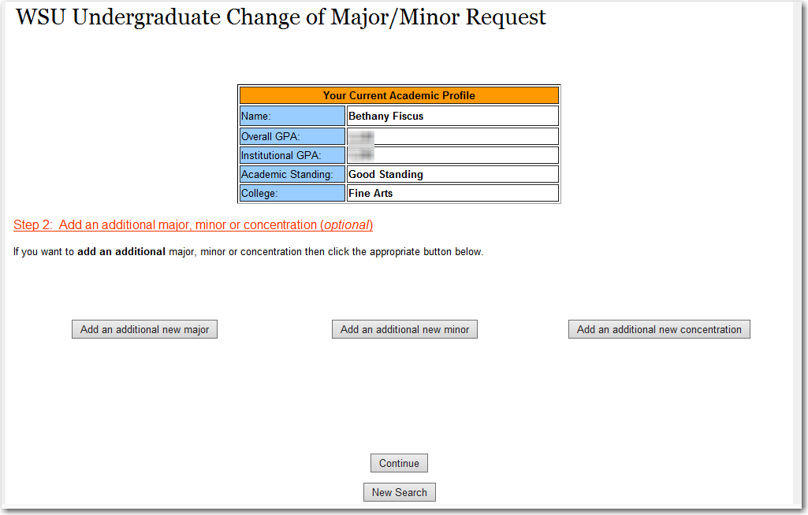

Step 3: Review changes. This request will go to Registrar’s Office to update in Banner.

If the information is correct, enter the term the change should be effective (i.e., spring 2014)

When applicable, check the boxes clarify if the major/degree is a DMAC, double major or a double degree.

Add notes to help clarify your submission. The Notes area should be used for unusual items such as LAS double majors that are coded as A81 or A82.

Also use the Notes area to indicate changes to the Catalog Year for the student. This can be submitted even if no other changes or additions were made to the student’s curriculum.

Click Submit Request to finalize.

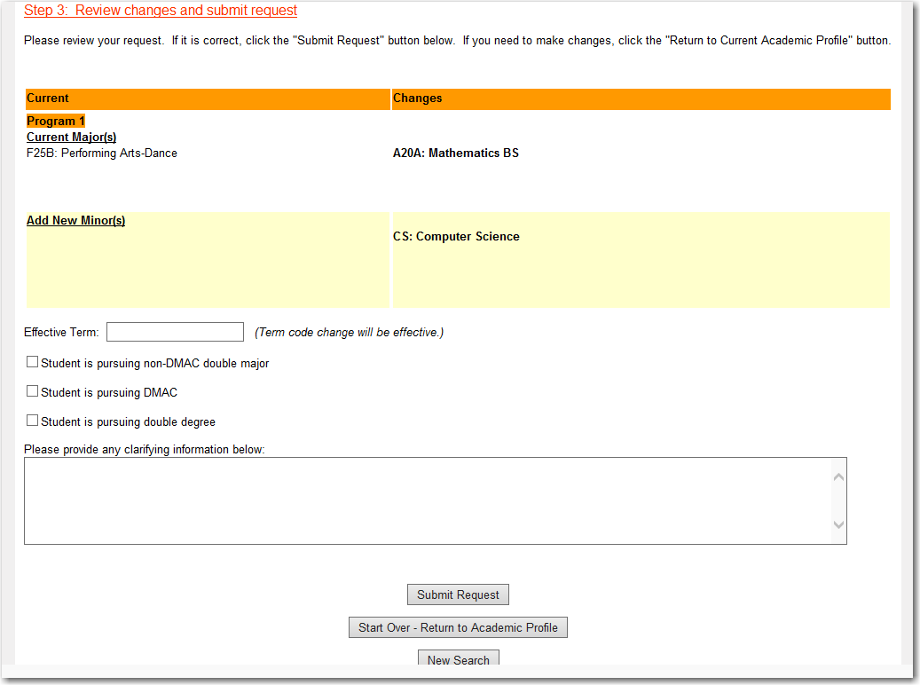

When the change has been made in Banner, an email will be sent to both the student and to the staff member who submitted the request.

Questions about major changes can be directed to Melissa Ellenz at x3090.

Rev. 2/20/2014

