WSU AE/NASA Experiential Aeronautics Fellowship (EAF) Application

Complete and submit to NASAinKansas@wichita.edu a single PDF-format document containing the following material:

- A completed EAF application (i.e., this document)
- A current resume (no more than 2 pages)
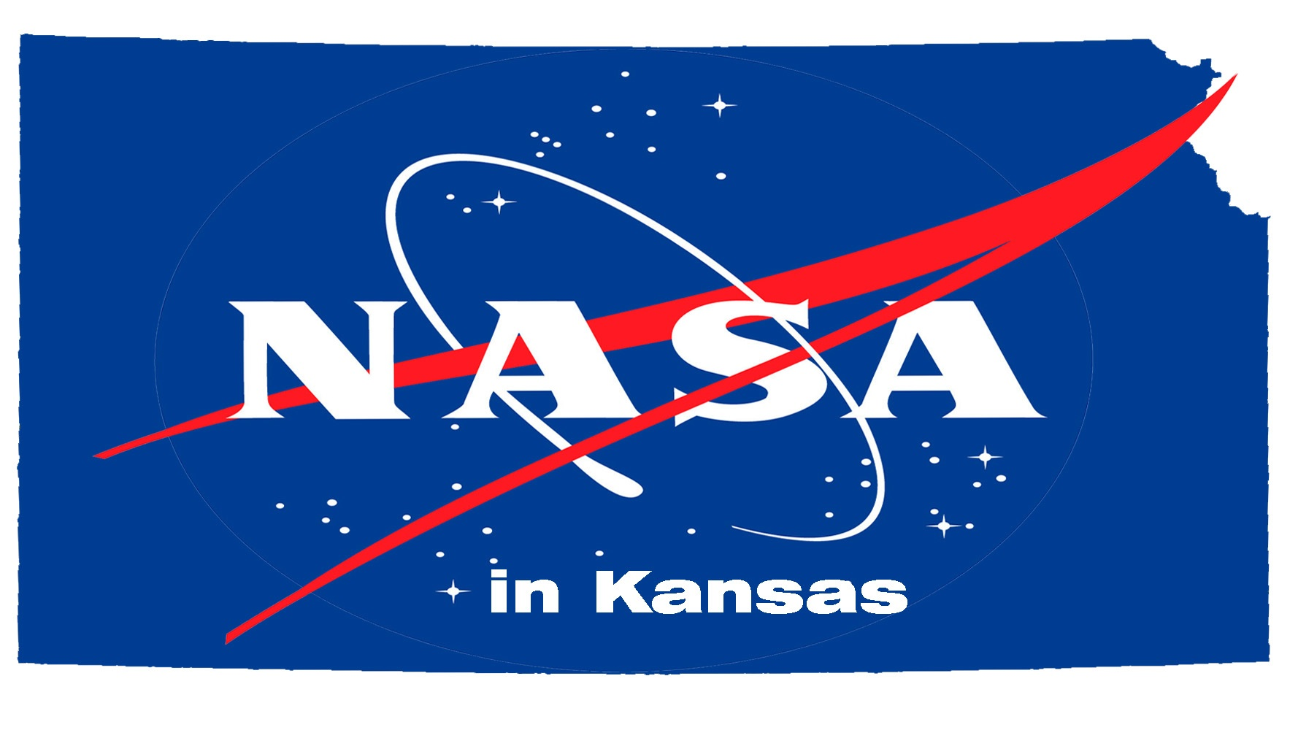
- A one-page essay demonstrating your maturity, motivation and potential to meet WSU’s and NASA’s EAF goals.

Date_________________________

Name___________________________________________________
(Last) (First)

Phone (Home) __________________ (Cell) ________________

MyWSU ID # __________________E-mail_________________________________

Major ______________________________

Total Cr Hrs ____________Total WSU Cr Hrs __________Cumulative GPA __________

Local Address: _______________________________________
_______________________________________

Long-term (Home) Address: _________________________________________
____________________________________________________________________

US Citizen: Y N

The NASA Space Grant Program requests information for analyzing success in promoting growth in
STEM related degree programs. The following optional information will help us to identify data for reporting.

Age at last birthday _______________________

Sex: ___M ___F Race/Ethnicity ___American Indian or Alaska Native
___Asian (including Middle East and India)
___Black or African American
___Hispanic or Latino
___Native Hawaiian or Other Pacific Islander
___White
___Other Race/Ethnicity

