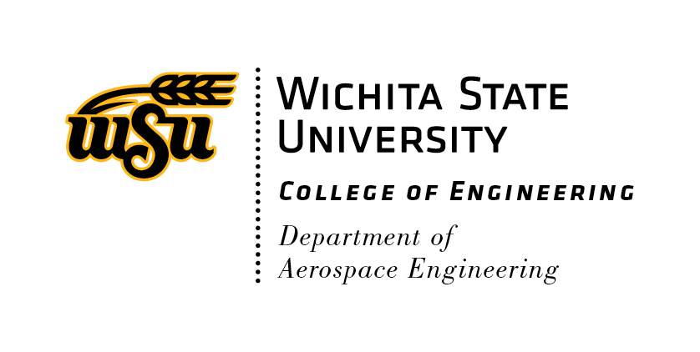**WSU Department of Aerospace Engineering**

**Palazola & Benmoussa Scholarship (P&B Scholarship) Application**

Applications should be electronically completed and submitted to Dr. Miller ([scott.miller@wichita.edu](mailto:scott.miller@wichita.edu)) in the AE Department. The following materials are required for a complete application package and must be submitted as a single compiled PDF format document.

1. A completed P&B Scholarship application form (i.e., this document).
2. A current resume (two-pages or less).
3. A one-page essay demonstrating your motivation, maturity, and potential to meet scholarship goals.
4. An endorsement letter, from an AE faculty member, outlining specific collaborative work and/or research outcomes.
5. A one page, or less, financial need essay. (See related document on AE web site)

Date:

Name (last, first):

MyWSU ID #:

Phone #:

WSU E-mail address:

Are you an AE Major?

Are you in good academic standing?

What is your WSU GPA?

Are you a full-time sophomore or first-semester junior?

What was your final grade in AE 324?

If selected, will you commit to 10-20 hours per week of work with an AE faculty member?

You understand, if selected, working elsewhere (including on-campus, off-campus, NIAR, Coop/Internships, etc.) is not acceptable?

Has an AE faculty member endorsed collaborations with you (if yes, with whom)?

Are you from rural Kansas (if yes, from where)?

Are you eligible to be employed in the United States?

Have you submitted financial need information?