

Faculty Senate Meeting
September 22nd, 2025 3:30-5pm Woolsey Hall 110A

Faculty Senate Meeting Agenda
What: Faculty Senate Meeting (2025-2026) When: Monday, Sep 22, 2025, 3:30-5:00 pm Where: Woolsey Hall 110A

Agenda Item | Notes/Discussion/Process | Time
Call to order | Christopher Stone
Approval of Minutes | Sep 22, 2025 | 1 min
Informal Statements |  | 2 min
President's Report | - Announcement from College of Applied Studies  - Update on KBOR and WSU workload policies  - Rumors and other updates | 15 min
Committee Reports | - Nominees for ratification – Rules Committee | 2 min
Old Business | - Proposed change to 4.13 Chair Policy and Procedures (Electorate) – Second read | 30 min
New Business
As May Arise
Adjourn | - Next meeting, October 27th at 3:30pm in Woolsey Hall 110A

Faculty Senate (2025 – 2026) Meeting Minutes - Draft Monday, September 8, 2025
3:30-5:00 pm Woolsey Hall, 110A

Attendance
Present: Amos, Asmatulu, Beck, Billingham, Bowen, Boynton, Butler, Castro, Celestin, Chesser, Cooper, Cossell, Dai, Delacruz, Dudley, Flores, Foster, Gilstrap, Griffith, Jamkartanian, Jorn, Kim, Kirby, Koop, Kreinath, Loibl, Lynch, Ma, Muether, Nelson, Nicks, O’Bryan, Ott, Price, Proctor, Pulaski, Rani, Ray, Sarionder, Shan, Sherwood, Showstack, Small, Stone, Swindle, Terry, Thompson, Twomey, Vasquez, Williams
Excused: Myose
Absent: Allen, Jones, Kuhlman, Tew, Zhu

Call to Order
- President Stone at 3:30 - Meeting Book
  - Reminder for Senators on Teams to post comments or questions in the Chat, which will be shared with the full Senate.
  - Reminder to keep cross-talk to a minimum in the room due to the table mics.

Approval of Minutes
- August 25, 2025 – no comments for corrections or additions; approved unanimously as submitted

Informal Statements
- None
Teams meeting recording started.
President Stone requested an adjustment in the agenda to move Committee Reports to before the President’s report – no objections, approved by consensus.

Committee Reports
- Rules Committee – President Elect Koop, Presented by President Stone
  - Senator nominees for ratification (Book p. 8) – confirmed unanimously
  - Committee members for ratification (Book p. 9) – confirmed unanimously
    - Appreciation to John Hammond (Sr. Educator, Math) for his work to seat the inaugural Student Affairs Committee members.
  - Several committee vacancies (Book p. 10) – share with constituents; watch for an interest form - please complete and return.

President’s Report (Book pp. 12-17)
- KBOR Faculty of the Year Awardees recognized
  - Correction – Dr. Parcell is a professor.
- Payroll periods and start/stop dates
  - Dates on Notice of Appointment align with payroll dates, not actual calendar dates.

  - Academic Affairs will start adding faculty start/stop dates to the academic calendar.
  - 27-week pay period year – HR working on a streamlined process (happens every 11 years).
- Syllabus template
  - Expect new version for spring 2026.
  - Will include a QR code for students using a paper version of the syllabus to easily access university policies.
- Pay compression/inversion
  - Leadership aware of the issues and working on a plan.
  - Deans have been asked to gather data from their units.
  - Refer questions to your Dean.
  - V. Whisenhant (Associate Vice President Culture and Chief Human Resources Officer) clarified that adjustments to floor salaries have been processed and will appear in the 9/26 check and retroactive to the respective appointment notice date.
- Update on KBOR and WSU workload policies
  - See documents posted on the Faculty Senate (FS) website – these are early drafts.
  - Goal is to create guidelines to support more equitable workloads across campus.
  - Specifics can be determined at the School/Department level, but will require approval from executive leadership.

Old Business
- None

New Business
- Chair Policy Task Force (TF), President Stone (Book pp. 19-22)
  - First started in approximately 2018; put on hold in 2020 due to pandemic.
  - TF has been reconvened and Chaired by Senator Castro.
  - Town hall next Monday in RSC 301 at 3:30; watch for more info in WSU Today or reach out to Senator Castro for a calendar invitation.
  - Proposed change to electorate (Book p. 26) – this change originates from Rules committee, while TF was on hold.
    - This change is intended to update the policy to current practice and is rooted in the fact that NTT are now considered faculty in the Constitution of the FS.
    - Would result in all faculty, as defined in the Constitution, having voting privileges.
    - 2nd read will be at next FS meeting.
  - Proposed change to term limit (Book pp. 31-32) – this change comes out of the TF.
    - Lots of discussion regarding what “extenuating circumstances” means, if the change would create barriers for candidates in an external search, create problems for small departments, and if more than two terms can be served if not consecutive.

As May Arise
- None

Adjourn FS
- Senator Castro requests faculty send her examples of how they would like to codify some of the above issues and encourages attendance at the upcoming Town Hall.
- Motion/second to postpone the 2nd read to allow for more discussion. Passed unanimously.

  - Next meeting is September 22, 3:30p in Woolsey Hall 110A
  - President Stone adjourned the meeting at 4:50. Minutes prepared by Rhonda Williams

Informal Statements?

Recording starts now.

Disclaimer: Any AI-generated notes from this meeting are not official records and may contain errors. Please refer to the official Faculty Senate meeting minutes.


Christopher Stone
Sep 8th, 2025
Faculty Senate Meeting
President’s Report

Announcement from College of Applied Studies

•• •• • ••
• • • •
•• •• •


•• ••
•
HONORING OUR LEGACY

•• :-;-.--;.; ,llilll!i-.�

•• •• • ••
- Founded in 1926 as the College of Education

• • • •

•• •• •• ••
- Nearly 100 years of preparing teachers,

•• •• •• ••

• •• • •
leaders, and professionals

•• •• •• ••

•• •• •• ••
- 2018 name change to College of Applied

• •• • •

•• •• •• ••
Studies reflected WSU's focus on applied

• • • ••
learning

• •• • •

•• •• •• ••
- Today, applied learning is embedded across

•• •• •• ••

• •• • ••
all colleges - not unique to CAS

•• •• •• ••

•• • •
••  (OLLECE OF


• •• • ••
• • • •

WICHITA STATE
UNIVERSITY

APPLIED STUDIES

• • • •
LISTENING TO OUR STAl<EHOLDERS :
• •
• •
• • • •
• • • •
• • • •

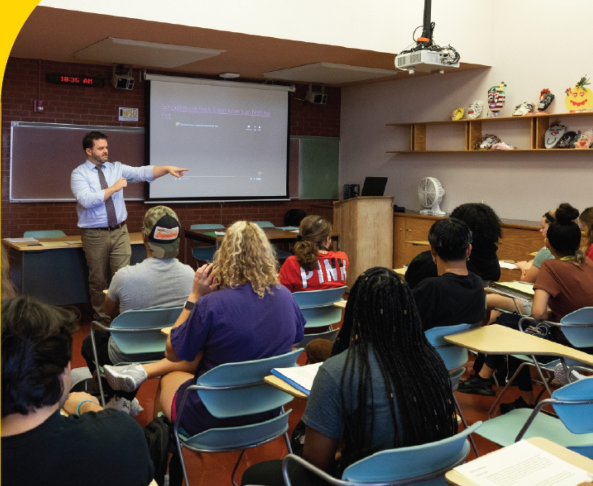
O Listening Sessions with current students, alumni, and donors
O Surveys & Feedback from faculty, staff, and Advisory Board
O Advisory Board members applauded the idea of returning Education to the name
Broad support for names that center Education
O The name change, timed with our 100th Anniversary in 2026, honors our legacy, reflects our mission, and strengthens our future identity
-tfiS{f COLLEGE OF
························ APPLIED STUDIES
WICHITA STATE
UNIVERSITY

• • • •
• • • •
• • • •
• • • •
• • • •
• • • •





WSU Academic Affairs will submit the following proposed name changes to the l<ansas Board of Regents:
0 College of Education

0 Department name changes:
- ISLE will return to CLES (Counseling, Educational Leadership, Educational and School Psychology) because the department will no longer include Teacher Apprentice Program, Special Education and Literacy
- School of Education will change to Teaching and Learning
•••••••••••••••••• ••••••••••••••
••••••••••••••••••••••••••••••••••••••••••••••••••••••••
•••••••••••••••••••••••••••••••••••••••••••••••••••••••••



h


WICHITA STATE UNIVERSITY

Workload policies
  - KBOR draft still in work
    - CoFSP continues to provide input
    - KBOR targeting a vote by December
  - WSU draft sent to Faculty Affairs Committee
    - Request completed work by beginning of Spring 2026
    - Survey being drafted
    - All faculty will receive a survey link in the coming weeks

KBOR updates
  - 90 cr hour baccalaureate – Task Force
  - Conversation regarding need for social media policy
  - Tuition assistance still under review

Rumors
  - Are adjuncts okay?
  - Misunderstanding regarding hiring adjuncts
  - Course optimization may reduce need for adjuncts
  - Savings can be used to appreciate salaries
  - Departments can still hire adjuncts as needed

Other Rumors or Questions?
Brief Q&A

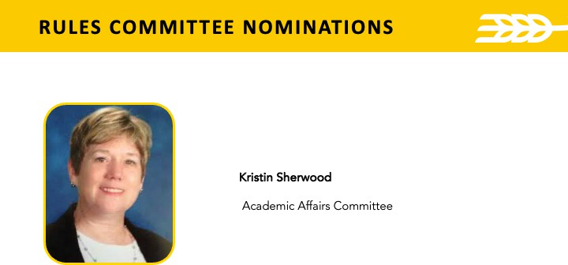

4.13 / Chair Policy and Procedures
Effective: July 01, 1997 Last Revised: October 22, 2024

Initiating Authority
  - The Faculty Senate serves as the initiating authority for this policy.

Purpose
  - This policy lays out the role, selection, review and evaluation of department chairs.

Policy
Undergraduate degree-granting colleges are organized by departments and schools headed by chairs or directors. Throughout this policy, any reference to "chair" also applies to directors, and any reference to "department" also applies to schools.

Title of the Office
The term "chair" as opposed to "head" is used herein to suggest consultative and open administrative procedures.

Role of the Chair
Appropriate functions of the chair include the following duties:

Academic Leadership
      - To inspire and to facilitate departmental staff action that identifies and moves effectively toward the realization of goals of the department.
      - To create and maintain an environment conducive to continuous departmental development by employing carefully considered and highly selective recruitment practices and by encouraging and facilitating professional growth in all members of the staff.

Representation
      - To represent to appropriate groups beyond the departmental staff, such as students, college administration, University administration and the general public, the academic, professional and economic needs and interests of the department and its staff.

      - To represent to the staff the interests of identified relevant groups beyond the departmental staff, such as University administration, college administration, students, the academic discipline and the general public.
      - To act on all budgetary matters of the department in consultation with representative staff and the dean.
      - To act on personnel problems of the department, and, in consultation with representative staff, to make decisions on or transmit to the dean recommendations regarding:
        - assignment of staff
        - evaluation of staff
        - level and equity of financial reward
        - tenure
        - promotion
        - nonrenewal of employment
The role of the chair is important to the wellbeing, morale and development of the professional staff and to the operation of the University. The departmental staff, the dean, the Provost and the President all share an interest in developing and following procedures to facilitate the selection of chairs who will foster the highest standards of professional performance, or when necessary, infuse new life into a department. The procedures outlined by this policy will be utilized in the selection, appointment and evaluation of chairs.

Eligibility for Chair
No eligibility requirements as to age or length of University service are recommended. Any Full-Time, Eligible Faculty Member may serve as department chair.

Term of the Chair
The term of the chair shall be set by a majority of the departmental electorate at not less than three years nor more than five years. The chair may serve more than one successive term on the vote of a majority of the departmental electorate. A chair shall have the prerogative of resigning the office at any time, with reasonable notice. The departmental electorate may, by a petition signed by a majority of the total electorate, ask the dean to consider removal of the chair, but in no instance shall such request be made prior to the first annual evaluation of the chair. If so requested, the dean shall initiate a

hearing. If an agreement cannot be reached, procedures stated under "IMPASSES" below shall be followed.
The dean may request, at any time, for good and sufficient reason, that the department consider removal of the chair. When removal is considered, the chair shall be accorded an opportunity for a full hearing, before the electorate and the dean, on his or her alleged shortcomings and have opportunity to respond.
A majority vote of the department electorate is required to support removal from office. If an agreement cannot be reached, procedures stated under "IMPASSES" below shall be followed.
Nothing in this document shall preclude the President from removing a chair from the position and/or appointing an interim chair if the President is convinced, beyond reasonable doubt, that the integrity of the University and its effective functioning requires such action and if the President has explored the situation, insofar as time permits, with faculty members and the chair of the department involved, and with the dean and appropriate committees of the college in which the department is housed. In keeping with the consultative spirit of this document, it is recommended that in reaching such decisions the President also seek the advice, insofar as practicable, of representatives of faculty and administration.
In the event of termination of a chair (due to completion of the term of office, resignation or removal), he or she shall be accorded the same professional rights as any other faculty member of like academic status.
If it is necessary to appoint an acting or interim chair for longer than one semester, the dean shall make the appointment, except that on petition of a majority of the departmental electorate, he or she shall institute the same selection procedure as is used in naming a chair for a full term. If the appointment of an interim or acting chair is for a semester or less or for serving for a chair who will return to his or her position, the dean and the regular chair shall decide on the interim appointee.

Electorate
The electorate for nominating a department chair shall, as a minimum, include all those serving as Full-Time professors, associate professors, assistant professors and tenured instructors, who provide at least 50 percent of their University duties within the department. This group may, by majority vote, establish as a policy the extension of the electorate to (but no farther than) all those in the department enfranchised to vote under the Constitution of the Faculty Senate.
Administrators, , are excluded from the electorate for the purposes of voting for a chair. A faculty member who has resigned or who is serving in the last

year of a terminal appointment shall also be excluded from the electorate for the purposes of voting for a chair.
In departments with an electorate of five or fewer persons, departures from the stated procedures may be made. In such instances, the dean shall utilize methods that conform to the spirit of democratic and consultative procedures implicit herein.
The dean shall ensure that the electorate is convened only after due notice. On convening, the electorate shall choose a presiding officer to serve until the selection of a chair is completed.
The electorate, as defined above, may, by majority vote, assign to a committee of its choosing the function of nominating a candidate or slate of candidates for chair. In the final selection of a nominee for chair, the total electorate shall be accorded the right to vote. In all votes provided for pursuant to these procedures, measures shall be taken to ensure the anonymity of each voter.
The electorate of a department recommends a nominee to the dean of the college. The dean, with the concurrence of the Provost, unless there is an impasse, may proceed to appoint the individual as chair of the department.
In the event that a new department is created and has no staff, the dean shall have the prerogative of appointing the initial chair for a term not to exceed three years.

Impasses
In the event of an impasse between the dean and the departmental electorate over the selection or removal of a chair, the dean shall meet with the entire departmental electorate, give reasons for and discuss his or her position regarding the decision, and respond to questions and discussion from the faculty. An attempt shall be made to find a mutually acceptable solution.
Failing a solution, the departmental electorate shall proceed through the nomination procedure a second time and make a nomination or nominations to the dean.
If an impasse persists, the issue shall be submitted for fact finding and mediation to an ad hoc committee of five faculty members. This committee shall consist of one person named by the dean, one person named by the departmental electorate, and three persons named from the Full-Time Eligible Faculty Members of WSU, by the two previously appointed representative members. If the fact-finding and mediation activities of the committee do not resolve the impasse, the committee will transmit its findings of fact and its recommendations, which shall be made public, to the dean, to the President and to the Provost for their action. In addition, a vote by secret ballot shall be

conducted among the department electorate to determine the number that support or oppose the recommendation of the dean. The record of this vote shall accompany the recommendation. Any member or group of the electorate shall be accorded the opportunity to make a statement in writing, support or opposing the recommendation, to the Provost.

Evaluation of the Chair
There shall be an annual, anonymous, written evaluation of the performance of chairs instituted by the dean and conducted by the electorate of the department as previously defined. The evaluation instrument used by the departmental electorate shall include questions submitted by the dean, by the chair and by representatives chosen by the departmental electorate from its membership. The results of the evaluation shall be available to the dean and to the chair; on the initiative of the chair, the results may be made available to others as designated by the chair.

Definitions
  - For the purpose of this policy only, the following definitions shall apply:
    - Administrator: The Administrator is defined by the Constitution of the Faculty Senate.
    - Eligible Faculty Member: For the purposes of this policy, Eligible Faculty Members are all employees who have teaching/research/library responsibilities of 50% or more that are eligible for membership in the Faculty Senate, including, but not limited to: temporary faculty, probationary faculty, tenured faculty, non-tenure track faculty (contingent unclassified professionals, provisional unclassified professionals, and regular unclassified professionals). These employees all have the e-class designation of FA or F2.
    - Full-Time: An employee who works 100% of the standard full-time workload as defined by the University. A 0.75 FTE appointment is considered full-time and includes eligibility for full benefits. This can represent 30 hours or more per week for staff or the equivalent teaching and service load for faculty.
    - University: Wichita State University and controlled affiliated organizations.

Applicable Laws And Additional Resources
  - Constitution of the Faculty Senate
  - Rules of the Faculty Senate

Revision Dates
  - July 1, 1997
  - November 15, 2011
  - October 22, 2024

Original Text
The electorate for nominating a department chair shall, as a minimum, include all those serving as Full-Time professors, associate professors, assistant professors and tenured instructors, who provide at least 50 percent of their University duties within the department. This group may, by majority vote, establish as a policy the extension of the electorate to (but no farther than) all those in the department enfranchised to vote under the Constitution of the Faculty Senate.

Second Read, Proposed Changes
The electorate for nominating a department chair shall, as a minimum, include all those serving as Full-Time professors, associate professors, assistant professors and tenured instructors, who provide at least 50 percent of their University duties within the department. This group may, by majority vote, establish as a policy the extension of the electorate to (but no farther than) all those in the department enfranchised to vote under the Constitution of the Faculty Senate.

Clean Second Read, Proposed Changes
The electorate for nominating a department chair shall include all those in the department enfranchised to vote under the Constitution of the Faculty Senate.

As may arise

Next meeting October 27th 3:30-5pm
Woolsey Hall 110A

