

Faculty Senate Meeting
Woolsey 110A

Faculty Senate Meeting Agenda
What: Faculty Senate Meeting (2025-2026) When: Monday, Oct 27, 2025, 3:30-5:00 pm Where: Woolsey Hall 110A

Agenda Item | Notes/Discussion/Process | Time
Call to order | Christopher Stone
Approval of Minutes | Sep 22, 2025 | 1 min
Informal Statements |  | 2 min
President's Report | - Updates  - Board Effect platform and invites | 10 min
Committee Reports | - Nominees for ratification – Rules Committee | 2 min
Old Business | - Proposed change to 4.13 Chair Policy and Procedures (Term Limits) – Second read | 30 min
New Business
As May Arise
Adjourn | - Next meeting, General Faculty Meeting November 10th at 3:30pm in Woolsey Hall  110A

Faculty Senate (2025 – 2026) Meeting Minutes - Draft Monday, September 22, 2025
3:30-5:00 pm Woolsey Hall, 110A

Attendance
Present: Allen, Asmatulu, Beck, Billingham, Bowen, Butler, Castro, Celestin, Chang, Chesser, Cooper, Cossell, Dai, Delacruz, Flores, Gilstrap, Griffith, Jamkartanian, Jones, Jorn, Kim, Kirby, Koop, Kreinath, Loibl, Lynch, Ma, Muether, Nelson, Nicks, O’Bryan, Ott, Price, Proctor, Pulaski, Rani, Ray, Sarionder, Sherwood, Showstack, Small, Stone, Swindle, Terry, Twomey, Vasquez, Williams, Zhu
Excused: Boynton, Dudley, Myose, Shan, Tew Absent: Boynton, Foster, Kuhlman, Li, Thompson

Call to Order
- President Stone at 3:30 - Meeting Book
  - Announcement that sign-in for Senate meetings will be through a Qualtrics survey; all senators will receive an email with a personalized link.
  - Reminder to keep cross-talk to a minimum in the room due to the table mics.

Approval of Minutes
- September 8, 2025 – no comments for corrections or additions; approved unanimously as submitted.

Informal Statements
- None
Teams meeting recording started. President’s Report
- Announcement from College of Applied Studies, Dean Friend (slides 10-13)
  - Provided additional information and context for the proposal to change the name of the College of Applied Studies (CAS) to College of Education.
  - Clarification that all programs currently in CAS will remain in the new College of Education.
- Update on KBOR and WSU Workload Policies (slides 15-17)
  - WSU workload policy – additional clarifications
    - Do not believe our policy will need approved by KBOR, but should be aligned with KBOR.
    - Goal is to bring a draft policy to Faculty Senate (FS) by early spring 2026 and to General Faculty meeting in April 2026.
    - In KBOR’s draft, WSU is “high research”.
    - Flexibility will be built into the policy.
    - Notes from the prior workload taskforce (TF) will be sent to the Faculty Affairs chair for consideration.

  - 90 CH Baccalaureate Degree – additional clarifications
    - KSU presented a proposal for a new 90-hour degree.
    - Per KBOR, gen ed requirements would remain largely intact.
    - Does not affect current programs.
    - Any new proposals will be to fill specific degree/field needs.
    - KBOR is launching a TF to study the idea.
    - Several Senators voiced opposition.
    - Additional context is that HLC is looking at the feasibility of 90 CH baccalaureate degrees and the idea is also industry-driven.
  - Social Media Policy
    - Current KBOR policy is from 2014.
    - Recommendation from Senator Castro to develop a procedure to guide how reports of social media posts are handled in relation to calls for termination and/or sanctions to the faculty member.
  - Tuition Assistance
    - Context – this is the proposal presented by the CoFSPs last year for inter- collegiate tuition assistance. No major action, still being considered.
  - Rumors and Other Updates – Additional Clarifications
    - Salary data will be shared with FS as it is made available to the FS Executive Committee by Provost Lounsbery.
    - Primary goal is to save costs where possible so that savings can be directed towards salary increases.
    - Please share comments and/or concerns with the FS Planning and Budget Committee (Chair, Past-President Mat Muether).

Committee Reports
- Rules Committee – President-Elect Koop, Presented by President Stone
  - Committee member for ratification (slide 19) – confirmed unanimously

Old Business
- Chair Policy TF, Second Read – Electorate Update, President Stone (slides 20-26)
  - Senator Castro shared that there is now a staff member on the TF.
  - Various senators shared several possible scenarios, discussion that these scenarios are outliers and while not impossible, could be handled if/when they arise.
  - Senator Cooper called the question, no second.
  - Continued discussion of potential outliers.
  - Motion to approve, seconded, motion carried 44-0.
  - Will present at next General Faculty Meeting for voting.

New Business
- None

As May Arise
- None

Adjourn FS
- Next meeting is October 27, 3:30p in Woolsey Hall 110A
- President Stone adjourned the meeting at 4:33. Minutes prepared by Rhonda Williams

Informal Statements?

Faculty Senate 10-27-2025
Informal Announcement shared on behalf of Jolynn Dowling – Janice M. Riordan
Distinguished Professor for Maternal Child Health in the School of Nursing and past FS President.
Thank you, Rhonda, for sharing this informal announcement, as I had a conflict with teaching this evening.

Faculty Senators,
As many of you know, October is Breast Cancer Awareness Month. I recognize that breast cancer has touched many lives in our community, whether personally or through someone close. As we approach the end of the month, I’d like to highlight the important role of
breastfeeding in reducing the risk of breast cancer.
The American Academy of Pediatrics (AAP) and World Health Organization (WHO)
recommend exclusive breastfeeding for 6 months, and continued breastfeeding with complementary foods for two years and beyond. Did you know that for every year a person breastfeeds, their risk of breast cancer decreases by 4.3%? This protective effect is cumulative. The longer someone breastfeeds and the more children they breastfeed, the greater the benefit. Even more compelling, breastfeeding can reduce the risk of Triple Negative Breast Cancer by about 20%, and for carriers of the BRCA1 gene, the reduction ranges from 22–55%.
Here in Kansas, we’re seeing strong breastfeeding initiation rate at 87% statewide, and even higher in Sedgwick County at approximately 90%. That means many of our students, staff, and faculty of reproductive age may be planning to include breastfeeding in their infant feeding journey. It’s essential that we continue to foster a campus culture that
supports breastfeeding, especially for those with a family history of breast cancer.
Unfortunately, one of the most common reasons people stop breastfeeding earlier than planned is lack of support from employers or the public. That’s why I’m proud to share that WSU was recognized in 2023 as a Gold Level Employer Supporting Breastfeeding, and as a Breastfeeding Welcome Here campus.
To help support our campus community:
- Policy 3.38 outlines support for lactating employees.
- Policy 8.21 and CTAC provide resources for pregnant and parenting students.

- We now have 17 lactation and wellness rooms across campus, with an interactive map to help locate them easily. Thanks to CTAC’s partnership with me in keeping this updated as our facilities grow.
If you have questions or want to learn more, please don’t hesitate to reach out to HR, CTAC, or to me directly. I’m always happy to be a resource.
Let’s continue to champion a supportive environment for all members of our campus community.
Thank You!

Jolynn Dowling
Senior Educator – Riordan Distinguished Professor Sources:
American Academy of Pediatrics Section on Breastfeeding. (2022). Policy statement: Breastfeeding and the use of human milk. Pediatrics, 150(1), e2022057988.
https://doi.org/10.1542/peds.2022-057988
Centers for Disease Control and Prevention. (2025, August 21). NIS-Child Data Results. NIS-Child Data Results | Breastfeeding Data | CDC
Stordal, B. (2023). Breastfeeding reduces the risk of breast cancer: A call for action in high- income countries with low rates of breastfeeding. Cancer Medicine, 12, 4616-4625. https://doi.org/10.1002/cam4.5288
World Health Organization. (2025). Breastfeeding: Recommendations. Breastfeeding

Recording starts now.

Disclaimer: Any AI-generated notes from this meeting are not official records and may contain errors. Please refer to the official Faculty Senate meeting minutes.


Christopher Stone
Oct 27th, 2025
Faculty Senate Meeting
President’s Report

Committees
- Survey for Faculty Affairs committee going out soon

- Student Affairs Committee started work

Library
- Met with Dean Mai to discuss recent changes and concerns
- Following best practices
- New access (see WSU Today)
- Data on library usage at a future meeting

Board Effect
- New platform for conducting Senate work

- Specific URL needed for SSO login

=tr"4"t·
Wichita State University

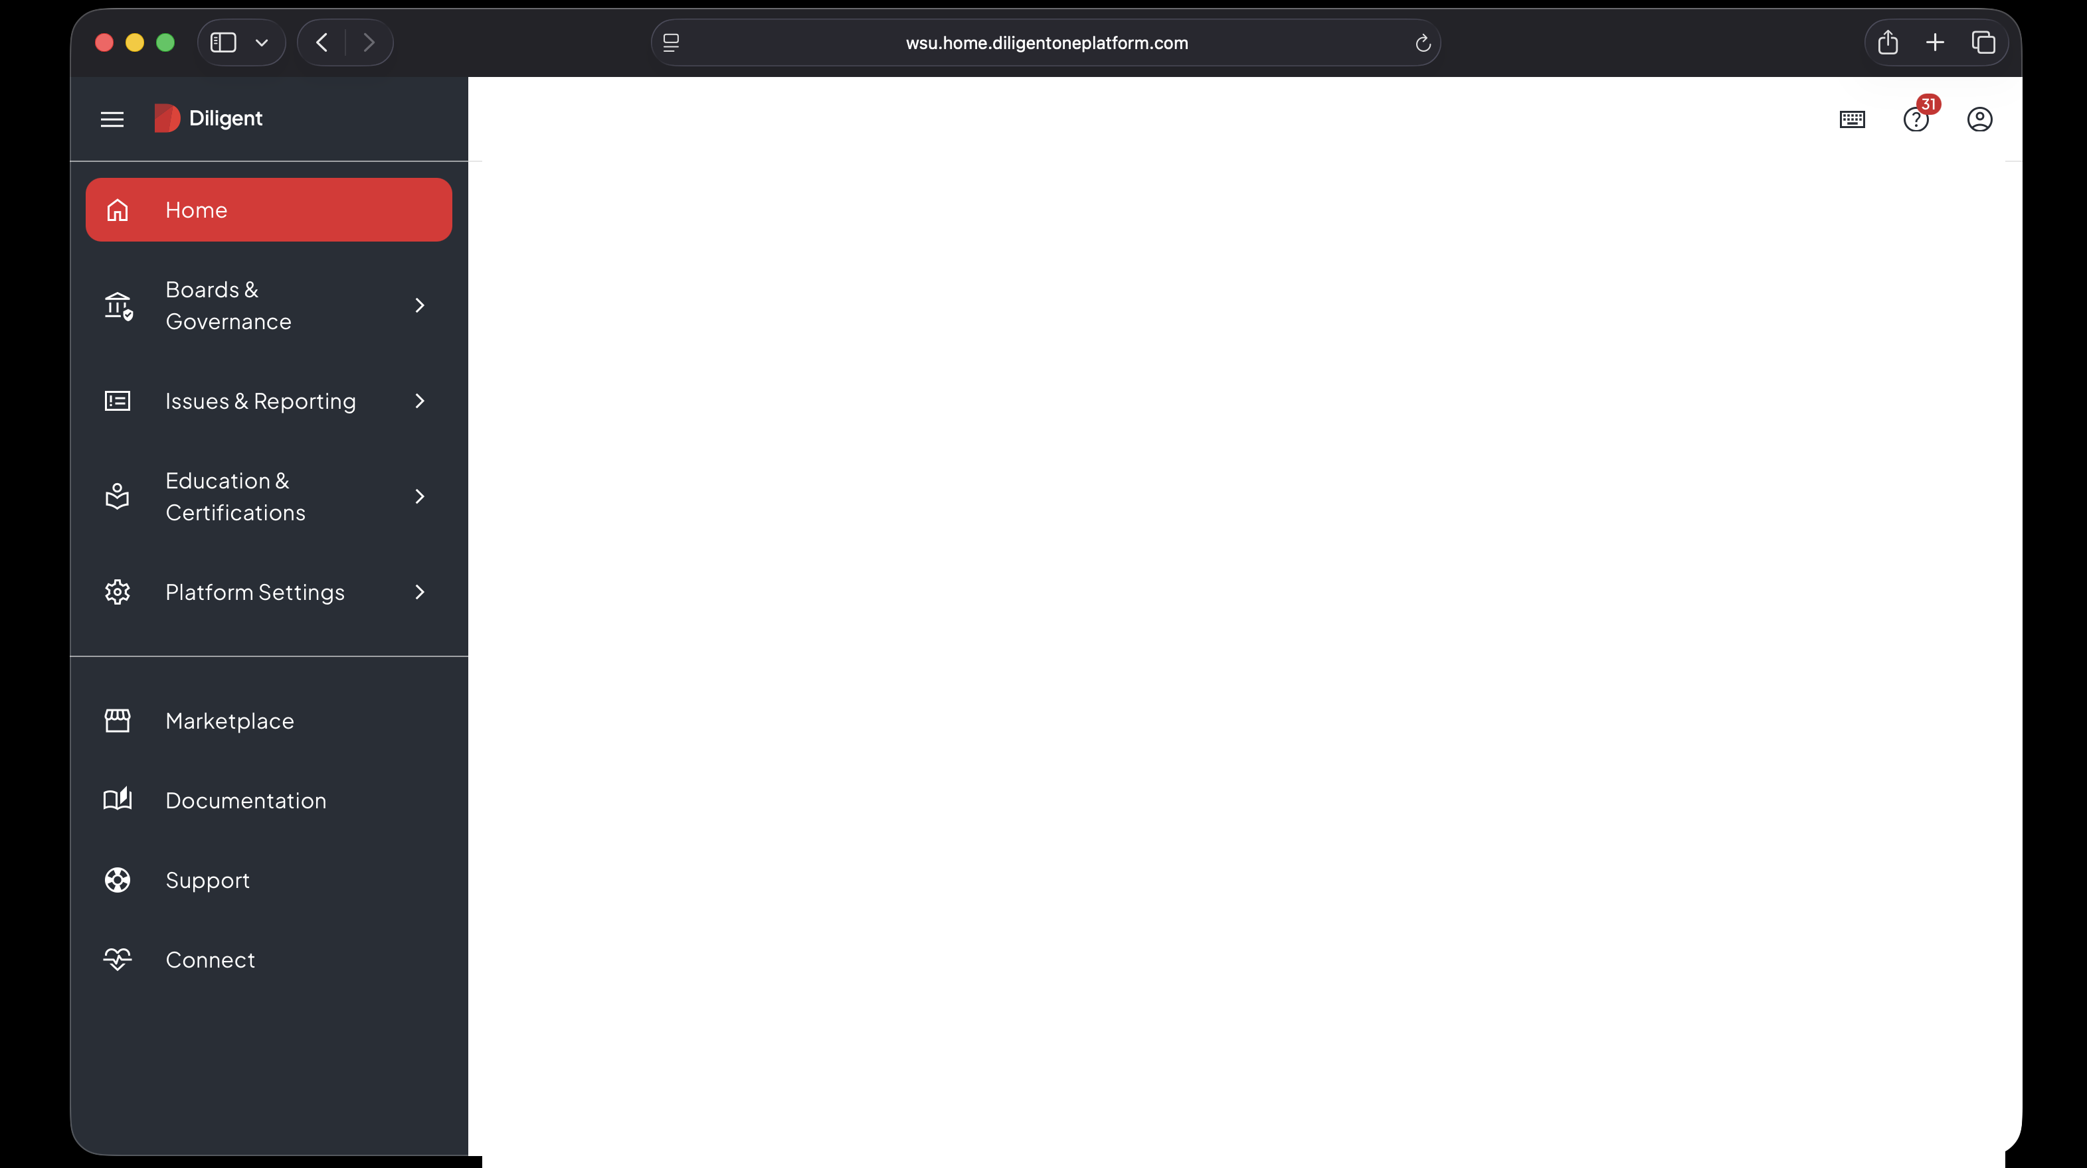

Boards & Governance Issues & Reporting Education & Certifications Resources

My Favorites $ Customize page

a a a
Have your favorite apps at hand by customizing this section.

Boards & Governance

BoardEffect

Issues & Reporting

Activity Center

-==·
�
Wichita State University

Home

> Welcome
Updated: June 13, 2025

Edit

v Events 0

Open calendar Exportall v

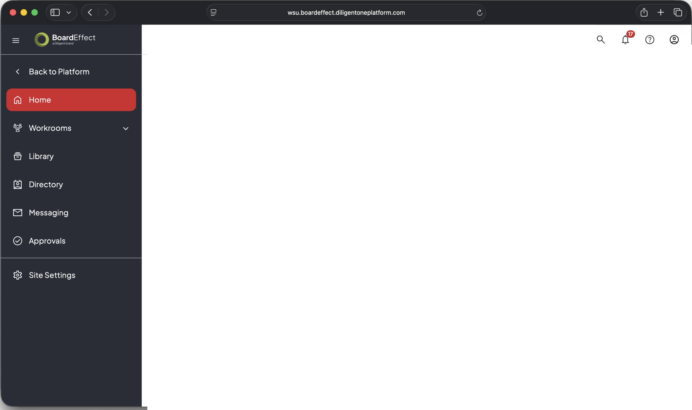

Faculty Senate Meeting
� Workroom: All Senators Monday, October 27, 2025
3:30 PM - 5:00 PM (CDT)
Senate Meetings

Join meeting [ Export v J

Privacy Policy �



Y ] } v M

] ( Y


WICHITA STATE UNIVERSITY

RULES COMMITTEE NOMINATIONS

Committee | Faculty Member
Rules Committee | Doris Chang (LAS – Social Sciences) through Spring 2027
Faculty Affairs | Kelly Young (LAS – Social Sciences) through Spring 2028
Library Committee | Mary Harbour (Graduate Student Representative) through Spring 2028
Tenure and Promotion Committee  (At-Large NTT) | Brian Rawson (Business) through Spring 2027 Kristin Sherwood (CAS) through Spring 2028
Accessibility Committee | Sara Rue (Libraries) through Spring 2026

COMMITTEE VACANCIES

Committee (# vacancies) | Faculty Member
Court of Academic Appeals (1) | CAS to Alternate (through Spring 2028)
General Education (1) | LAS Social Sciences (through 2026)
Faculty Affairs (1) | Business (through 2027)
Accessibility (1) | LAS – Natural Sciences (through 2028)
Library (2) | Health Professions (through 2028) Fine Arts (through 2026)
University Exceptions (2) | Business (through 2028)  CAS (through 2027)

Accessibility Committee Composition Change




Proposed Composition
9 Faculty
1 Student
1 Ex-Officio from the University Accessibility Committee

+ Director of ADA (Ex- Officio)
+ 1 Staff Senate representative from
Facilities
Current Composition
9 Faculty
1 Student
1 Ex-Officio from the University Accessibility Committee

4.13 / Chair Policy and Procedures
Effective: July 01, 1997 Last Revised: October 22, 2024

Initiating Authority
  - The Faculty Senate serves as the initiating authority for this policy.

Purpose
  - This policy lays out the role, selection, review and evaluation of department chairs.

Policy
Undergraduate degree-granting colleges are organized by departments and schools headed by chairs or directors. Throughout this policy, any reference to "chair" also applies to directors, and any reference to "department" also applies to schools.

Title of the Office
The term "chair" as opposed to "head" is used herein to suggest consultative and open administrative procedures.

Role of the Chair
Appropriate functions of the chair include the following duties:

Academic Leadership
      - To inspire and to facilitate departmental staff action that identifies and moves effectively toward the realization of goals of the department.
      - To create and maintain an environment conducive to continuous departmental development by employing carefully considered and highly selective recruitment practices and by encouraging and facilitating professional growth in all members of the staff.

Representation
      - To represent to appropriate groups beyond the departmental staff, such as students, college administration, University administration and the general public, the academic, professional and economic needs and interests of the department and its staff.

      - To represent to the staff the interests of identified relevant groups beyond the departmental staff, such as University administration, college administration, students, the academic discipline and the general public.
      - To act on all budgetary matters of the department in consultation with representative staff and the dean.
      - To act on personnel problems of the department, and, in consultation with representative staff, to make decisions on or transmit to the dean recommendations regarding:
        - assignment of staff
        - evaluation of staff
        - level and equity of financial reward
        - tenure
        - promotion
        - nonrenewal of employment
The role of the chair is important to the wellbeing, morale and development of the professional staff and to the operation of the University. The departmental staff, the dean, the Provost and the President all share an interest in developing and following procedures to facilitate the selection of chairs who will foster the highest standards of professional performance, or when necessary, infuse new life into a department. The procedures outlined by this policy will be utilized in the selection, appointment and evaluation of chairs.

Eligibility for Chair
No eligibility requirements as to age or length of University service are recommended. Any Full-Time, Eligible Faculty Member may serve as department chair.

Term of the Chair
The term of the chair shall be set by a majority of the departmental electorate at not less than three years nor more than five years. The chair may serve more than one successive term on the vote of a majority of the departmental electorate.
Given the importance of shared governance and leadership development in higher education, chairs are expected to foster an inclusive environment that actively supports the preparation of all department members for future

leadership roles. This includes providing intentional inclusive mentorship, creating opportunities for growth, and engaging in succession planning, while also developing a thoughtful post-chair career trajectory for themselves.

Department chairs may therefore serve no more than two consecutive terms except in extenuating circumstances. Length of each chair term may be 3-5 years, as determined by the department electorate.

Effective date: January 2026. Chairs who have already exceeded this timeframe or are at the limit will be expected to complete their term before transitioning, with appropriate support and planning for leadership handoff.

A chair shall have the prerogative of resigning the office at any time, with reasonable notice. The departmental electorate may, by a petition signed by a majority of the total electorate, ask the dean to consider removal of the chair, but in no instance shall such request be made prior to the first annual evaluation of the chair. If so requested, the dean shall initiate a hearing. If an agreement cannot be reached, procedures stated under "IMPASSES" below shall be followed.
The dean may request, at any time, for good and sufficient reason, that the department consider removal of the chair. When removal is considered, the chair shall be accorded an opportunity for a full hearing, before the electorate and the dean, on his or her alleged shortcomings and have opportunity to respond.
A majority vote of the department electorate is required to support removal from office. If an agreement cannot be reached, procedures stated under "IMPASSES" below shall be followed.
Nothing in this document shall preclude the President from removing a chair from the position and/or appointing an interim chair if the President is convinced, beyond reasonable doubt, that the integrity of the University and its effective functioning requires such action and if the President has explored the situation, insofar as time permits, with faculty members and the chair of the department involved, and with the dean and appropriate committees of the college in which the department is housed. In keeping with the consultative spirit of this document, it is recommended that in reaching such decisions the President also seek the advice, insofar as practicable, of representatives of faculty and administration.
In the event of termination of a chair (due to completion of the term of office, resignation or removal), he or she shall be accorded the same professional rights as any other faculty member of like academic status.

If it is necessary to appoint an acting or interim chair for longer than one semester, the dean shall make the appointment, except that on petition of a majority of the departmental electorate, he or she shall institute the same selection procedure as is used in naming a chair for a full term. If the appointment of an interim or acting chair is for a semester or less or for serving for a chair who will return to his or her position, the dean and the regular chair shall decide on the interim appointee.

Electorate
The electorate for nominating a department chair shall, as a minimum, include all those serving as Full-Time professors, associate professors, assistant professors and tenured instructors, who provide at least 50 percent of their University duties within the department. This group may, by majority vote, establish as a policy the extension of the electorate to (but no farther than) all those in the department enfranchised to vote under the Constitution of the Faculty Senate.
Administrators, , are excluded from the electorate for the purposes of voting for a chair. A faculty member who has resigned or who is serving in the last year of a terminal appointment shall also be excluded from the electorate for the purposes of voting for a chair.
In departments with an electorate of five or fewer persons, departures from the stated procedures may be made. In such instances, the dean shall utilize methods that conform to the spirit of democratic and consultative procedures implicit herein.
The dean shall ensure that the electorate is convened only after due notice. On convening, the electorate shall choose a presiding officer to serve until the selection of a chair is completed.
The electorate, as defined above, may, by majority vote, assign to a committee of its choosing the function of nominating a candidate or slate of candidates for chair. In the final selection of a nominee for chair, the total electorate shall be accorded the right to vote. In all votes provided for pursuant to these procedures, measures shall be taken to ensure the anonymity of each voter.
The electorate of a department recommends a nominee to the dean of the college. The dean, with the concurrence of the Provost, unless there is an impasse, may proceed to appoint the individual as chair of the department.
In the event that a new department is created and has no staff, the dean shall have the prerogative of appointing the initial chair for a term not to exceed three years.

Impasses

In the event of an impasse between the dean and the departmental electorate over the selection or removal of a chair, the dean shall meet with the entire departmental electorate, give reasons for and discuss his or her position regarding the decision, and respond to questions and discussion from the faculty. An attempt shall be made to find a mutually acceptable solution.
Failing a solution, the departmental electorate shall proceed through the nomination procedure a second time and make a nomination or nominations to the dean.
If an impasse persists, the issue shall be submitted for fact finding and mediation to an ad hoc committee of five faculty members. This committee shall consist of one person named by the dean, one person named by the departmental electorate, and three persons named from the Full-Time Eligible Faculty Members of WSU, by the two previously appointed representative members. If the fact-finding and mediation activities of the committee do not resolve the impasse, the committee will transmit its findings of fact and its recommendations, which shall be made public, to the dean, to the President and to the Provost for their action. In addition, a vote by secret ballot shall be conducted among the department electorate to determine the number that support or oppose the recommendation of the dean. The record of this vote shall accompany the recommendation. Any member or group of the electorate shall be accorded the opportunity to make a statement in writing, support or opposing the recommendation, to the Provost.

Evaluation of the Chair
There shall be an annual, anonymous, written evaluation of the performance of chairs instituted by the dean and conducted by the electorate of the department as previously defined. The evaluation instrument used by the departmental electorate shall include questions submitted by the dean, by the chair and by representatives chosen by the departmental electorate from its membership. The results of the evaluation shall be available to the dean and to the chair; on the initiative of the chair, the results may be made available to others as designated by the chair.

Definitions
  - For the purpose of this policy only, the following definitions shall apply:
    - Administrator: The Administrator is defined by the Constitution of the Faculty Senate.
    - Eligible Faculty Member: For the purposes of this policy, Eligible Faculty Members are all employees who have teaching/research/library responsibilities of 50% or more that are eligible for membership in the Faculty Senate, including, but not

limited to: temporary faculty, probationary faculty, tenured faculty, non-tenure track faculty (contingent unclassified professionals, provisional unclassified professionals, and regular unclassified professionals). These employees all have the e-class designation of FA or F2.
    - Full-Time: An employee who works 100% of the standard full-time workload as defined by the University. A 0.75 FTE appointment is considered full-time and includes eligibility for full benefits. This can represent 30 hours or more per week for staff or the equivalent teaching and service load for faculty.
    - University: Wichita State University and controlled affiliated organizations.

Applicable Laws And Additional Resources
  - Constitution of the Faculty Senate
  - Rules of the Faculty Senate

Revision Dates
  - July 1, 1997
  - November 15, 2011
  - October 22, 2024

As may arise

Next meeting General Faculty Meeting
Nov 10th 3:30-5pm
Woolsey Hall 110A

