

Faculty Senate Meeting 08252025
Woolsey Hall 110A

Faculty Senate Meeting Minutes - Draft Monday, May 12, 2025
3:30-5:00 pm Woolsey Hall, 110A

Attendance
Present: Amos, Asmatulu, Bowen, Butler, Cooper, Cossell, Delacruz, Dowling, Dudley, Figy, Foster, Gilstrap, Hulett, Jamkartanian, Kirby, Kuhlman, Li, Loibl, Lynch, Ma, Marble-Flint, Markova, Moody, Moscoso, Muether, Myose, Nelson, Nicks, Ott, Proctor, Rai, Rani, Ray, Ross, Sherif, Sherwood, Showstack, Small, Sterrett, Stone, Tew, Thompson N., Williams.
Excused: Billingham, Boynton, Celestin, Pang, Price, Thompson, V.
Absent: Bussard, Chang, Gregory, Jarman, Sun, Zhu.

Call to Order
- President Muether at 3:30 pm - Meeting slide deck
- Brief orientation to room microphones by R. Corcoran

Informal Statements
- Senator Marble-Flint – comments on 9-month faculty contracts ending May 10th. Cites policy 4.11 and lists multiple faculty responsibilities that occur after this date (finals week, grade entry, commencement, etc.).
- Senator Price – comments requesting improved communication/transparency for faculty and staff related to updates on executive orders, legislative provisos, and changing policies.

Approval of Minutes
- April 28, 2025 – approved unanimously as submitted

President’s Report
- Deferred report and reserved this time for the end of this session when President passes gavel.

Committee Reports
- Rules Committee – Vice President Sheriff
  - Senator term extension through May 2026 (slide deck #6) – passed unanimously
  - Presentation of elected Senators for AY2025-2026 (slide deck #7) – informational only
  - Confirmation of University Committee members (slide deck #8) – confirmed unanimously
  - Senate & Committee Vacancies – Please consider serving.
- PIAC Report – Bayram Yildirim, Chair
  - Recognized committee members; R1 was focus this year; see PIAC slides
  - Comments – strategy should focus on all enrollment, not just PhD; has there been any discussion on distribution across various units related to roles graduates would enter; R1 only a possibility because Carnegie updated the requirements – diluted and now not as prestigious. Consider whether R1 is worth it at this point.

Response from Senator Castro – lots of research still needs to be completed to answer these questions; PIAC is working on it.
  - Additional comments or question, please email the Chair.
- Ombuds Report – Dr. Carolyn Shaw
  - See submitted report
  - One recommendation regarding T&P – weak or unclear workload statements/policies seem to be a root cause of several ombuds encounters. Recommend that the standard workload is clearly stated and documented in the record.
  - Comment: is it possible for the FAAR to include a workload section. Shaw will follow-up.
- Standing Committee Annual Reports
  - Academic Affairs, Dr. Raina Rutti
    - Much of the work is reviewing and approving CIM submissions.
    - Also looked at proposal to change the start times from 8a to 8:30a – engaged several stakeholders, including student gov assoc. Decision was that the request was a big change that would benefit a small number of people and potentially cause more concerns for a greater amount of students. Proposal not supported.
    - Excused absence policy reviewed – engaged with several stakeholders. Split into 2 policies = bereavement and religious observation. After minor edits, the proposals were supported.
    - Absences r/t travel to represent the university – informal discussion held.
  - Accessibility, Andrew Bowman
    - Met 4 times this academic year (AY).
    - Use of PDF files – create a big problem at WSU and are poorly accessible. Externally facing documents particularly expose us to complaints.
    - Use of website filters can be very helpful for adding content.
    - Role/charge of this committee will likely be updated to include staff.
  - Court of Academic Appeals, Dr. Rajiv Bagai
    - Only meet when there is a grade appeal submitted (UG or grad).
    - 14 encounters this AY.
  - Faculty Affairs, Dr. Beatrice Latavietz – see also meeting slide deck 9
    - Major work this semester was a comprehensive review of workload processes across campus.
    - Question: did KU have NTT information? Per Latavietz, yes, they had information, please email her and she will expand.
    - Question: flexible teaching reductions tied to research – how does this look here as we move to R1 – has this been discussed at all? How does the effort impact programs that don’t have PhDs? Per President Muether – more information will be forthcoming, FS exec and other leadership groups have been looking into this with various stakeholders.

  - Faculty Support, Dr. Bayram Yildirim – also see slide 11
    - Met 5 times; awarded nearly 90k in internal grant funding to faculty.
    - New pilot grant for ug/grad research assistantships (SUGRA)
    - Comments regarding revising application forms to allow broader types of applications, any plans to extend to NTT, and would the committee consider restructuring internal awards as some faculty feel it is too much work for too little funding, and has there been any research to evaluate the ROI for these funds? Responses per Yildirim – these funds meant to serve as seeds for future research and are considered an investment for work to prepare for the next, bigger grant application; NTT may be a bigger risk for these funds. There has been minimal formal research on the impact and/or ROI on the grants. Email Dr. Yildirim for further discussion.
  - Tenure & Promotion, Dr. Bayram Yildirim – also see slide 10
    - Met 4 times; reviewed multiple candidates for promotion.
  - Undergraduate Research, Dr. Semih Tartaroglu – Annual report pending
    - 30 poster presentations
    - Question: is this committee involved with the honors group for research – John Hammond had been the liaison; also honors hired a new person. No, this committee has not been involved with Honors.

Old Business
- None

New Business
- Discussion of State Proviso and Compliance Implementation – President Muether,
Provost Lounsbery
  - Brief overview of the requirements in the proviso; WSU received it April 11.
  - Challenge to implement/meet the proviso given the time of year and faculty leaving for summer. Must certify by August 1.
  - Item 5 – removing gender identifying pronouns. This includes email signatures. Looking into getting details on other forms of “communication” that are included – possibly Zoom, Teams, syllabi, handbooks, etc.
  - See information in WSU Today from today
  - Discussion
    - Has the legality/constitutionality of the proviso been addressed? Per General Counsel S. Boden, there have been no lawsuits filed yet; based on her experience would likely be upheld because the state restricted employee communication and there is no law/constitution issue with action being a violation of free speech
    - Concern over the vagueness of the proviso and potential to cause confusion. Per Provost, there is ambiguity, especially in interpretation. WSU has chosen to focus on a very “surgical” approach – doing nothing more than exactly what is stated. Current focus is only on employees, not research or curriculum. As time goes and get more information or clarification, will flex as needed.

    - Advice on advocating for DEI on employee’s own time. Per Provost, can express own point of view and exercise civic rights, just cannot represent WSU when doing so.
    - Closing statement by Provost reinforces that WSU always has and always will be a university for everyone; is a place where we want to continue to strive to become even better at the work of helping everyone to thrive and succeed. How we do that will comply with state law. Everyone should feel safe, welcome.
    - All are encouraged to email the FS President or Provost with additional questions.
- Request by President Muether to extend FS meeting by 10 minutes.
  - Motion Senator Bowen, seconded by Senator Small – motion passed unanimously.

As May Arise
- None

Pass the gavel – President Muether
- Shared an overview of FS accomplishments this year and recognized Senators for their time and work.
- Recognition of L. Birdwell for her service; presentation of flowers and gift.
- Gavel passed to President-Elect Stone

Adjourn FS Session for AY 2024-2025
- President Muether adjourned the meeting at 5:02 pm.

Call to Order 2025-2026 FS Session
- President Stone at 5:03 pm
  - Recognition of Past-President Muether and presentation of gift.
- President’s Report – President Stone
  - Welcome to new Senators and university committee members
  - Encouraged new senators to familiarize themselves with FS governing documents – see links on meeting slide deck #17.
- Election of Officers – President Stone
  - 2025-2026 slate of officers for Executive Committee presented and approved unanimously.
- As May Arise
  - None
- Adjourn
  - Next FS meeting is August 25, 2025, Woolsey Hall 110A, 3:30-5:00 pm.
  - Adjourned 5:07 pm Minutes prepared by Rhonda Williams


Christopher Stone
08/25/2025
Faculty Senate Meeting

President’s Report

H o w t o b e a S e n a t o r

ifi�· WICHITA STATE
�..., UNIVERSITY


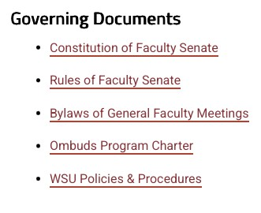
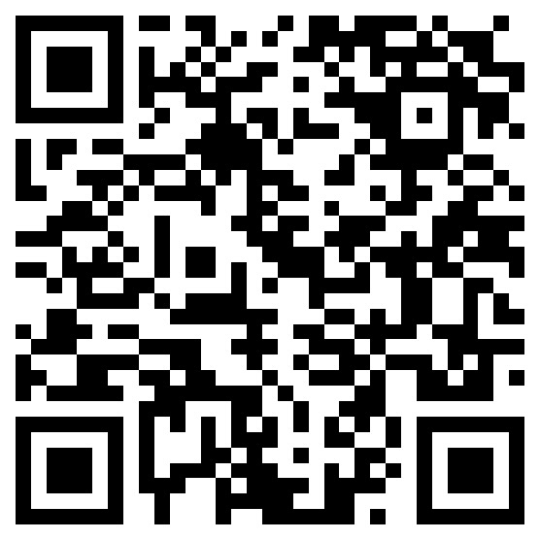
Welcome, new Senators
- Faculty Senate webpage
- https://www.wichita.edu/acade mics/facultysenate/

Senator expectations
- Attend meetings regularly
- Represent your unit
- Report relevant information to your unit
- Bring concerns and questions from your unit to the Senate
- Your votes should be informed by your unit

Participation
- All mics in the room are live (minimize cross chat)
- The mics only project to Teams
- Remote participants will be asked to use chat function in Teams

Bringing Issues to Senate
- First stop is your reporting chain (e.g., chair, dean, provost)
- Next stop is Executive Committee
  - Email me at christopher.stone@wichita.edu
  - Chat before or after meeting, or mention during meeting
  - We will assist and determine if it is a Senate issue
  - If not, we will point you to the right person
- Executive Committee sets agenda for meetings
  - We may ask you to come meet with the committee first

Updates
Actions since last meeting

Meetings with Stakeholders
- KBOR meetings, PET Retreat, COD meetings
- SGA leadership – discuss their priorities for AY26
- Provost Lounsbery – multiple issues (faculty pay, T&P, workload)
- AVP Alicia Newell – updates to academic integrity needed
- Several small policy changes from GC (compliance)

Changes and work in progress
- New hiring approval process for tenure-track lines
  - Improvements ongoing
- Watermark will be used for T&P
  - Policy updates needed
- Workload policy
  - KBOR update in work
  - Draft WSU policy to committee soon
- New online platform for Senate work (board management platform)
  - Will serve as a repository for documentation, meeting info, etc.
  - Plan to fully adopt by Spring 2026
  - Senators will receive training (15 minutes)

P r i o r i t i e s f o r A Y 2 6

ifi�· WICHITA STATE
�..., UNIVERSITY

General Faculty Meetings
- Will be held on November 10th and April 27th
- Priority – discuss and vote on policy changes
- Will hold Town Hall in place of meeting if no items for review

Reduce unnecessary presentations
- Requests to present to Senate will be reviewed
  - Robust discussion or decision needed from Senate
  - Purely informational sessions will be denied unless required

- Focus Senate attention on policy review and updates

Goals and Action Items
- Workload policy
  - KBOR draft in work
  - WSU draft to committee soon
  - Policy will ensure better equity across units
- Department Chair policy
  - Chair policy task force active with items ready for review
- Tenure and Promotion policy
  - Updates needed to reflect new process
- Faculty review policy
  - Updates needed to reflect new process

RULES COMMITTEE NOMINATIONS

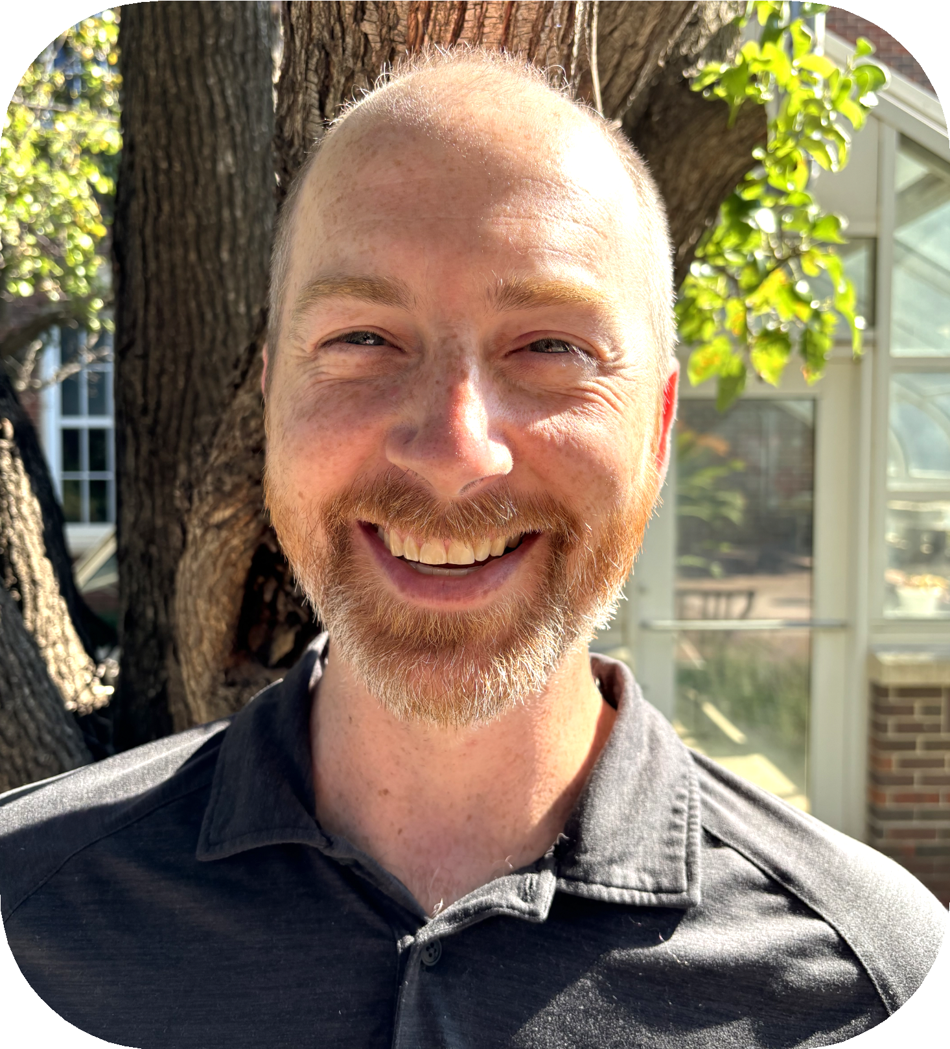
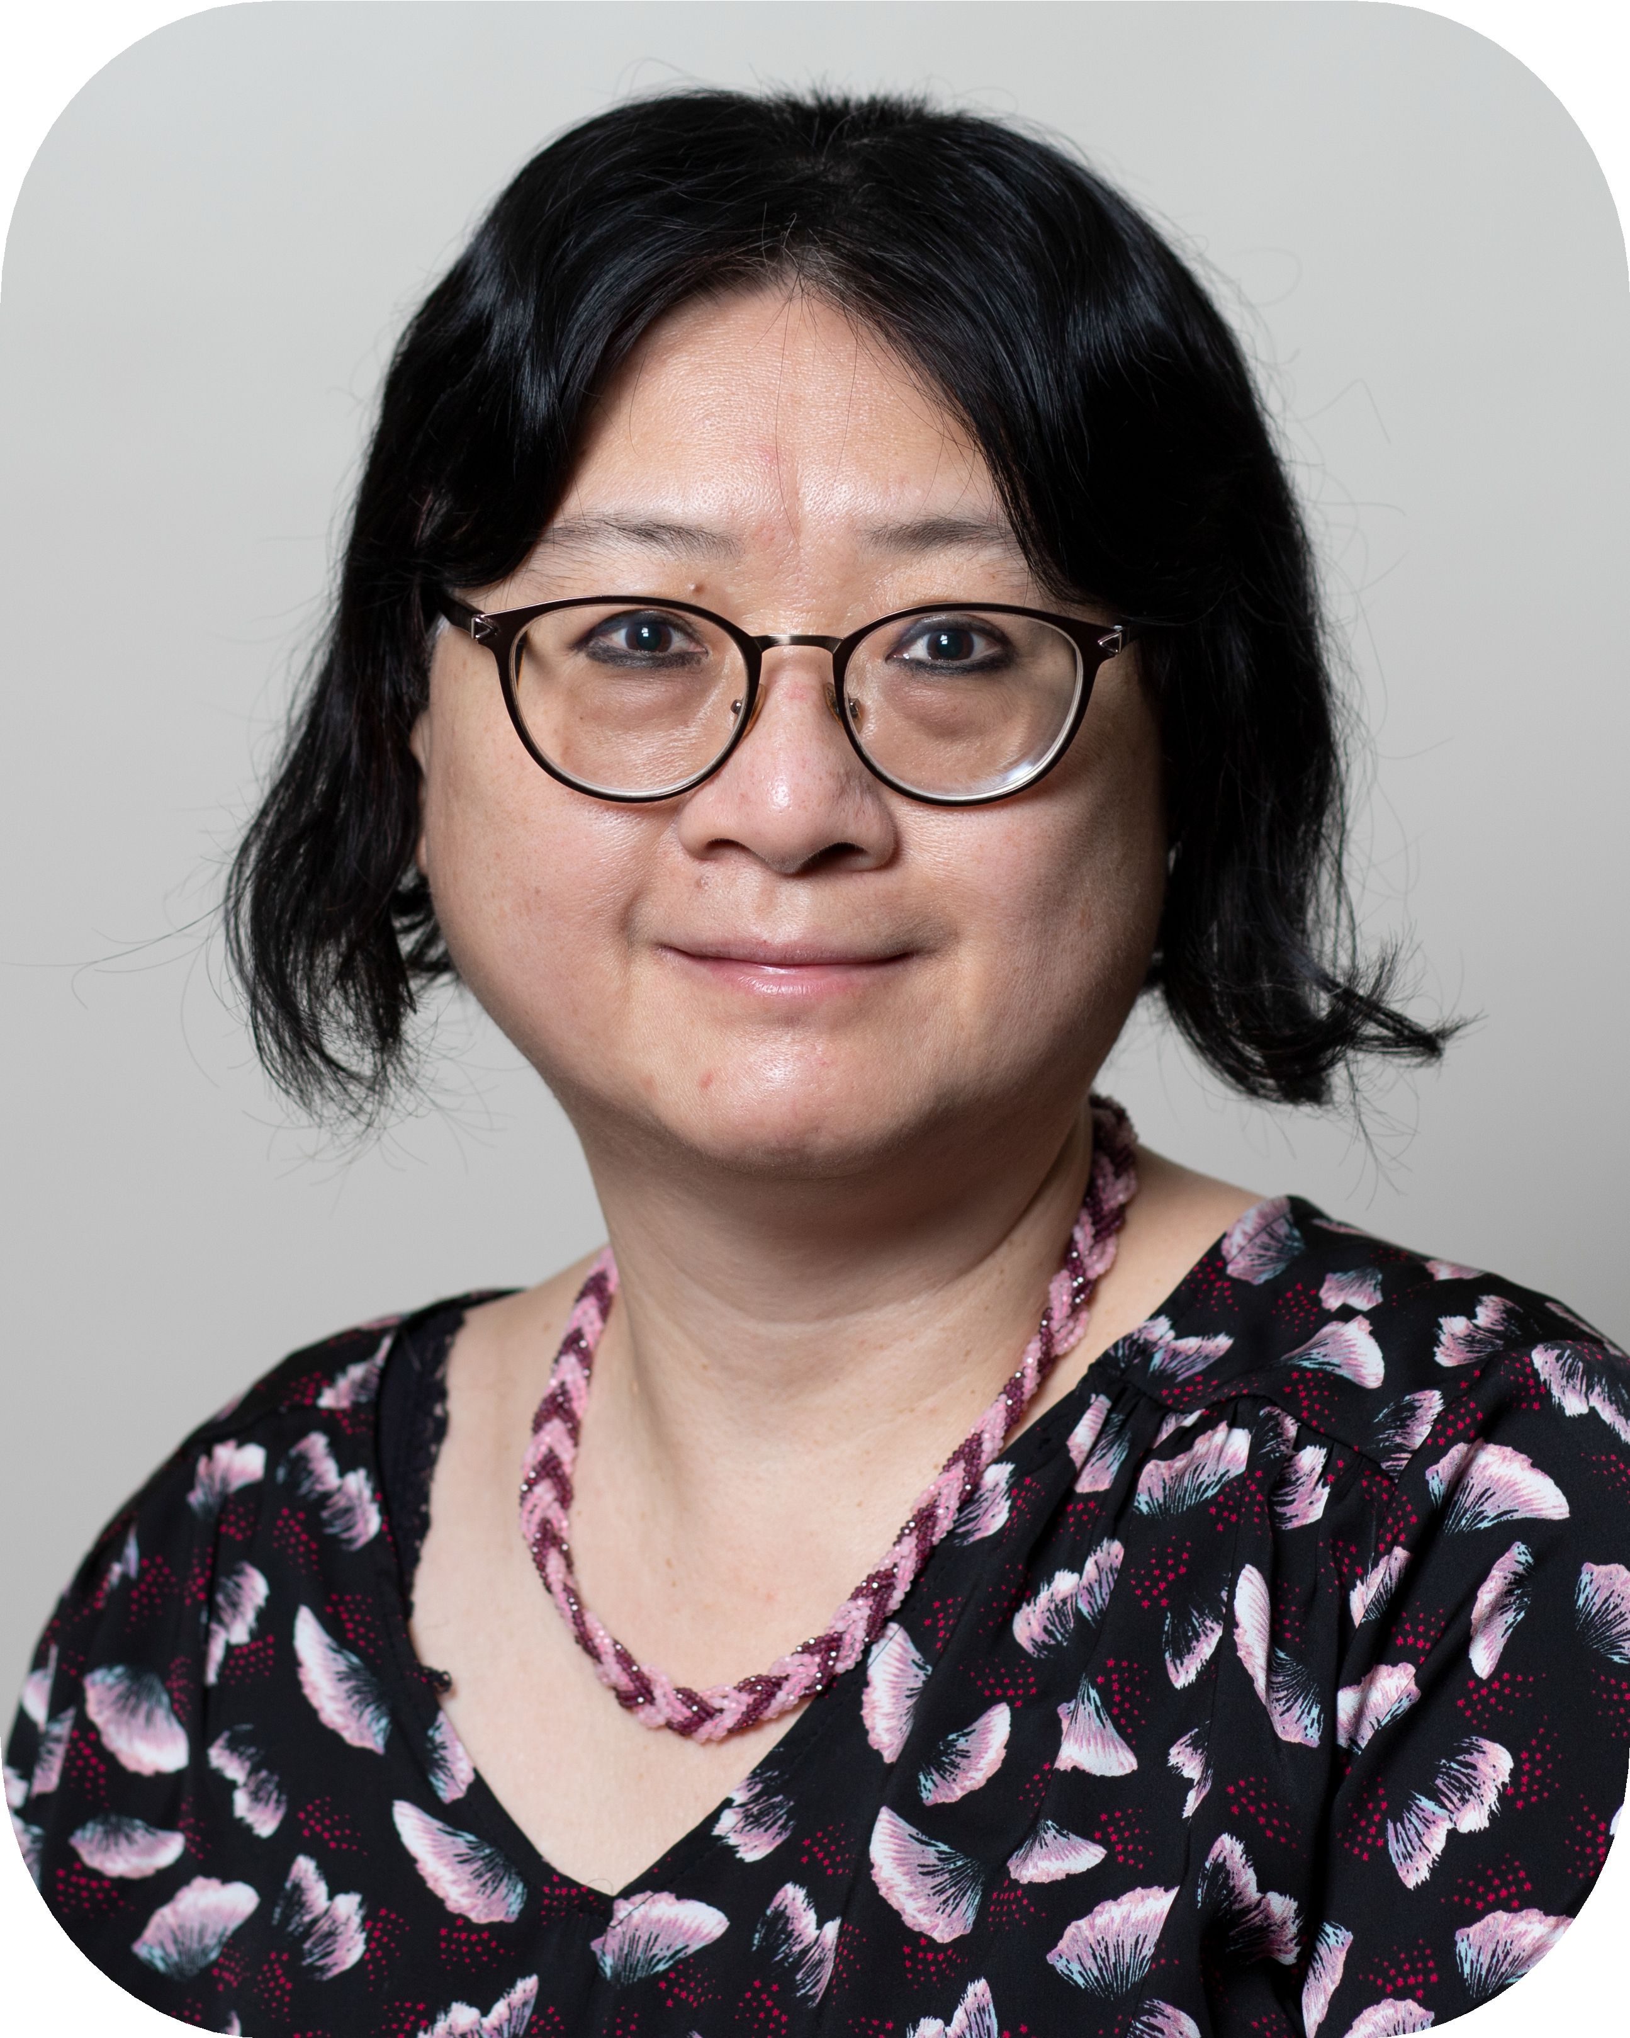

Ryan Jorn

Senator for Physics (Terrance Figgy) Fall 2025 only
Doris Chang

Senator for Social Sciences (Brian Amos)
Fall 2025 only

Theresa Cooper Planning & Budget Committee

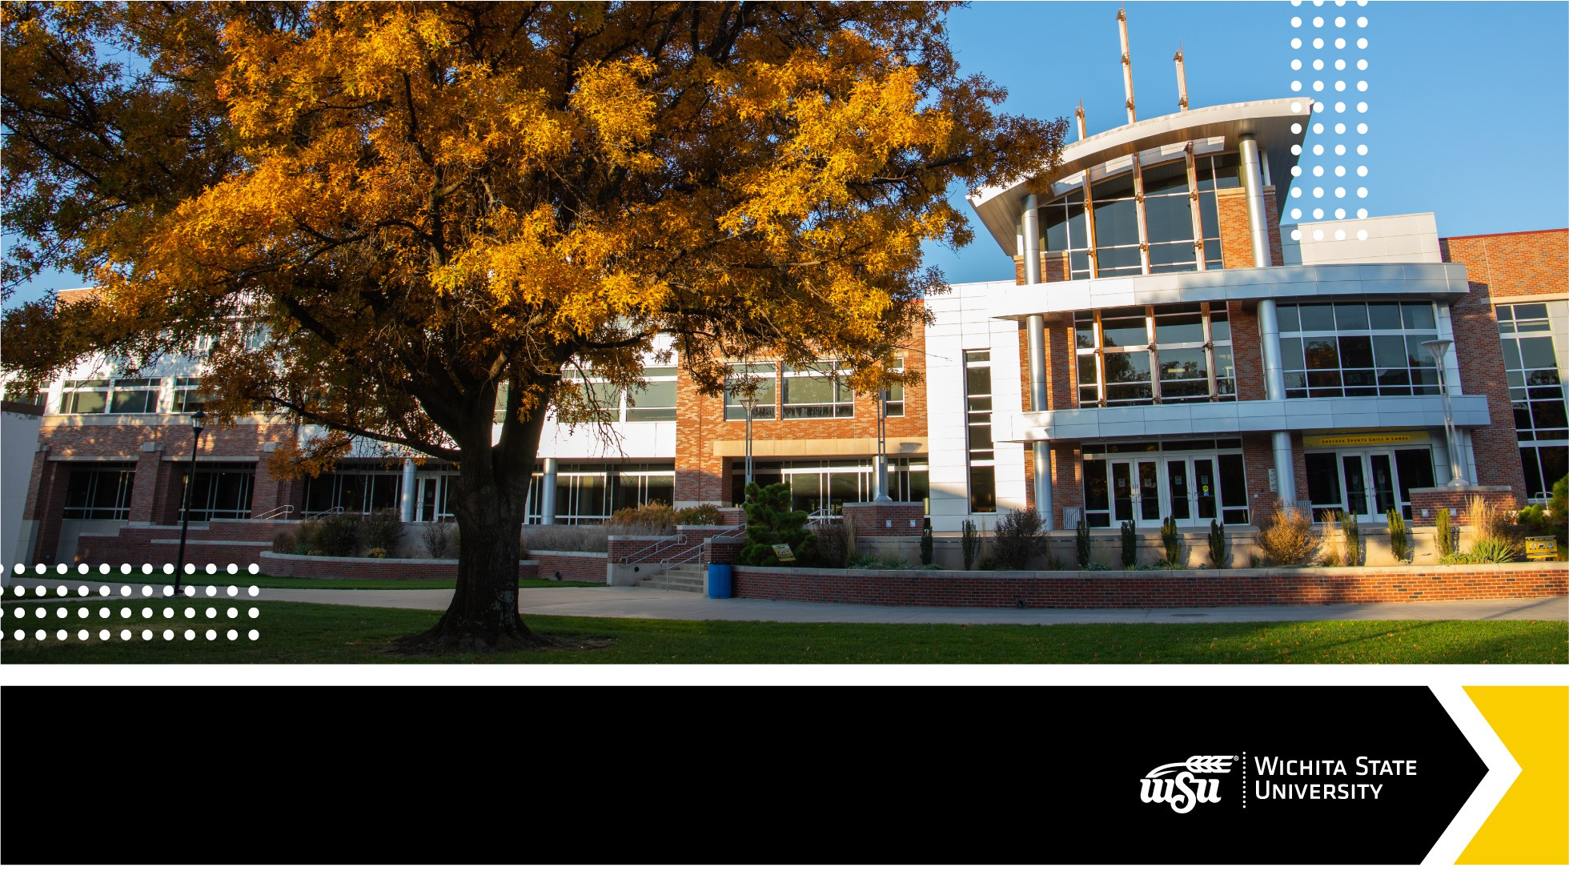

NEW FACULTY HIRES
AY 2025 - 2026


COLLEGE OF APPLIED STUDIES

Yang Fu – Associate Professor - Special Education
Jacy Krsmanovic – Assistant Educator - School Psychology Julie Lang – Temp Assistant Educator – Counseling
Solomon Moore – Temp Assistant Clinical Professor - Counseling Erin Nichols – Assistant Educator – Education and Director of
Transitions to Teaching Program

BARTON SCHOOL OF BUSINESS

Jason Hamlin – Senior Educator in Accounting Anastasia Smith – Senior Educator in Economics Marisa Vanskiver – Senior Educator in Marketing

COLLEGE OF FINE ARTS

Ruben Balboa - Assistant Professor of Viola/Violin and String Music Education Megan Bascom - Assistant Professor of Performing Arts - Contemporary Dance Kate Compton - Assistant Professor of Performing Arts - Acting
Jamison Rhoads - Assistant Professor of Performing Arts - Design and Technical Theatre
Katelyn Peterson - Assistant Professor of Music Education and Associate Director of Choral Activities
Lily Vetter - Assistant Teaching Professor of Performing Arts - Design and Technical Theatre

COLLEGE OF HEALTH PROFESSIONS
Megan Colvin – Assistant Clinical Professor/Physician Associate Program Audry Garcia – Assistant Clinical Professor/Physical Therapy
Kelsey Gaughan-Dodaro – Assistant Educator/Medical Laboratory Science Penny Glenn – Assistant Educator/Nursing/K-State Pathway
Carly Havner – Dept Chair & Program Director/Dental Hygiene Heather Henderson – Associate Dean of Research, Compliance, and
Accreditation/Dean’s Office
Brittany Imel – Assistant Clinical Professor/Physician Associate Program

COLLEGE OF HEALTH PROFESSIONS CONT’D

Shirley James – Assistant Teaching Professor/Physical Therapy Catelin Kass – Assistant Teaching Professor/Physical Therapy Jennifer Koalenz – Assistant Educator, Nursing/K-State Pathway
Tracie Moya – Assistant Educator/Assistant Teaching Professor/Dental Hygiene
Evan Ohlman – Chair & Program Director/Physician Associate Program Christy Reser – Assistant Educator/Nursing

COLLEGE OF HEALTH PROFESSIONS CONT’D

Scott Romeiser – Assistant Educator/Scientific Foundations Laurisa Washburn – Assistant Clinical Professor/Physician Associate
Program
Kara Wiens – Assistant Educator/Nursing
Ryleigh Williams – Assistant Clinical Professor/Physical Therapy Nikki Keene Woods – Department Chair/Public Health Science

COLLEGE OF LIBERAL ARTS & SCIENCES

Abdulaziz Abubshait – Assistant Professor/Psychology Vanessa Aguilar – Assistant Professor of Latinx Studies/English Louis Alvarado – Assistant Professor of Biological Anthropology
Victoria Bochniak – Visiting Prof and NAGPRA Coordinator/Anthropology Jordan Butcher – Assistant Professor/Hugo Wall School
Colby Clark – Visiting Assistant Professor/Philosophy Adam Daily – Associate Teaching Professor/Chemistry
Maria Hernandez-Etura – Assistant Professor of Spanish/MCLL

COLLEGE OF LIBERAL ARTS & SCIENCES
CONT’D
Nicole Fox – Assistant Professor/Social Work
Tracey Jenkins – Assistant Educator/School of Criminal Justice Dayla Jensen – Assistant Educator/MSP
Ryan Jorn – Associate Professor/Chemistry
Emily Mee – Assistant Professor, Public Admin and/or Nonprofit Management/Hugo Wall
Christian Pettersen – Assistant Professor of Geography/Geography Program Coordinator/History

COLLEGE OF LIBERAL ARTS & SCIENCE
CONT’D
Aweke Tadesse – Assistant Professor/Social Work
Haley Schroer – Assistant Professor of Latinx History/History Barbara Sponsel – Assistant Teaching Professor/ Math and Statistics Tisha Whitehead – Assistant Educator/Sociology
Kelly Young – Assistant Professor/Social Work

UNIVERSITY LIBRARIES

Fiona Holly – Student Success Librarian and Assistant Professor Sara Rue – Assessment and User Experience Librarian and
Assistant Professor

Christopher Stone
08/25/2025
Faculty Senate Meeting

New Business

Open Discussion of Updates and Priorities for AY26

Update on Faculty Pay
Provost Lounsbery

As may arise

Next meeting September 8th, 3:30- 5pm
Woolsey Hall 110A

