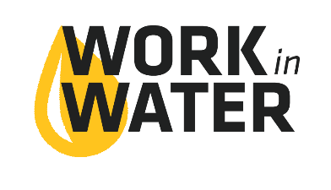
1 Group – usually 25 or fewer students
8:45 AM | 9:00 AM | 11:15 AM | 12:15 AM | 2:30 AM | 2:45 PM
Bus leaves school | Work in Water Session @  Utility Service Center | LUNCH | Facility Tours | Bus Pick Up | Back to School

2 Groups – usually 30-50 students
 | 8:30 AM | 8:45 AM | 9:00 AM | 11:15 AM | 12:00 PM | 2:30 PM | 2:45 PM | 3:00 PM
Group A | Bus leaves school | Introduction @ Utility Service Center | Facility Tours | LUNCH | Work in Water Session @  Utility Service Center | Wrap up @ Utility Service Center | Bus Pick Up | Back to School
Group B |  |  | Work in Water Session @  Utility Service Center |  | Facility Tours

2-Day Schedule
DAY 1
7:45 AM | Students gather
8:00 AM | Begin Work in Water Experience (715 W 2nd Street, OPD)
9:20 AM | Students Released
DAY 2
7:45 AM | Students Load the Bus
8:00 AM | Bus Leaves School Lot
8:15 AM | Tour the Water Reclamation Facility
9:15 AM | Load Bus & Travel to Water Reclamation Facility
9:30 AM | Tour the Water Treatment Plant
10:30 AM | Load Bus
10:45 AM | Students Back at School

