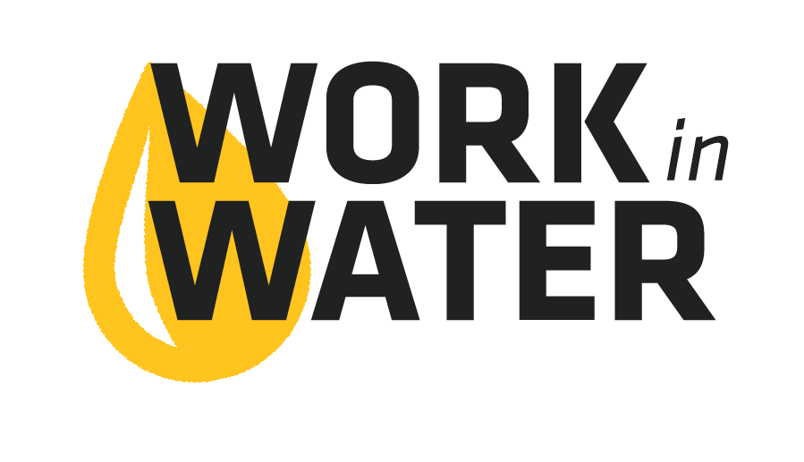
Sample Internship Schedule
Week 1 – Orientation
- Organization Structure – Mentor, Supervisors, Administration, and Governing Body
- Organization Standard Policies and Procedures (phone, email, internet, etc.)
- Safety Training

Week 1-4 – Water Treatment and Distribution
- System Tour
- Source Water, Treatment, Storage, Distribution

Week 5-8 – Wastewater Treatment and Collections
- System Tour

Week 9 – Management / Administration
- Utility Management ABC – Accounting, Billing, Customer Service
- City Council Meeting

