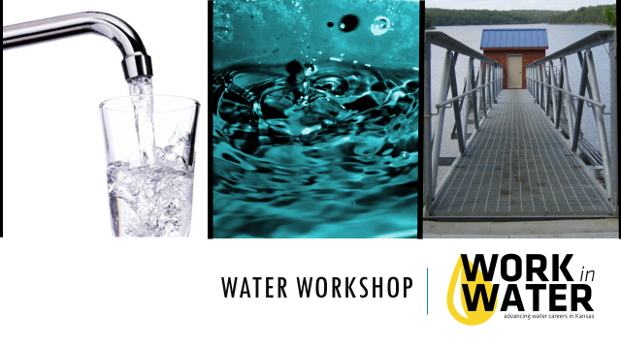
Classroom Presentation Script

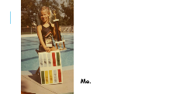
Introduction (15 min):
Start out by telling your water story. Show a slide with at least one picture of you that goes along with that story.

For example: My water story is… I grew up in a family where my parents were teachers so they had summers off. My dad’s summer job was to manage a local swimming pool. I spent all day every day at the pool. The crystal blue water of a swimming pool is my favorite body of water. I love the smell of chlorine. It smells like summer. The pool is where I played, it’s where my friends were, where I could compete, and it’s where I found adventure (flips off the board, swimming the length of the pool in one breath). The pool was the hub of my childhood. Without water, this huge part of my life would have been very different.
My name is __________________, and I work for ______________________. Today we are going to explore the importance of water to you and to our community.
----------------------------------------------
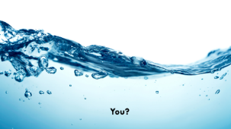
But, first I want to know from each of you what your water story is. We are going to go around the room and hear from each of you what your favorite body of water is (a lake, river, creek, ocean) or a favorite memory with water. You will have less than 1 minute to share. If you’re having trouble thinking of a water story, think about all the different forms water can take (rain, snow, ice) and in all sorts of different places (homes, water balloons, etc.). Go around the room and have each student share.
Likely you will find out more about the water in your water memory today. Be thinking how your water memory fits in to this BIGGER Water Story.
Who can raise their hand and tell us where your drinking water comes from? (Answers vary – the tap, the river, the lake, etc.). After today’s presentation, you will know exactly where your drinking water comes from. Who knows where the water goes after you are done using it? (Answers vary). You’ll learn that too.
----------------------------------------------
Water Cycle Review (1 min):
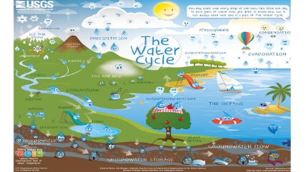
The same amount of water exists on Earth now as it did when the Earth began. How can that be? Because water is constantly cycling from salty ocean water into clouds, into fresh water as rain, which flows back to the oceans. This is called the Water Cycle (Water Cycle slide - point out the five main parts). The water cycle has five parts: evaporation & transpiration, condensation, precipitation, infiltration and surface run-off. The water cycle is powered by the energy of the sun. The sun heats the Earth and changes water into a gas called water vapor, which is called Evaporation. Plants also release water vapor from their leaves, and this is called Transpiration. This water vapor rises into the sky where it clings to dust particles. The colder air up high turns the gas back into liquid water droplets that group together to make clouds. This is called Condensation. Air currents move the clouds around the Earth. Eventually the clouds gather more water than they can hold, and the water falls back to earth as rain or snow. This is called Precipitation. The precipitation either infiltrates (soaks) into the ground, or runs off the surface into streams, rivers, and lakes which eventually flow back to the ocean where the process starts over again.
----------------------------------------------

Water Sources (total 20 min):
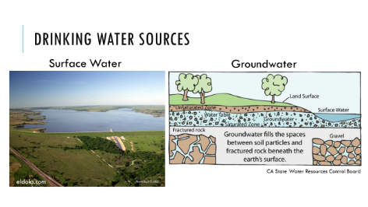
Where does our water come from? (1 min) – So where does the water we use for drinking here come from? Drinking water sources come from either surface water or groundwater. Surface water is water you can see that sits on the surface of the Earth - streams, lakes, rivers, ponds, etc. Groundwater is found underground in the cracks and spaces made by the soil, sand and rock.
----------------------------------------------
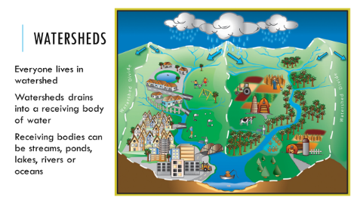
Watersheds & Surface Water (12 min.) – To understand where your drinking water comes from, we first have to learn about watersheds. Who can tell me what a watershed is? Take an answer, then show slide. A watershed is an area of land that drains water towards a downhill point. The point can be a stream segment, river, lake or pond. Movement of water is directed by gravity, so a watershed is separated from other watersheds by land with higher points of elevation.
**ACTIVITY: Watershed
- Have one student in each group crumple up a sheet of wax paper.
- Point out that this is like a topographic map of an imaginary state. It has peaks, valleys, mountains, plains, ridges, etc.
- Have another student spray (rain) over the paper. How is the water running off?
- Can they identify the watersheds? Small ones. Large ones.
- Sometimes a watershed is also called a river basin.
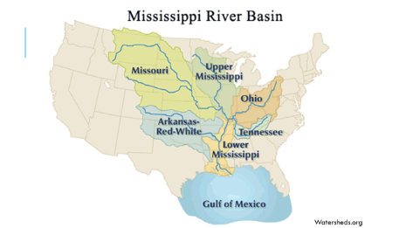
----------------------------------------------
Kansas is part of the Mississippi River Basin, the largest watershed in the US. (Point out watersheds on slide and direction of flow.) The water that flows across the southern half of the state ends up in the Arkansas River. Water that falls on the northern part of the state flows in to the Missouri River. Eventually, both rivers flow in to the Mississippi River and then in to the Gulf of Mexico.
----------------------------------------------
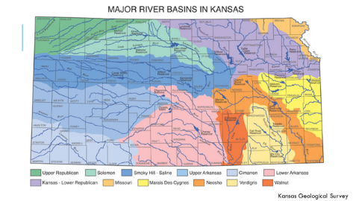
- Which watershed path does the water that falls at your house take?
There are 12 smaller watersheds inside the state of Kansas.
- Which one do you live in?
The trouble with watersheds is that as water flows across the surface of the land it picks up things and carries them along. Where does the runoff eventually get to? Right. Streams, lakes, ponds, ocean. We call this type of pollution nonpoint source pollution because we can’t just “point” to the source, it comes from all of us over a wide area.
- Think about the types of things that could get picked up and carried along during a rain storm in your neighborhood and carried along to the nearest stream.
(Soil, gravel, oil, road salt, pesticides, dog poop (bacteria), etc.)
**ACTIVITY: Nonpoint Source Pollution
- Have students dry or shake off their watersheds a bit if they are too wet.
- Have students place a drop of food coloring representing a type of nonpoint source pollution of their choice.
- “Rain” again on the watershed. What happens to the pollution?
- How could they have stopped the pollution?
- What do they do now if the lake or river that now has the pollutant in it is where they get their drinking water?
- Give students pieces of sponge and have them see if that stops some of the pollution. Natural buffers like grass swales, etc. make good pollution sponges.
----------------------------------------------
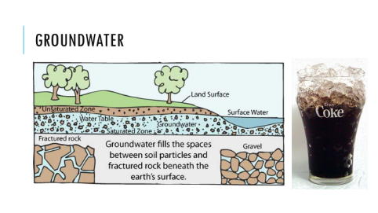
Groundwater (5 min.)
The other source of water available to Kansans is water from under the ground. Groundwater is held in aquifers. Let’s do a short demonstration about how aquifers work.

**ACTIVITY: Groundwater Demonstration
- Hold up a clear cup or container up filled with ice.
- Show students the concept of how water sits in the spaces between the ice cubes (small spaces or large).
- Water can then be drawn out of there with a well (straw).
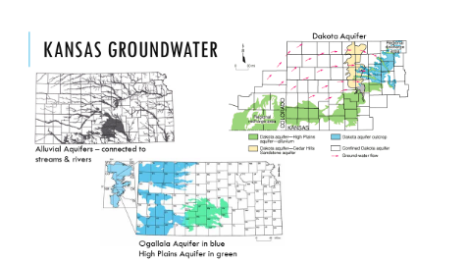
----------------------------------------------
Underground there are areas that are not permeable, or hold no water, and then areas that hold a great deal of water. Some aquifers are close to the surface and are actually connected to streams and rivers. Those are called Alluvial Aquifers. Show the Alluvial Aquifers map on the slide. Other aquifers are deep underground, and we drill deep wells to find that water to use for irrigation, drinking or industry. The largest aquifer in the Midwest is the Ogallala Aquifer. Show map on the slide. Many communities in Kansas get their drinking water from this underground water source.
When communities get water from aquifers they often have to do less water treatment before sending the water out to their customers. As water infiltrates down from the land’s surface through the soils, sand and gravel it can filter out bacteria and other nutrients and chemicals that the water picked up as it ran across the land. Groundwater is not 100% purified or cleaned up, but it usually needs less treatment to get it to drinking water quality than surface water.
Why do you think that is?
Your Drinking Water Source (2 min.)
INSERT INFO HERE ABOUT THE DW SOURCES FOR YOUR UTILITY HERE!
El Dorado gets its drinking water from El Dorado Reservoir. A reservoir is a man-made lake to hold water for a water supply. El Dorado Reservoir was built in 1981. It is 8,400-acres and can store 50 billion gallons of water.
The water from El Dorado Lake is transported through large water mains (pipes) to the water treatment plant.
----------------------------------------------

Water Quality and Treatment (total 21 min):

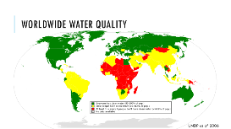
Worldwide water quality (2 minutes):
The US has some of the safest water in the world thanks to strict regulations. However, other countries are not as fortunate as we are. Take a look at worldwide water quality.

----------------------------------------------
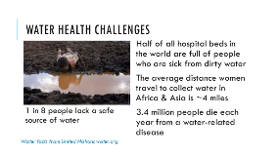
Altogether 3.4 million people die every year because of water related disease. That’s would be as if the entire population of Denver died, twice a year! In developing countries nearly 1 out of 8 people don’t have access to clean water. And many of them have to spend most of their day walking far distances to collect this water that may not be safe to use. We really are lucky to live here where our water quality is monitored, safe, and readily available at the turn of a faucet handle.
----------------------------------------------
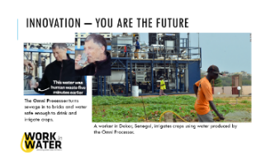
Perhaps you will consider a future career as a water professional. Maybe you can help design an affordable system to bring clean water to developing countries like the Omniprocessor. This unit was designed by students at several universities through funding by Bill Gates. The Omniprocessor takes sewage, separates the solids and incinerates them into ash that can be used to make bricks. The liquid is distilled back into pure water that can be used for drinking or irrigation. Pretty cool!
Drinking Water Treatment – Activity*** (12 minutes)
Water is treated using 4 steps. 1) Coagulation, 2) Sedimentation, 3) Filtration, 4) Disinfection. And we are going to “act out those steps with our “Lake Water.”
- Give each group of students a cup with the lake water, a Styrofoam cup, and another clear plastic cup.
First, the water is pumped from the reservoirs to the treatment plant where a chemical like alum (aluminum sulfate) is added to it to make the dirt and particles stick together to make big heavy particles. The water is mixed in large holding tanks with a “propeller” type mixing device. This is called coagulation and flocculation, which is a fancy way of saying “stick together and make bigger pieces. “
- Sprinkle 1/8 tsp. alum over the surface of the water. The soil particles will stick together and form “floc” this is called flocation or coagulation.
Next the water is allowed to settle the heavy particles to the bottom of the sedimentation tank, while the clarified (clear) water flows off the top to the next step. This second step is called sedimentation.
- Let samples sit for 5-ish minutes - sedimentation
The third step is called filtration, and leads the water through filters made of materials with varying densities and pore space. Filters are made of anthracite coal on top, followed by fine, medium, coarse sand, and finally gravel on the bottom. Walk around the room to show the filter samples while talking. The water filters trap any remaining suspended solids such as particles including clays and silts, natural organic matter, precipitates from the alum, iron and manganese, and microorganisms. The filters get cleaned about every other day because they get full of particles.
- Poke 10 small holes in the bottom of a Styrofoam cup
- Place a small piece of paper towel in the bottom of the cup to act as a filter. Next, add a layer of sand then a layer of gravel. Pour the water through the filter and catch the water that comes through with the other clear cup.
The final step in our water treatment process is disinfection. Chlorine is added to the water to kill any remaining harmful microbes, and then it is stored in water storage tanks from where it travels to your house through pipes underground.
- Add a drop of yellow food coloring to represent chlorine.
----------------------------------------------
Water Quality Standards (7 minutes)

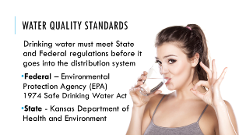
The EPA (Environmental Protection Agency) oversees the Safe Drinking Water Act, which is a federal law that requires a certain level of cleanliness before water can be used for drinking. In Kansas, the KS Department of Health and Environment has the job to oversee that all KS drinking water plants are sending out water that meets the Safe Drinking Water Act requirements.
----------------------------------------------
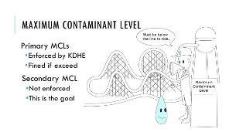
The EPA has set limits on over 90 contaminants in drinking water. Primary standards are limits on contaminants that pose a health risk to people if they are in our drinking water. Secondary standards are suggested limits on contaminants that could make the water smell, taste or look unappealing, but will not cause health problems. Drinking water utilities must test for these contaminants and compare them to EPA’s Maximum Contaminant Levels or MCLs. When testing the water, the lab wants to see levels below the MCL.
----------------------------------------------
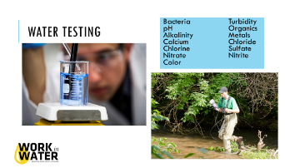
***ACTIVITY - Pass out the latest Consumer Confidence Report.
Our utility tests the water 2,500 each month to make sure it meets the standards, and is as clean as or cleaner than required by law. If you like chemistry, consider working in our laboratory after you finish college.

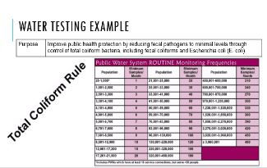
----------------------------------------------
Here is just one of the 95 contaminants that your water utility tests for. How many samples each month does your system take for total coliform?

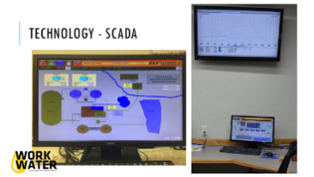
----------------------------------------------
There is quite a bit of technology in the water management field. This is a SCADA (Supervisory Control Data Acquisition) system, which is computer based control system. Many water treatment plants have systems like this to help them monitor what’s going on throughout the system. SCADA can control equipment remotely, monitor temperatures, pressures, let operators know when maintenance is needed, etc. One very technical job opportunity would be to design these types of systems or operate them as an employee of the water treatment plant.
----------------------------------------------
Water Distribution (total 20 min):
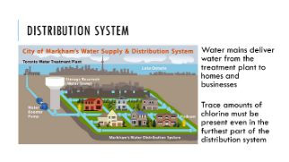
Distribution (10 min)
After water treatment, water has to get from the treatment plant to your house. The distribution system includes finished water storage tanks, miles of pipes (HOW MANY FOR YOUR SYSTEM?), pressure reducing valves and pump stations. Gravity is used to move the water through the pipes to your house. But, when gravity isn’t enough lift stations are installed to pump and push water through.
----------------------------------------------
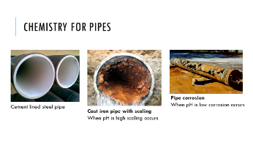
Chemistry is still important when the water is in the distribution system. It’s a big job to keep the distribution pipes in good shape and to ensure that the water delivered to your house is excellent quality. We continuously monitor general water quality parameters within the distribution system.
Balancing pH in drinking water is a necessity for all water utilities to control water quality and pipe corrosion or scaling. If pH is too high, we’ll get more scaling. However, if pH is low, then the pipes will corrode faster.
- Use pH test strips to test the water sample each group made in the drinking water treatment simulation
----------------------------------------------
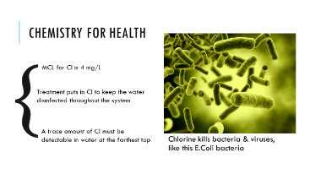
All water treatment plants use chlorine to kill bacteria. Chlorine disinfection is required by the Safe Drinking Water Act. The law says that the furthest tap must have a “trace” of chlorine (this trace level will be defined in 2016 as 0.2 mg/L. Too much chlorine in the water is dangerous, but too little chlorine is also dangerous because then disease causing pathogens can be an issue. The primary chlorine MCL = 4 mg/L. We need to “load” water at the water treatment plant with enough chlorine to still show a trace amount (0.2 mg/L) at the furthest tap, however we cannot exceed 4 mg/L. Larger systems have chlorine booster systems throughout of the distribution system to help maintain chlorine levels in the parts of the system farther away from the treatment plant.
** ACTIVITY: Chlorine Test
- Have students complete a Cl test with water from the plant and water from their school
- Will there be pathogens in the water at the school?
Talk about how often Cl tests must be completed, how long Cl lasts in the sample, and how their utility accomplishes the Cl tests.
----------------------------------------------
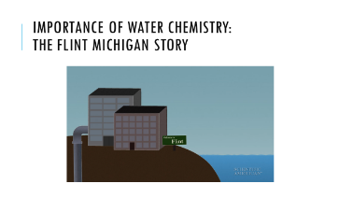
Sometimes, when rules and procedures aren’t followed the public’s health is threatened. You have seen an example of this recently in Flint, Michigan. Let’s watch this video to see what they problems were.
What was the problem here? Whose fault is it? Whose responsibility is it to fix? If it was your job to fix it, what would you do?
----------------------------------------------
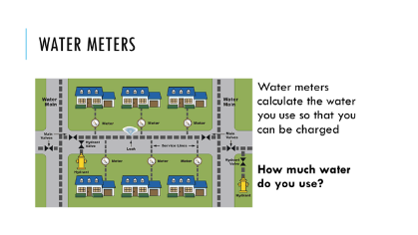
Household Water Use (10 min) –
A water meter measures the amount of water coming into your home or business. Your water meter may be located in your basement or outside in a pit or hole. A meter reader reads the water meter on a regular basis. The utility bills you for the amount of water used. The bill covers the costs of treating and distributing the water. Sometimes, a utility must buy water. All of these costs and the wages for the utility’s staff must be met. Water is a bargain. The average price of water in the United States is less than $4.00 for 1,000 gallons. At that price, a gallon of water costs less than one penny. How does that compare with one can of soft drink? - See more at: http://www.drinktap.org/kids-place/is-water-free.aspx#sthash.GZ5TQWxS.dpuf
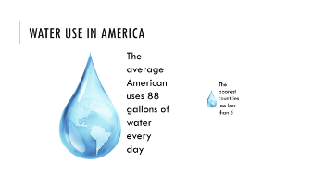
----------------------------------------------
Who can guess how many gallons of water are used on average per person every day? Take guesses and then click slide to show the answer – 88 gallons. Think of all the things you do in a day that use water – have students name those things.
Why do you think that poorer countries use so much less water? Take answers. Discuss no need to water the lawns, fewer clothes, no dishwashers, no access, have to carry water, etc. ----------------------------------------------
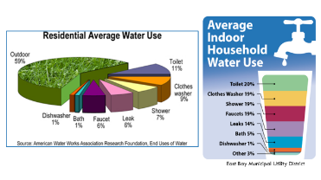
So how do you use the water? Show Water Use slide and have students identify the highest water use. Outdoors = landscaping. Discuss water use inside the house and have them tell you where the most water is used indoors (it is a tie between the toilet and the clothes washer).
----------------------------------------------
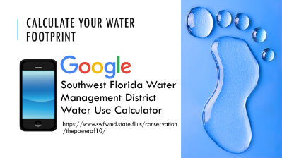
***Activity: Water Footprint Calculator
- Ask students how much water they thing they use in one day. Are the above or below the average? Let’s check out your water footprint.
- Have students take out their phones (or share with a friend) and Google: Southwest Florida Water Management District Water Use Calculator.
- Students will answer the questions in the online tool and figure out how many gallons of water they use every day.
- How can they reduce their footprint?
** OPTIONAL - Conservation Math Activity
Let’s compare showering for instance. Americans love to shower often and for a long time. If the water is flowing at a rate of 2.5 gallons per minute from the showerhead, and the shower is 10 minutes long – how many gallons did that shower use? Correct, 25 gallons. Now let’s compare that to a shower that flows at 0.5 gallons per minutes, and the user only turned on the water to get wet, then turned it off to shampoo and soap up, followed by a quick rinse. The water was only flowing for 2 minutes, at half a gallon per minute, so how much water did that shower take? Only 1 gallon! That will really add up to a huge water savings over the course of a week, month and year. Consider how you can use less water when you shower. We recommend taking a shower for no more than 5 minutes. You can also exchange your showerhead to us for a high efficiency version for free while supplies last!
An easy way to save 10 gallons of water a day is turning off the faucet while you brush your teeth or wash your hands. Remember the toilet was one of the highest use of water inside the home? Often the toilet is a silent leaker and is wasting water without you even knowing it. A good way to check your toilets for leaks to is put a few drops of food coloring in the water inside the tank, don’t flush, wait 10 minutes, then lift the lid to see if any colored water appears in the bowl. If you see any colored water, then your toilet flapper isn’t sealing and your losing water all day long. You can impress your parents by fixing the toilet yourself! All you need to do is ask your parents to take you to any hardware store and give you $4. Then you can buy a universal toilet flapper (show example of flapper), and go home to put in the new one. Your parents will be so impressed, and you will not only save water, but money too.
----------------------------------------------
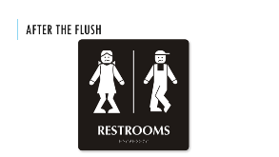
Wastewater Treatment (10 min)
Wastewater Treatment Process (6 min.)
Where does the water go when we’re done with it?

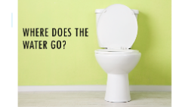
----------------------------------------------
Show toilet slide, take answers. The water inside your house from your toilet, sinks, dishwasher, clothes washer, etc. goes through a sewer pipe (called a Main) to a wastewater treatment plant. After treatment the water is usually put back in to local streams, rivers or held in ponds to evaporate.
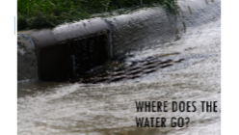
----------------------------------------------
Show the stormdrain slide, take answers. Outside water flows into storm water drains that dump directly into streams in town. That’s why it is important not to wash spilled oil, soapy carwash water or trash into the gutter.
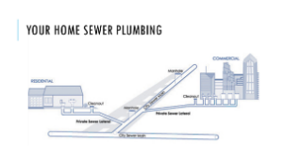
----------------------------------------------
Wastewater flows from your house through pipes in your yard, to the city’s sewer main where it is combined with all your neighbors’ wastewater and is taken to the wastewater treatment plant.

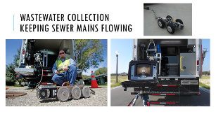
----------------------------------------------
It is critical to keep wastewater sewer mains flowing smoothly. But there are many things working against that smooth flow: tree roots, grease, clogs caused by flushing things you shouldn’t. Sewer line maintenance crews often use TV cameras to inspect sewer lines and identify trouble spots so that they can be fixed before they become a problem. Cameras are attached to crawlers that are remotely controlled by a worker.
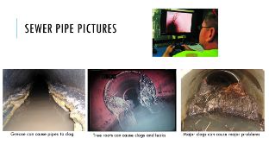
----------------------------------------------
When clogs or leaks are found crews note the problem and rate it to determine how critical the problem is; that means: how quickly do they need to fix it. How would you determine that? (Cost, number of people impacted, etc.). It is water system managers’ job to set up a plan to tackle these sorts of questions.
----------------------------------------------
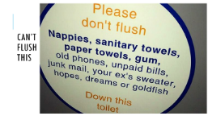
Sometime clogs or leaks do happen. Ever have a toilet back up = worst day ever! Sometimes it is the homeowner that caused the problem themselves, by flushing things that shouldn’t be flushed. Here’s how to avoid those bad days. Show “Can’t Flush This” video.
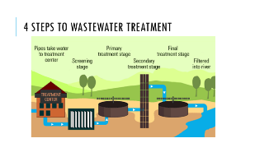
----------------------------------------------
So how do they clean-up the water enough to put it back into the environment? Wastewater is just a large mixture of water from your sinks, toilet, shower, dishwasher, etc. The idea is to separate the solids from the liquids, and clean the liquid back into clear, clean water.
----------------------------------------------
There are 4 steps to the wastewater treatment process (show wastewater treatment slide). The steps are called Preliminary, Primary, Secondary, and Tertiary.
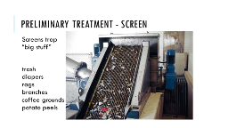
First, during preliminary, the wastewater flows through screens that trap inorganic material like trash, diapers, rags, branches, coffee grounds, etc. This material eventually gets hauled to the landfill.
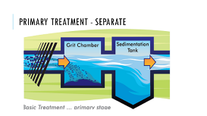
----------------------------------------------
The water is slowed and separated in the Primary treatment step so that the lighter particles like kitchen grease float to the top, and the heavier particles sink to the bottom (bio-solids, also known as “potty bits”).
----------------------------------------------
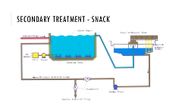
Now we are left with the liquid. How do we turn the brown, smelly water into clean and clear water like one of the vials? The third step is called Secondary Treatment, and in this step microorganisms (mostly bacteria) snack on the organic matter in the wastewater. The mass of bacteria that does the work in this step is called Activated Sludge. This process occurs in aeration tanks because the microbes need different amounts of oxygen to eat the organics, phosphorous, ammonia, and nitrates in the water.
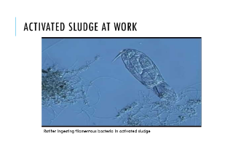
----------------------------------------------
Show activated sludge video. I have a video that shows microbes at work. Over 50 of these “critters” live in one drop of wastewater. Once the microbes have done their job (usually within 10 hours), they get full and heavy and fall to the bottom leaving the cleaner water to rise to the surface (clarification). The top is poured off for the final step.
----------------------------------------------
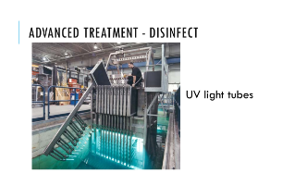
The fourth step is known as Tertiary or Advanced treatment. It’s the last step and may include disinfection with either chlorine or other chemicals, ultraviolet light tubes or ozone that make any remaining microbes inert (changes the DNA of any remaining bugs so that they cannot reproduce).
----------------------------------------------
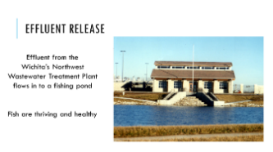
Water then is released in to ponds, creeks, rivers or the ocean, depending on where you live. Or sometimes water is reused to water golf courses or in industrial process. There are some communities who are turning wastewater directly into drinking water. What do you think about that?
----------------------------------------------
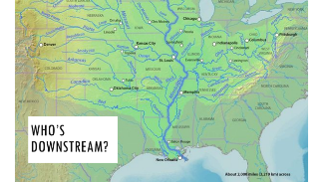
Where does the water go? (Total 2 min.)
Downstream users (2 min) – Where does the water go when it leaves the wastewater treatment plant? Does it join the larger watershed? Do you see all the cities along the journey of the water to the Gulf of Mexico? Where do they get their water from? The water is used by people in cities downstream who need the water after it’s already been through our houses and wastewater treatment process. Then the people downstream from them use it after it’s been through their systems, and so on. In fact, our water travels from Kansas to Oklahoma or Missouri, then Arkansas before it joins with the Mississippi River and flows through Louisiana before reaching the Gulf of Mexico. The water passes through hundreds of cities along its way to the Gulf – those are a lot of downstream users!
Hydrate Your Career… Work in Water (15 min)
Go through the careers and quotes. Take a poll to see what students are attracted to.
Supplemental activity: WET in the City, Water Work Shuffle, pg. 332.

Review/ Post-assessment (total 5 min):
You have learned a lot about your water system today. We started with a review of the Water Cycle, talked about where our drinking water comes from, how the water is treated to make it safe to drink, what happens to it after we use it, and how many other cities use our water before it eventually ends up in the Gulf of Mexico and the Atlantic Ocean. Are there any questions? Take questions.
Make every drop count! Thank you.

