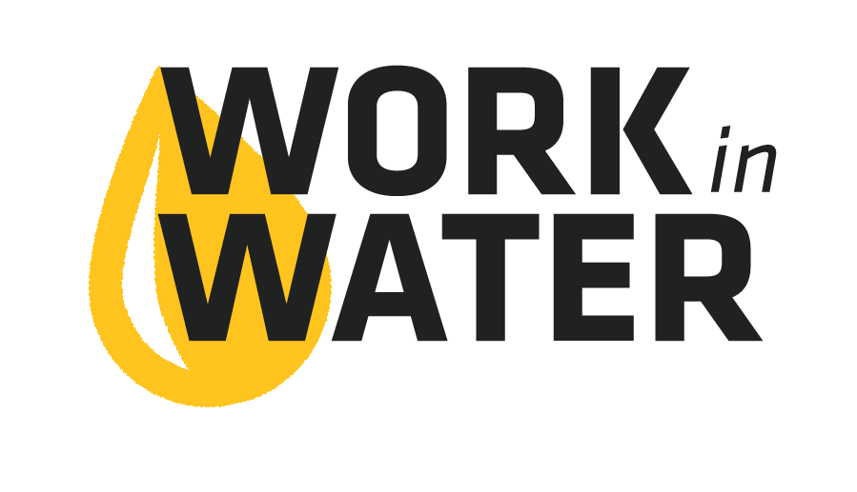
Copy and paste the template below into an email to your local high school counselor sometime in Nov – Feb in order to give the school enough time to plan for the event.

The highlighted sections below indicate portions of the email that need to be adapted to your utility, local high school, etc. Please, read through the email thoroughly before sending to make sure that it is edited to fit your community.

[INSERT SCHOOL COUNSELOR’S NAME HERE],

Are you looking to introduce students to well-paying science careers in their own community?
Careers that can start right after graduation or could be waiting for them after college?

My name is [INSERT YOUR NAME HERE] and I work for the [INSERT YOUR UTILITY’S NAME HERE]. We have a fun and educational water career exploration experience called Work in Water that we would like to invite your juniors and seniors to participate in.

The Work in Water Experience includes an interactive workshop for students to learn about drinking water and wastewater. Then, students will have the opportunity to tour the water and wastewater treatment facilities. Throughout the Experience students will meet water professionals (lab staff, biologists, mechanical engineers, water operators, managers, etc.). These water professionals will talk about how they found their water career, and they will share their passion for providing the community with safe and reliable drinking water and the ecosystem service of wastewater recycling.

Our next step is to start working with [INSERT HIGH SCHOOL NAME HERE] to find out which students or teachers to target for this opportunity. We are starting the conversation with you as the counselor because of the career connection. However, this project is very flexible and we can make it fit your school. Our goal is to conduct the Work in Water Experience in the Spring 2019, so that we can offer participating students the opportunity to apply for a summer internship this summer.

I would like to set up a time to talk about how we could bring Work in Water to your students. I am available [LIST TIMES YOUR ARE AVAILABLE].

Thank you.
[INSERT YOUR NAME AND CONTACT INFORMATION HERE]

