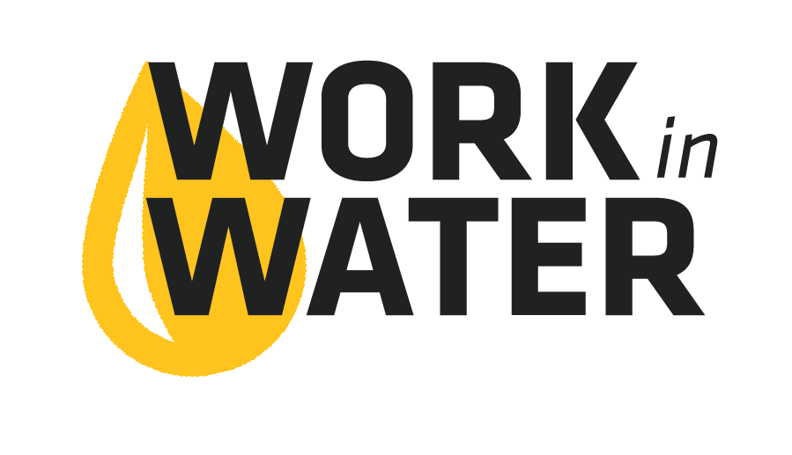
Contact [Contact]  Telephone [Company Phone]  Email [Company E-mail]  Website | FOR IMMEDIATE RELEASE  [Date]

work in water experience coming to {School name}
Looking for a fun way to boost your resume and explore your career options? {Utility Name} is bringing the Work in Water Experience to {School Name} on {Event Date}.This day-long experience will include field trips, interactive learning and hands-on science experiments, all designed to show you the importance of jobs that provide safe, clean water to the community. You’ll also learn how your skills and talents will work great in water! {All students/seniors and juniors} are eligible to sign up.

# # #
If you would like more information about this topic, please contact [Author] at [Company Phone] or email at [Company E-mail].

