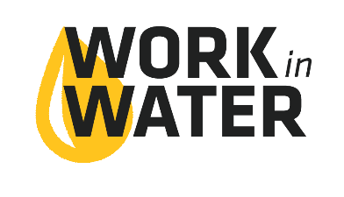
Packing and Shopping List
These quantities will cover multiple sessions of students divided into six small groups.
ACTIVITY |  | ITEM | QTY | NOTES
Watershed & Nonpoint Source Pollution Activity |  | Towels | 2 | Hand towel size or larger - just in case of spills
 |  | Plastic Dishwashing Tubs | 6 | About: 15” L x 12” W x 6” H
 |  | Wax paper | 2 boxes
 |  | Spray bottles | 6 | For water, make sure they can make a wide, mist-type spray
 |  | Food Coloring | 2 boxes | Color doesn’t matter, need 6 individual bottles total
 |  | Sponges | 6 | Small sponges are fine, or cut a big sponge into smaller pieces
Groundwater Demonstration |  | Clear cup – at least 16oz | 1 per session  (not per group – this is a demonstration) | Glass or very clear plastic
 |  | Ice | Enough to fill the cup | Small – medium size ice chunks work best
 |  | Soda | 1 per session  (not per group – this is a demonstration) | Anything but clear pop, I like to use orange soda
 |  | Straw | 1 pack | NOT individually wrapped
Drinking Water Treatment |  | Styrofoam cups | 1 package (at least 24) | 12-16oz
 |  | Clear plastic cups | 1 package (at least 24) | 12-16oz
 |  | Water from a local water body | About a gallon per session | I like to use pond water from my backyard so the students can see a color and sediment change (most of the time it comes out clear)
 |  | Paper towels | 2 rolls | Ones that absorb, like you use at home, not like the brown-ones in the hand driers at the office
 |  | Sand | Small bag | Each group will use about a cup, each session will use about 1 gallon baggie full
 |  | Pea gravel | Small bag | Each group will use about a cup, each session will use about 1 gallon baggie full
pH Test |  | pH test strips or a meter | 1 box of strips | pH range 0-14
Cl Test |  | Chlorine test strips or a meter | 1 box

