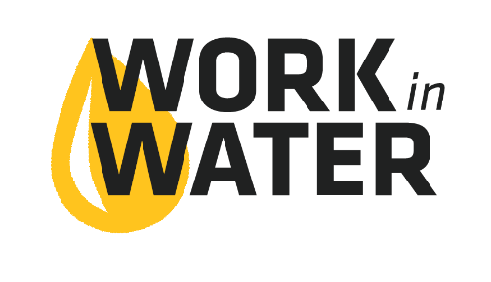
Return to Dale Schwieger at dschwieger@osagecity.com
Deadline May 13, 2022

Osage City Water Internship Application

Requirements
- Commit to 9 weeks, 19 hrs/week, during summer for internship (schedule can be worked out with your supervisor when you are hired)
- Finishing Junior or Senior year
- Recommendation from school teacher or counselor
- Work with supervisory to choose and complete a Capstone Project

Internship: The Work in Water Intern will work alongside seasoned water utility staff to understand all aspects of water service in Osage City, including intake from Melvern Lake, production and out to distribution to the City. Find out about how water is supplied to your community and learn about a career field you can join right out of high school.

Name ________________________________________________________________________
Address _______________________________________________________________________
City _________________________________________ Kansas Zip Code ________________
Phone _________________________________ Email __________________________________
Current Age ____________ Current Year in School: ___ Junior ___ Senior
School Name ___________________________________________________________________
Teacher/Counselor recommending you for this internship: ______________________________

Why are you interested in a Work in Water Internship this summer?

Student Signature _______________________________________________________________

