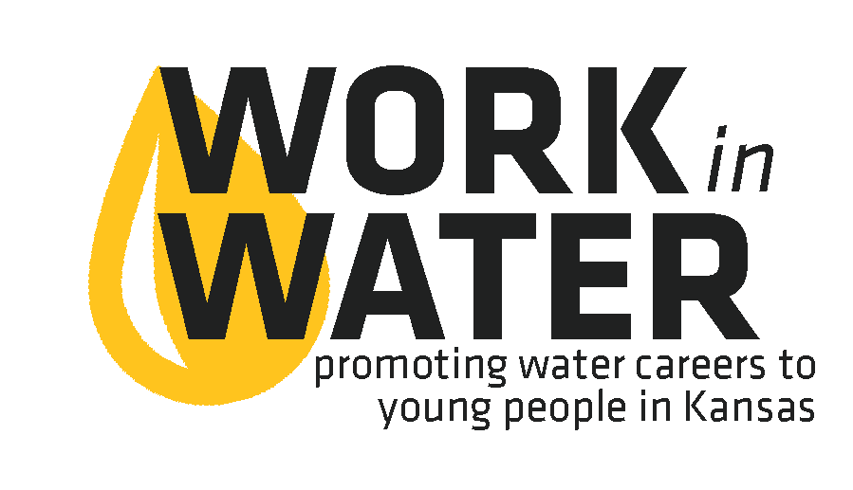
 | FOR IMMEDIATE RELEASE  [Date]
  Contact | Leslie Kimble
  Telephone | 316.978.7460
  Email | leslie.kimble@wichita.edu
  Website | www.wichita.edu/efc

work in water experience coming to Olathe west
Looking for a fun way to boost your resume and explore your career options? Wichita State University is bringing the Work in Water Experience to Olathe West High School on April 3. This day-long experience will include field trips, interactive learning and hands-on science experiments, all designed to show you the importance of jobs that provide safe, clean water to the community. You’ll also learn how your skills and talents will work great in water! <<All students/seniors and juniors>> are eligible to sign up.

# # #

If you would like more information about this topic, please contact Leslie Kimble at 316.978.7460 or email at leslie.kimble@wichita.edu.

