Department of Political Science
(May 2022-April 2024)

Political science is the study of governments, public policies and political behavior in the United States and countries around the world, using quantitative and qualitative methods. Our Faculty researches in the areas of voting, political participation, political institutions, international peace and conflict, international organizations, foreign policy, democracy and autocracy, women in politics, public opinion, political culture, constitutional law, race relations, human rights, and political economy, among others.
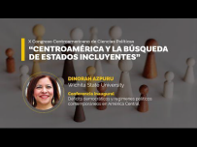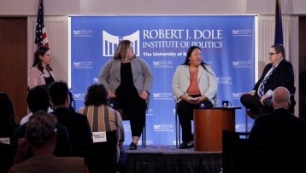
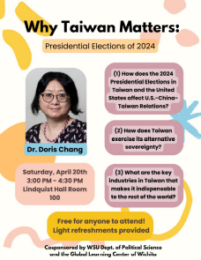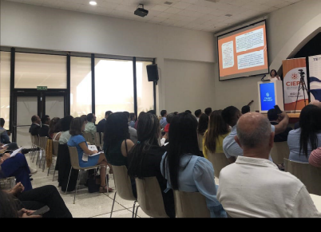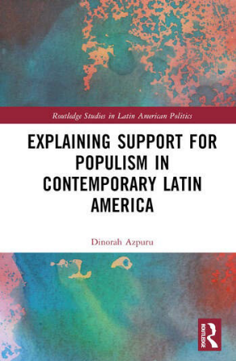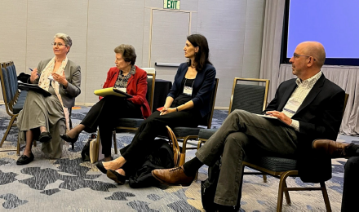

Publications
Books
Azpuru. Explaining Support for Populism in Contemporary Latin America. Routledge, Forthcoming, August 2024.
Journal Articles
Azpuru.“DeterminantesdelaconfianzaenlaseleccionesenAméricaLatina”(DeterminantsofTrustinElectionsinLatinAmerica).RevistaElecciones.ForthcomingJuly2024.
Azpuru.“CanLatinAmericanPoliticalCultureHelpSaveDemocracy?”inLASAForum.Pittsburgh.Vol.54,No.2,Spring2023.InvitedarticleforaspecialeditionondemocracyinLatinAmerica.
Book Chapters
Azpuru. “Political Behavior and Democracy in Guatemala” in Democratic Institutions in Guatemala: Theory and Practice.Omar Sanchez-Sibony, Editor. Rowman and Littlefield. Forthcoming 2024.
Azpuru.“PoliticalParticipationandInterpersonalTrustintheNorthernTriangleinCentralAmerica”inEldesencantodemocráticoenelTriánguloNortedeCentroamérica(DisenchantmentwithdemocracyintheNorthernTriangleinCentralAmerica),editedbyRicardoCordova,ElSalvador:FundaUngo.2023.
Chang. “Feminist Engagement in Transforming Laws that Affect Women’s Status in Taiwan.” In Oxford Handbook on Gender History in East Asia, edited by Barbara Molony, Janet Theiss, and HyaeweolChoi. New York: Oxford University Press, 2023.
Shaw. “Simulating International Organizations” in Teaching International Organizations, edited by Kent Kille, Edward Elgar Publishing. Forthcoming 2024
Middlewood. “Tactical is the New Black: Examining Gun Owner Fashion as Political Expression” with Noah S. Schwartz and Anne Wasinger, in Handbook of Fashion and Politics, edited by Karen Kedrowski, Candice Ortbals, Lori Poloni-Staudinger, and J. Cherie Strachan, Palgrave McmillianPublishing. Forthcoming, June 2024.

Publications II
Public Scholarship
Amos:
Voting and Election Science Team, nationwide precinct-level election results for all statewide races, 2016-2020. August 2022.
Azpuru:
“Why is Bukeleon the Path to Reelection in El Salvador?” Canning House, United Kingdom. January 30, 2024. With Mary F. Malone and Christine Wade.
“A Watershed Moment for Guatemala’s Democracy?” Part 1 (July 21, 2023) and Part 2 (July 26, 2023). Global Americans.
“As the Summit for Democracy Ends, What is the State of Democracy in Latin America?” Global Americans, March 31, 2023.
“Guatemala’s Authoritarian Slide Under GiammatteiIs Putting Biden in a Bind.” World Politics Review, December 12, 2022.
“How do North and South Americans view the U.S.? The Monkey Cage in The Washington Post, June 3, 2022.
Chang:
“Transformation of Women’s Status in Taiwan, 1920-2020” Taiwan Insight: The Online Magazine of the Taiwan Research Hub, March 2023.
Middlewood:
“The ‘Massacre Generation’ Believes Government Can Prevent Mass Shootings” Monkey Cage, Washington Post. 8 June 2022.
“Kansas is Bleeding But Not Broken: Disintegrating Democracy in the Free State”, 50 Takes on Democracy series, Pulaski Institution. 22 June 2022.
Insight Kansas. Monthly researched-based op-ed columns for local newspapers across the state of Kansas.
Professional Conference Presentations:
American Association for Chinese Studies
American Political Science Association
Election Science, Reform, and Administration Annual Conference
Great Plains Political Science Association
International Studies Association
Midwest Political Science Association
Southern Political Science Association
Latin American Studies Association
Latin American Public Opinion Project Conference
Brennan Center Racial TurnoutGap Symposium

Research Presentations
Invited Presentations
Azpuru:
Hudson Institute. “Latin America’s Democratic Recession.” December 2023
University of Illinois and University of Maryland. Joint Event organized by the Centers for Latin American Studies. Roundtable on Guatemala’s 2023 Elections. October 2023.
“State on Democracy in the Northern Triangle in Central America.” September 2022. Consultant for the U.S. Department of State.
Keynote Speaker (Inaugural Conference) at X Central American Congress of Political Science.“Déficits democráticos y regímenes políticos contemporáneos en América Central.” (DemocraticDeficitsand ContemporaryPoliticalRegimesin Central America). PanamaCity, Panama. September2023.
“Cultura política, democracia y comportamiento electoral” (PoliticalCulture, Democracyand Electoral Behavior) In SeminarTheStateofDemocracyin Central Americaand DominicanRepublic.. Organized by the Institute for Democracy and Electoral Assistance (IDEA). Panama. December 2022.
Invited Speaker.“Political-Electoral Behavior.” Specialization Course about Elections, Electoral Systems and Political Partiesat Universidad Autónomade México UNAM and Observatory of Political Reforms in Latin America, Mexico. June 2022.
Chang:
Why Taiwan Matters: Presidential Elections of 2024, Wichita State University, April 20, 2024.
Middlewood:
Kansas Speaks: The Crossroads of Policy and Public Opinion. Dole Institute of Politics, University of Kansas March 2024.
Democracy 101 for Adults. Wichita Public Library. 9 January 2024.
Get the Job: Preparing for the Academic Job Market Professional Development Panel. American Political Science Association, September 2023.
Kansans’ Attitudes on Firearms and Gun Policy: Results from the 2022 Kansas Speaks Public Opinion Survey. Kansas Byrne State Crisis Intervention Program Advisory Board. 21 June 2023.
Kansas Post-Election Conference. Dole Institute of Politics, University of Kansas, December 2022.
2022 General Election Constitutional Amendments. Community panel hosted by Shockers Vote!, League of Women Voters of Wichita-Metro, Loud Light, Kansas Interfaith Action, Mainstream Coalition, League of Women Voters of Johnson County, and League of Women Votersof Lawrence-Douglas County. November 2022.
Kansas Elections 2022. Political Science Club, Fort Hays State University. 14 November 2022.
Tactical is the New Black: Examining Gun Owner Fashion as Political Expression. Fairmount College Advisory Council. April 2022.
Gun Ownership and Attitudes on Gun Laws. Moms Demand Action of Kansas Leadership Retreat. Nov. 2023.
Gun Ownership and Attitudes on Gun Laws. Moms Demand Action of Johnson County, Jan. 2024
Can Government Prevent Mass Shootings? Young People Say Yes! Moms Demand Action of Salina. Sept. 2022.

Other Research-Related Activities
Grants and Projects
Middlewood and Amos: Co-founders of IKE Lab at WSU, providing data and analysis on Kansas elections.
Amos: University Research/Creative Projects Award Grant, $4,500. 2024.
Other Activities
Allen:
Frequent Guest, Kansas Week on PBS Kansas.
Amos:
Roundtable leader, Kansas County Clerks & Election Officials Association, Sanborn Institution, March2023.
Election analysis, “Value Them Both” amendment, October 2022. Sunflower State Journal.
Azpuru
“The Perception of Democracy in Latin America.” TV Program Razónde Estado in NTN24 (TV Program transmitted throughout Latin America).
Expert Advisor. Latin American Public Opinion Project (LAPOP), Vanderbilt University.
Country Expert for Guatemala. V-Democracy Indicators Project. University of Gothenburg, Sweden.
Middlewood
Policy Fellow at the Docking Institute of Public Affairs at Fort Hays State University as a contributor for the Kansas Speakssurvey.
WEHC Red, White, and Confused Radio Show & Podcast, “Public Attitudes About Gun Policies” 16 June 2022.
The Periphery from Pulaski Podcast, Pulaski Institution “Alex Middlewood on Home Rule, Factionalism, and Political Change in Kansas” 3 January 2023.
The Periphery from Pulaski Podcast, Pulaski Institution "Alex Middlewood on IKE Lab, Kansas Politics, and Local Democracy" 7 March 2024.

