Condensed Test Report Guide

This report provides answer choice frequency information for each question on the exam. It can be used to see how well the exam was written and is a great way to see question and class performance at a glance. This report could also be used as a way to check if the instructor accidently provided incorrect information on the answer key, such as bubbling in the wrong choice for the correct answer.

Heading
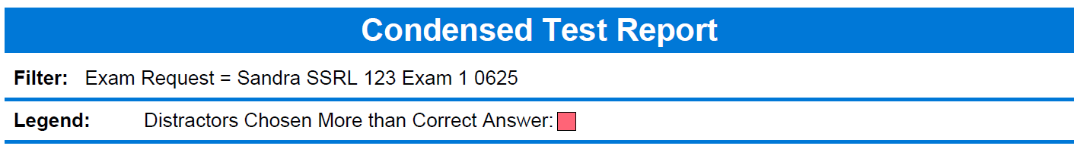
- The Filter lists the information provided on the Exam Grading Request.
- The Legend for chosen distractors will be marked in red if an incorrect answer is chosen more than the correct answer.
  - Printouts from the SSRL will not show the red text.

Overall Statistics
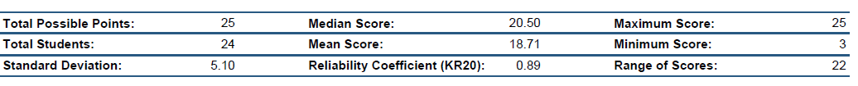
- The exam questions are worth one point unless a PPRM (weighted) bubble form is provided.
- Total Students represents the total number of exams graded.
  - The number of exams graded could be different than the number submitted. This could be caused by an exam being blank or the scanner was unable to read the exam.
- Standard Deviation is a measure of how spread out the distribution of scores is from the mean. The more spread apart the data is, the higher the deviation. A low standard deviation indicates that most of the students’ scores are close to average.
- The Reliability Coefficient (KR20) measures exam reliability and is an overall measure of internal consistency. A higher value for the exam indicates a strong relationship between items on the test. A value of at least .70 is desirable. Range: 0.00 – 1.00
- The Range of Scores is the difference between the maximum score and the minimum score. Range shows how much the scores vary.

Distribution by Question
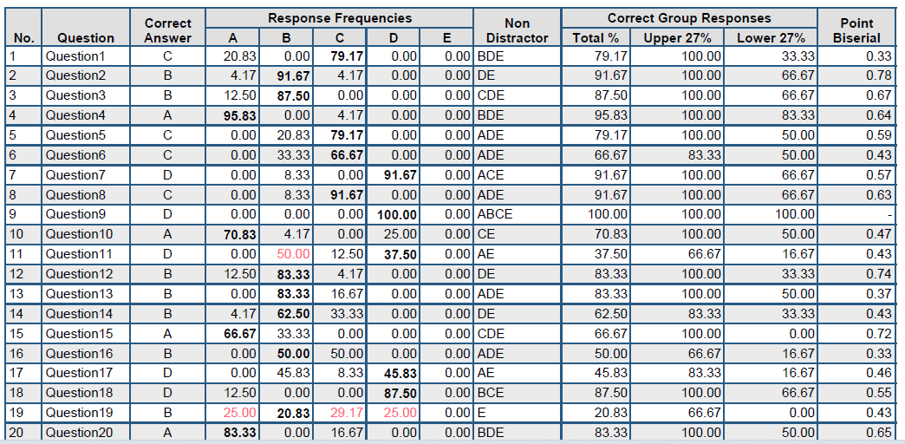
- The correct response provided from the answer key is indicated under the Correct Answer column.
- The following five columns will display the percentage or total number of times a particular answer choice was chosen by the students for a particular question.
  - The correct answer’s frequency will be in bold.
  - If the percentages do not total 100%, it could be that a student left an item blank or mismarked an item.
    - Check the Student Response Report to locate the reasoning.
- Next is the non-distractor column. These are responses to the questions that were not selected by any students.
- The next three columns are percentages of the Correct Group Responses.
  - Total %: This is the percentage of students who answered the question correctly.
  - Upper 27%: This displays the percent correct for the individual question based on the students who scored in the upper 27% for the exam.
  - Lower 27%: This displays the percent correct for the individual question based on the students who scored in the lower 27% for the exam.
- The last column gives the Point Biserial coefficients. This is a measurement of the discrimination of an item. It indicates the relationship between a response for a given item and the overall test score of the respondent. This indicates that the students who performed well on the exam also selected the correct response, so this is a good discriminator between high-scoring and low-scoring students. It is also a way to help you know how well the exam was written.
  - General Interpretation
    - Very Good Item: .30 and above
    - Reasonably Good: .20 - .29
    - Marginal Item: .09 - .19
    - Poor Item: below .09

