Upcoming School of Music Concerts

Visit the WSU School of Music webpage for a full listing of concerts:
www.wichita.edu/musiccalendar

Like us on:

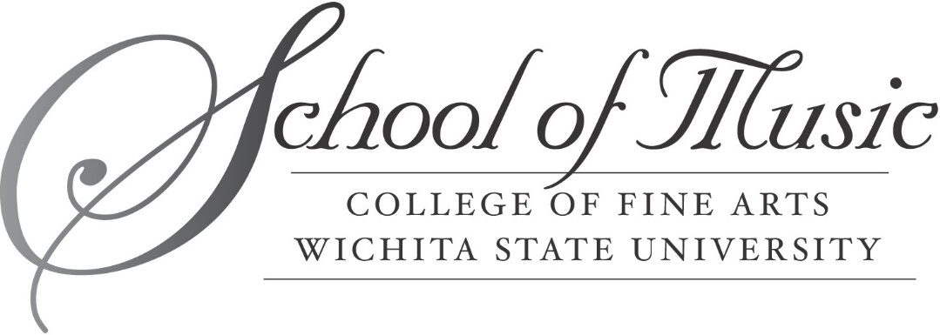
Presents

WSU IMPULSE PERCUSSION GROUP

Concert Title

Featuring
Name

Andrew Slater, director
Sunday, November 18, 2018 – Miller Concert Hall – 3:00 p.m.

PROGRAM
Title Composer
(xxxx-xxxx)

Title Composer
(xxxx-xxxx)

Title Composer
(xxxx-xxxx)

Title Composer
(xxxx-xxxx)

Title Composer
(xxxx-xxxx)

Title Composer
(xxxx-xxxx)

INTERMISSION

Title Composer
(xxxx-xxxx)

Title Composer
(xxxx-xxxx)

Title Composer
(xxxx-xxxx)

Title Composer
(xxxx-xxxx)

Title Composer
(xxxx-xxxx)

Title Composer
(xxxx-xxxx)andrew.

GUEST ARTIST BIOGRAPHY

IMPULSE PERCUSSION GROUP PERSONNEL

Name, city, state Name, city, state
Name, city, state Name, city, state
Name, city, state Name, city, state
Name, city, state Name, city, state
Name, city, state Name, city, state
Name, city, state Name, city, state
Name, city, state Name, city, state
Name, city, state Name, city, state
Name, city, state Name, city, state

SPECIAL THANKS
List names here

