Ethnic Origin:____________________________________________________________

MM: ____________ CSP: _______

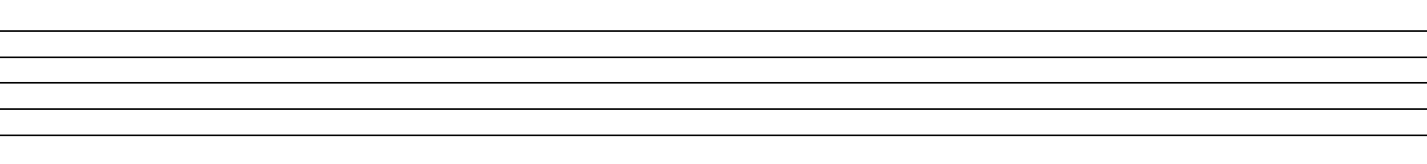

Song Analysis Classroom Use

Tone Set: Rhythm:

Scale:

Form: Melody:

Rhythm:

Other: Other:

Source:

Ethnic Origin:____________________________________________________________

MM: ____________ CSP: _______

Song Analysis Classroom Use

Tone Set: Rhythm:

Scale:

Form: Melody:

Rhythm:

Other: Other:

Source:

Ethnic Origin:____________________________________________________________

MM: ____________ CSP: _______

Song Analysis Classroom Use

Tone Set: Rhythm:

Scale:

Form: Melody:

Rhythm:

Other: Other:

Source:

