Circle of 4ths for Tone, Balance & Time

MM: _varies___ CSP: _varies___
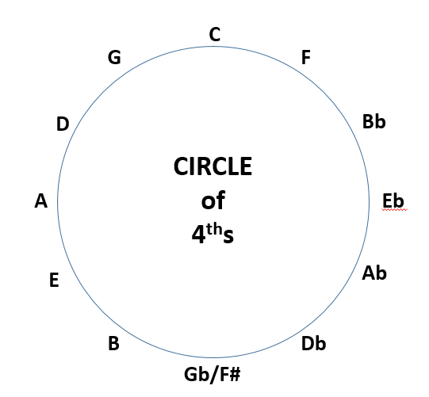
Playing around the circle of 4ths creates a sense of V⁷–I cadences.

Variation Purpose

Play each pitch on an 8 count pattern, holding for 4, resting for 4 | Tone, attacks & releases

Song Analysis Classroom Use

Tone Set: __________________________ Rhythm:________________________

Scale: __________________________ ________________________

Form: __________________________ Melody: ________________________

Rhythm List: _______________________ ________________________

Other: ___________________________ Other: ________________________
(Extra Analysis Info – may be blank) (Extra Classroom Info – may be blank)

Source:
Circle of 4ths for Velocity

MM: _varies___ CSP: _varies___
Playing around the circle of 4ths creates a sense of V⁷–I cadences.

Variation Purpose

Play each pitch on an 8 count pattern, holding for 4, resting for 4 | Tone, attacks & releases
Song Analysis Classroom Use

Tone Set: __________________________ Rhythm:________________________

Scale: __________________________ ________________________

Form: __________________________ Melody: ________________________

Rhythm List: _______________________ ________________________

Other: ___________________________ Other: ________________________
(Extra Analysis Info – may be blank) (Extra Classroom Info – may be blank)

Source:
Add 1’s

MM: ____________ CSP: _______

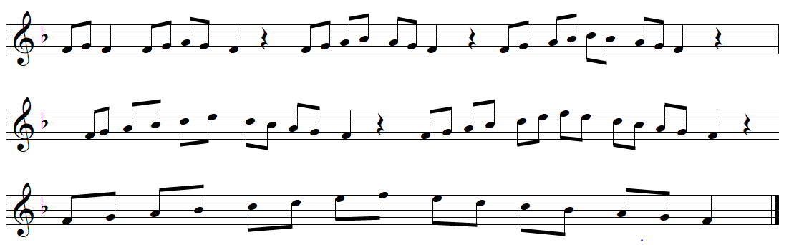

Variation Purpose

Song Analysis Classroom Use

Tone Set: __________________________ Rhythm:________________________

Scale: __________________________ ________________________

Form: __________________________ Melody: ________________________

Rhythm List: _______________________ ________________________

Other: ___________________________ Other: ________________________
(Extra Analysis Info – may be blank) (Extra Classroom Info – may be blank)

Source:
Exercise

MM: ____________ CSP: _______

Variation Purpose

Song Analysis Classroom Use

Tone Set: __________________________ Rhythm:________________________

Scale: __________________________ ________________________

Form: __________________________ Melody: ________________________

Rhythm List: _______________________ ________________________

Other: ___________________________ Other: ________________________
(Extra Analysis Info – may be blank) (Extra Classroom Info – may be blank)

Source:
Exercise

MM: ____________ CSP: _______
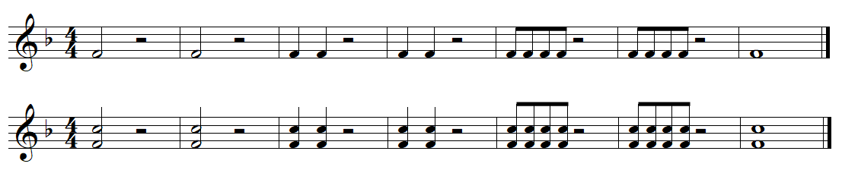

Variation Purpose

Song Analysis Classroom Use

Tone Set: __________________________ Rhythm:________________________

Scale: __________________________ ________________________

Form: __________________________ Melody: ________________________

Rhythm List: _______________________ ________________________

Other: ___________________________ Other: ________________________
(Extra Analysis Info – may be blank) (Extra Classroom Info – may be blank)

Source:
Remingtons

MM: ____________ CSP: _______
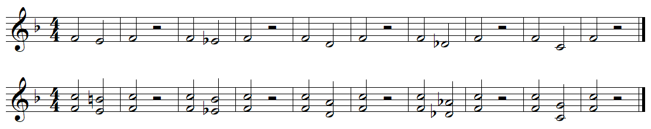

Variation Purpose

Song Analysis Classroom Use

Tone Set: __________________________ Rhythm:________________________

Scale: __________________________ ________________________

Form: __________________________ Melody: ________________________

Rhythm List: _______________________ ________________________

Other: ___________________________ Other: ________________________
(Extra Analysis Info – may be blank) (Extra Classroom Info – may be blank)

Source:

Add 1’s

MM: ____________ CSP: _______
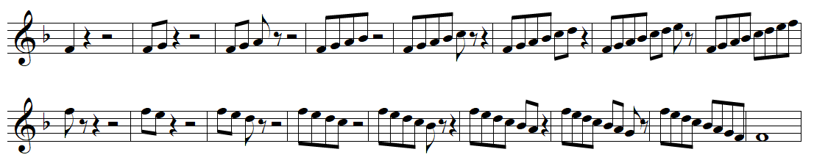

Variation Purpose

Song Analysis Classroom Use

Tone Set: __________________________ Rhythm:________________________

Scale: __________________________ ________________________

Form: __________________________ Melody: ________________________

Rhythm List: _______________________ ________________________

Other: ___________________________ Other: ________________________
(Extra Analysis Info – may be blank) (Extra Classroom Info – may be blank)

Source:
Exercise

MM: ____________ CSP: _______

Variation Purpose

Song Analysis Classroom Use

Tone Set: __________________________ Rhythm:________________________

Scale: __________________________ ________________________

Form: __________________________ Melody: ________________________

Rhythm List: _______________________ ________________________

Other: ___________________________ Other: ________________________
(Extra Analysis Info – may be blank) (Extra Classroom Info – may be blank)

Source:

Exercise

MM: ____________ CSP: _______

Variation Purpose

Song Analysis Classroom Use

Tone Set: __________________________ Rhythm:________________________

Scale: __________________________ ________________________

Form: __________________________ Melody: ________________________

Rhythm List: _______________________ ________________________

Other: ___________________________ Other: ________________________
(Extra Analysis Info – may be blank) (Extra Classroom Info – may be blank)

Source:
Exercise

MM: ____________ CSP: _______

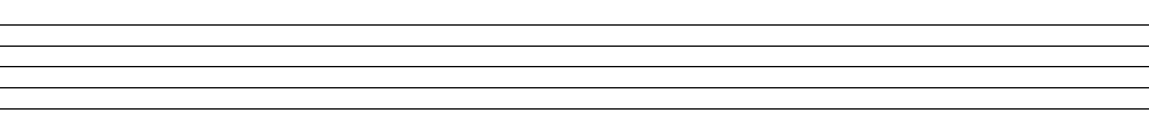

Variation Purpose

Song Analysis Classroom Use

Tone Set: __________________________ Rhythm:________________________

Scale: __________________________ ________________________

Form: __________________________ Melody: ________________________

Rhythm List: _______________________ ________________________

Other: ___________________________ Other: ________________________
(Extra Analysis Info – may be blank) (Extra Classroom Info – may be blank)
Source:
Exercise

MM: ____________ CSP: _______

Variation Purpose

Song Analysis Classroom Use

Tone Set: __________________________ Rhythm:________________________
Scale: __________________________ ________________________
Form: __________________________ Melody: ________________________
Rhythm List: _______________________ ________________________
Other: ___________________________ Other: ________________________
(Extra Analysis Info – may be blank) (Extra Classroom Info – may be blank)
Source:
Exercise

MM: ____________ CSP: _______

Variation Purpose

______

Song Analysis Classroom Use

Tone Set: __________________________ Rhythm:________________________

Scale: __________________________ ________________________

Form: __________________________ Melody: ________________________

Rhythm List: _______________________ ________________________

Other: ___________________________ Other: ________________________
(Extra Analysis Info – may be blank) (Extra Classroom Info – may be blank)

Source:

