General Education Committee Meeting

Minutes 12-9-2024

- Members in Attendance: Natalie Delacruz, Sally Fiscus, Gina Crabtree, Linnea Glenmaye, Julie Henderson, Brittany Lockard (Chair), Josh Mallard (Student Rep), Angie Paul and Jan Wolcutt
Absent: Samantha Corcoran, Carolyn Shaw, , Sandy Sipes
APPROVAL OF MINUTES
- It was moved and seconded to approve the minutes from the 11-11-24 meeting. Approved 5-0.

COURSE PROPOSAL REVIEW
    - Reminder: Committee members can preview proposals by going to MyWSU Faculty/Staff Courseleaf (CAT and CIM), right side of page Courseleaf Approval Page. Once there, at the top, choose “General Education Committee Chair” as your role to see a list of pending courses.

The committee reviewed the following courses:
- Theater 241: Improvisation for the Actor: requested to change to title and course description: Approved
- Theater 243: Acting 1: Acting 1—Foundations: requested to change to title and course description: Approved
    - POLS 340: Global Challenges: was already approved as a Gen Ed course. They are requesting to start in January instead of fall, but this committee cannot do that.
    - PHS 512: Aging Across Cultures: Course title change; Moved and seconded to approve contingent on confirmation. Approved 6-0
    - PHS 404: Psychology of Aging: already an approved Gen Ed. They are changing pre-requisites. Moved and seconded to approve. Motion passes: 6-0
    - PHS 344: Culturally Informed Healthcare: This course was already approved, so Brittany will send it along its way.
    - MUSC 164: American Popular Music; already Gen Ed, this is just a title change Approved 6-0
    - MUSC 162: already Gen Ed Global Music Culture: Title change Approved 6-0
    - JAPN 322: Japanese Film: removing the cross listing of Phil 307. Approved
    - JAPN 224: Intermediate Japanese: seeking the Gen Ed attribute. This course has JAPN 204 and 223 as prerequisites. Foundational courses (210, for example) are generally not Gen Ed, but 200 level class typically have goals like a literature class, and similar course in other languages are Gen ed. Approved 6-0
    - HNRS 305Y: Peace: a new course. The catalogue description is overly long, but the catalog editor will likely request that it be shortened. Approved 6-0
    - ENGL 365: African American Literature: already an extent Gen Ed. Moved and seconded to Approved: 6-0
    - Hist 552 The History of Global Public Health: The committee began discussing this proposal, but there was not enough time remaining to vote.
    - Carolyn Shaw provided these links in an email in preparation for our review of the General Education program:
https://www.wichita.edu/academics/generaleducation/
https://www.kansasregents.org/academic_affairs/general-education
https://www.wichita.edu/academics/facultysenate/RulesOfTheFacultySenate_3.25.24_Part2.pdf

GENERAL EDUCATION DISCUSSION

The current GEP description is so broad that just about any class could be considered Gen Ed. Brittany asked for suggestions as to how to proceed. The committee referred to the Regents Gen Ed proposal but did not come to a conclusion due to time constraints. Brittany is going to try to schedule another meeting in January.

NEXT MEETING:

Brittany would like to meet in January before the semester recommences to finally talk as a whole committee about our vision of the gen ed program and requested our availability after the shutdown. She hopes to get a meeting scheduled by the end of the week.

She provided the information below and requested that we review Dr. Shaw’s comments and the subcommittee findings.

Here is the Faculty Senate Rules document with our committee charge:

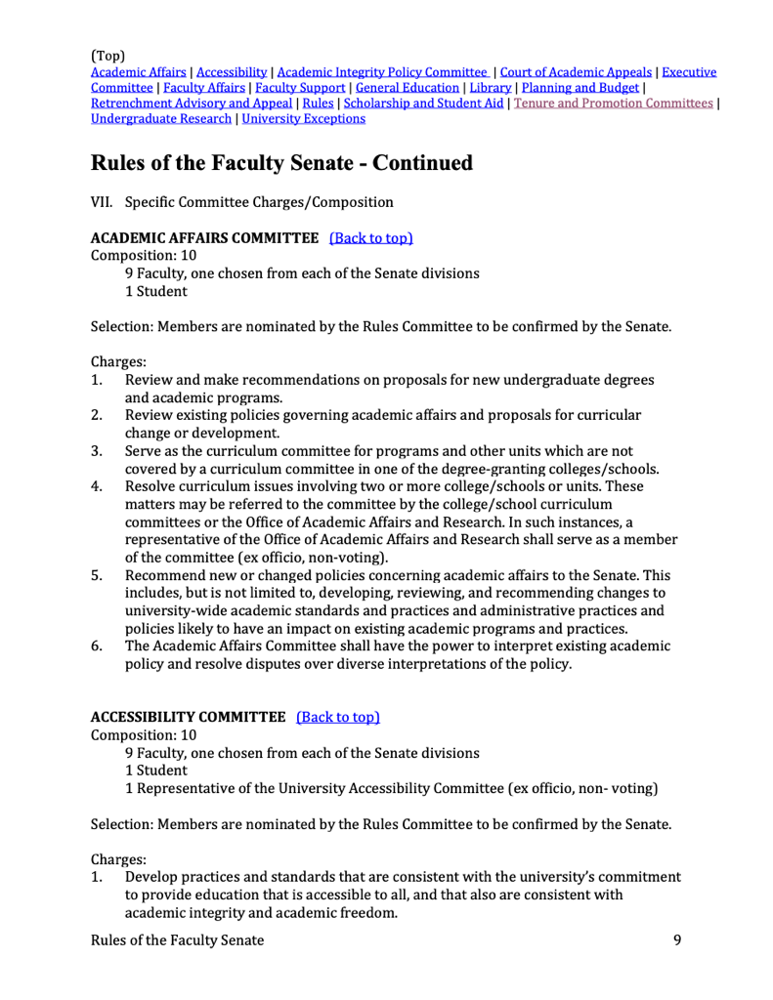
RulesOfTheFacultySenate_3.25.24_Part2
PDF Document · 206 KB

Here’s the gen ed program description on the website:
General Education Program
wichita.edu

ADJOURNMENT

The meeting ended at 2:00 pm.

