General Education Committee Meeting

Minutes 1-27-2025
Members in Attendance: Brett Bruner, Natalie Delacruz, Sally Fiscus, Gina Crabtree, Linnea Glenmaye, Julie Henderson, Brittany Lockard (Chair), Josh Mallard (Student Rep), Angie Paul, Carolyn Shaw, Sandy Sipes and Jan Wolcutt
Absent: Samantha Corcoran
APPROVAL OF MINUTES
- It was moved and seconded to approve the minutes from the 12-9-24 meeting. Approved 5-0.
DISCUSSION AOUT GEP REQUIREMENTS FOR OUT-OF-STATE TRANSFER STUDENTS AND !/4 SEMESTER TRANSFER STUDENTS.

Some students have transferred science classes with a lab that are deemed equivalent to a 4-credit hour WSU course but are only 3 credit hours. Currently students would need to go through the Exceptions Committee to have that course counted under Bucket 4. The 4-hour credit requirement was originally based on what universities in Kansas were doing at the time. Currently, if a student has a 3-credit hour course, but does not have 6 hours in that bucket, the student will not fulfill the requirements for that bucket and would have to take another course. This also applies to classes based on the quarter system. The issue is whether they would need to take another 3-hour Gen Ed course to make the 34-hour total when they might only need one credit hour. In the past, the Exceptions Committee has made an exception if the student is only one or two hours short. They usually do not approve the exception if the student is 3 or more credit hours short. Often the student already has additional courses with the General Education attribute, so the issue of having 34 credits in General Education does not arise. However, the Exceptions Committee does see this request often enough that it seems reasonable to have a consistent policy in place that the Registrar’s Office can implement.

It was moved and seconded to have Sally draft a statement to accept 3-credit hour labs that have been deemed to be equivalent to a WSU Gen Ed course to count for Bucket 4 without requiring the student to take an additional 3-hour course if the student has at least 33 hours of Gen Ed courses. Motion passes 8-0.

COURSE PROPOSAL REVIEW

Reminder: Committee members can preview proposals by going to MyWSU Faculty/Staff Courseleaf (CAT and CIM), right side of page Courseleaf Approval Page. Once there, at the top, choose “General Education Committee Chair” as your role to see a list of pending courses.

    - Hist 552 The History of Global Public Health:
The History Department is seeking Gen Ed status for this new class. The committee was concerned because a 500-level class can not be taken in the first 2 years and that 1st year students cannot take this class without permission. It was moved and seconded to approve General Education status for this class. The motion fails:0 for-5 against -15 against -1 abstention. The class was not approved.

    - STAT 171: Intro to Statistics
This class is being reactivated as a math pathway course. The department did not originally seek the Gen Ed attribute because it had an algebra as a prerequisite. It no longer requires College Algebra as a prerequisite. It was moved and seconded to approve General Education status for this class. Brittany will let the department know they must fill out the Gen Ed goals after the course goes through workflow. Approved 8-0.

GENERAL EDUCATION DISCUSSION

Carolyn thoughtfully provided this information as a prelude to the discussion.

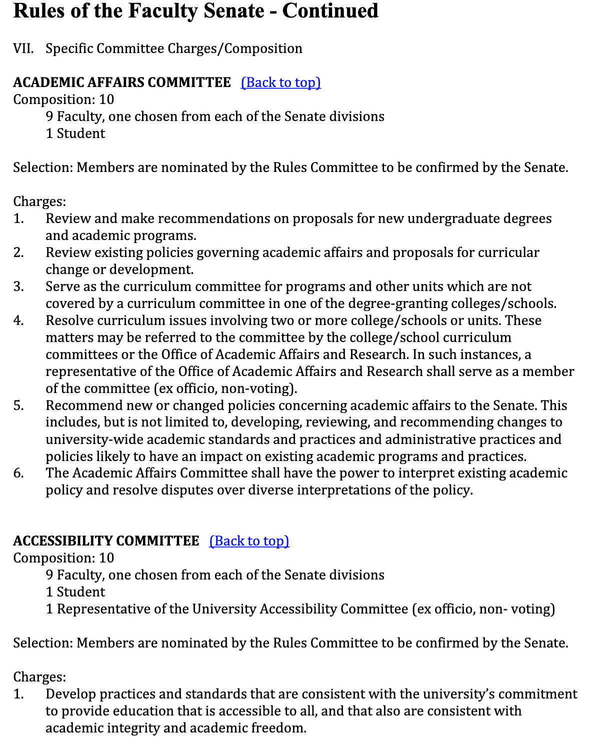

The current GEP description is so broad that just about any class could be considered Gen Ed. Brittany asked for suggestions as to how to proceed. Here are the links provided in the chat:
https://www.wichita.edu/academics/generaleducation/
https://www.kansasregents.org/academic_affairs/general-education
https://www.wichita.edu/academics/facultysenate/RulesOfTheFacultySenate_3.25.24_Part2.pdf

RulesOfTheFacultySenate_3.25.24_Part2
PDF Document · 206 KB

Here’s the General Education program description on the website:
General Education Program
wichita.edu

Carolyn also provided some documents in Teams to aid the discussion:

https://www.wichita.edu/academics/generaleducation/
https://www.wichita.edu/academics/generaleducation/genedassessment.php
https://www.wichita.edu/admissions/transferguide/Gen_Ed_requirement_options.php
https://www.kansasregents.org/academic_affairs/general-education
https://www.kansasregents.org/academic_affairs/general-education/master-course-lists
https://www.wichita.edu/academics/generaleducation/courses.php

Possible solution: The committee could state that Gen Ed courses should not have prerequisites and there cannot be a requirement that students need permission to take the course.

Here is what the catalog says about General Education:

http://catalog.wichita.edu/undergraduate/academic-information/general-education-program/?_gl=1*1wl7ksm*_gcl_au*MzMzNjg5NTE4LjE3MzgwMDIyMjU.*_ga*MTU1NzcwMTc1Ny4xNzMwMTI1NDg0*_ga_CR952CBJWM*MTczODAwMjIyNC4yNC4xLjE3MzgwMDIzMzUuMTguMC4xMjE0Mjk1MzQw

Brittany will send an email asking the committee to come up with a list of what we would approve as General Education courses for the next meeting: Here is Angie’s suggestion: A general education class introduce students to fundamental ideas of a given subject and supports critical thinking. A general education class should be available to all freshmen without exceptions or requirements.
The committee will need to prepare a report to Faculty Senate shortly. Angie prepared the report for the library section last year.

NEXT MEETING: February 10

ADJOURNMENT

The meeting ended at 2:05 pm.

