General Education Committee Meeting

Minutes 4-28-2025
Members in Attendance: Brett Bruner, Samantha Corcoran, Natalie Delacruz, Sally Fiscus, Linnea Glenmaye, Julie Henderson, Ashlie Jack, Brittany Lockard (Chair), Josh Mallard, Angie Paul, Carolyn Shaw, Sandy Sipes and Jan Wolcutt
Absent: Robin Folherts

APPROVAL OF MINUTES
- It was moved and seconded to approve the minutes from the 4-14 meeting as amended to note that Linnea did attend. Approved 8-0.

WELCOME AND INTRODUCTION TO NEW MEMBER
- William Ingle will be a new member, but did not attend today.
SUMMARY OF REPORT TO FACULTY SENATE
- Note: LAS Competencies is a growing list and is NOT the same as Gen Ed requirements.
- The report to Faculty Senate reflects concerns that were brought forward but these concerns will not be addressed by this committee.
NOMINATION, DISCUSSION AND VOTE ON A NEW CHAIR

- https://www.wichita.edu/academics/facultysenate/RulesOfTheFacultySenate_3.25.24_Part2.pdf
- Carlolyn Shaw cannot be the new chair, as concerns in her department prevent her.
- Samantha Corcoran was elected to be the new chair: 8-0

THANK TO BRITTANY FOR A JOB WELL DONE.

- We all learned how to do new emojis to thank Brittany for a job well done!

NEXT MEETING: Fall 2025

ADJOURNMENT
- The meeting adjourned at 12:55 pm.

Note: Faculty assigned to represent their colleges are listed below, and can be found at
https://www.wichita.edu/academics/facultysenate/2425committees.php#General%20Education
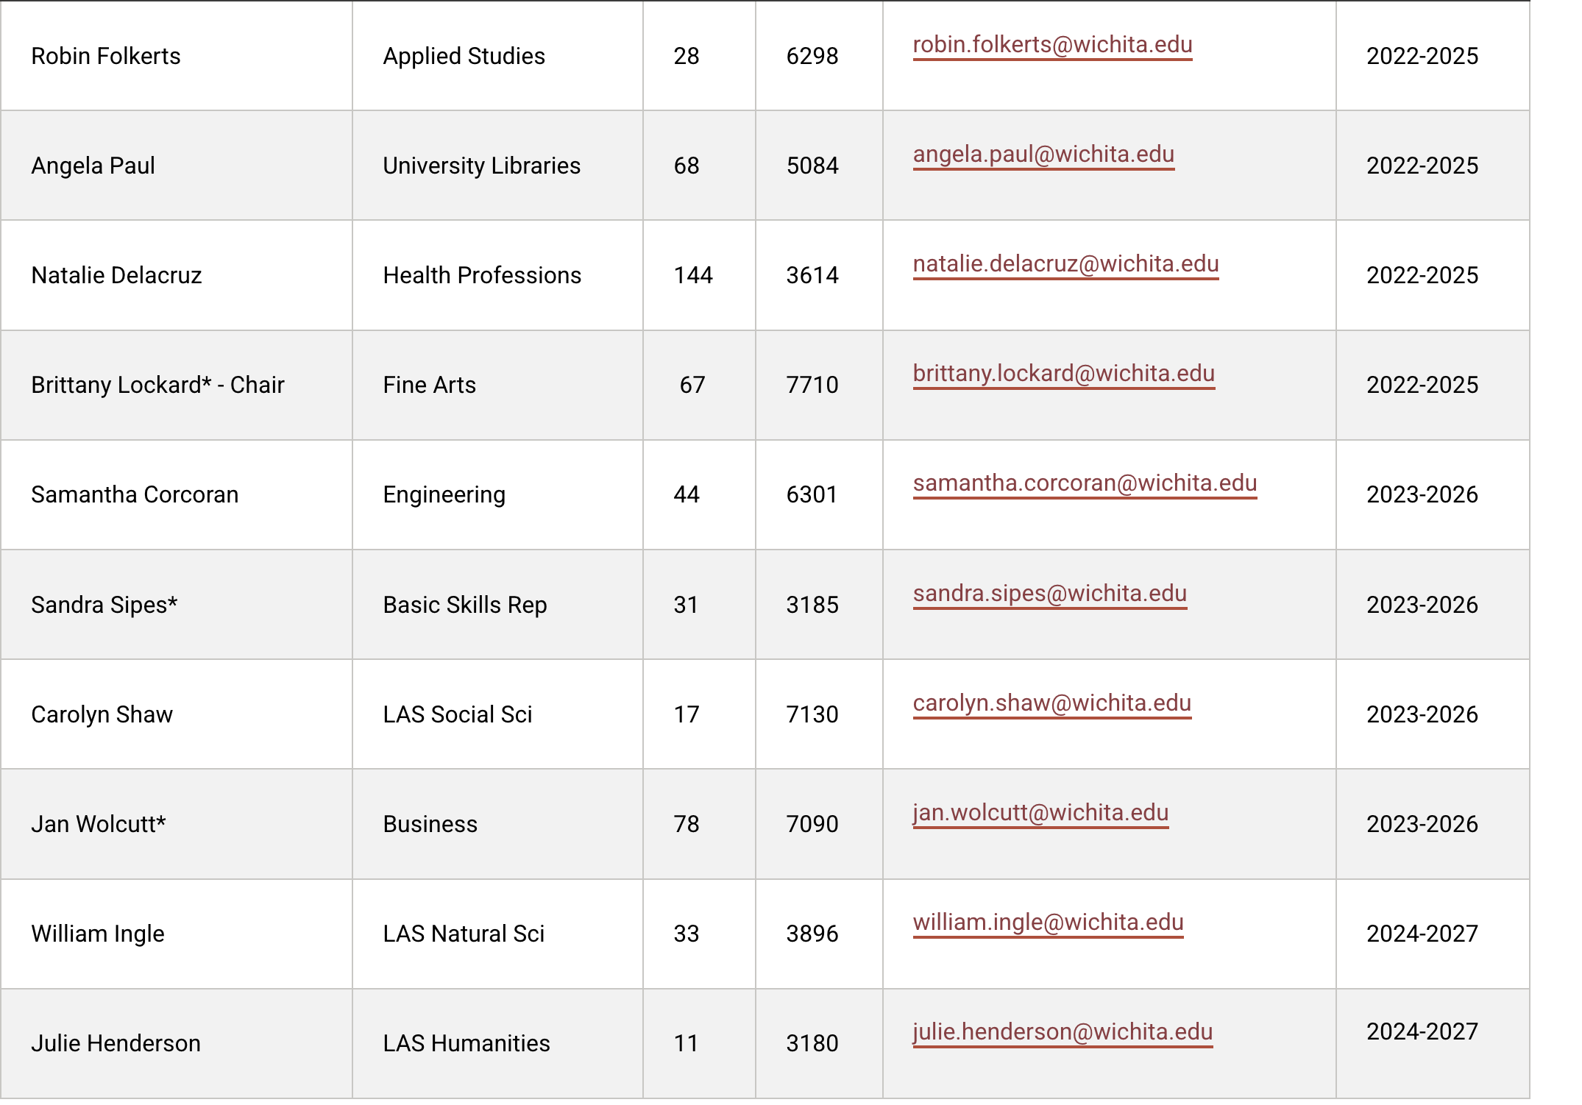
Student: Joshua Mallard jrmallard@shockers.wichita.edu

