Calculating Transfer Equivalencies
- Go to the WSU Course Transfer Equivalency website.
The Direct link is http://www.wichita.edu/transfer

- You can also go through the WSU website by going to http://www.wichita.edu, then click on transfer credits at the bottom under Admissions


- BEFORE GOING ANY FURTHER, READ THE DOCUMENTATION UNDER THE TRANSFER EQUIVILANCY. Not doing so, could result in inaccurate transfer information.

- Above the Documentation is the transfer equivalency lookup.

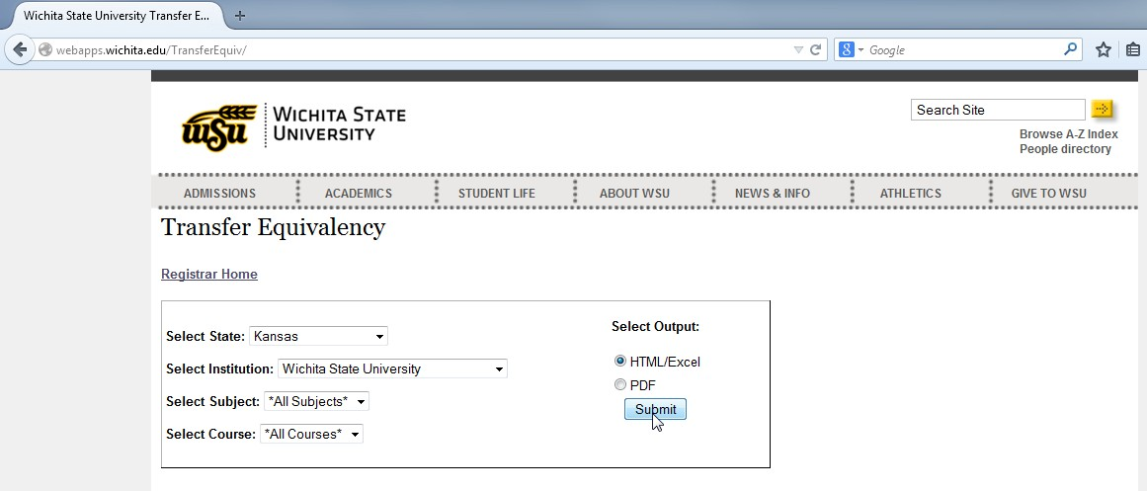
- Select the state that you are planning on transferring courses from to Wichita State University
- Select the Institution (if your institution or course is not listed, you will need to get further help on course transfers, so please let us know)
- Select the Subject. You are also able to select *All Subjects*
- Select the Course. You are also able to select *All Courses*
- You can either export this information into HTML, Excel, or Adobe PDF.
- After exporting you will see a list of courses.
Here is an example from a local community college of course transfer equivalencies.
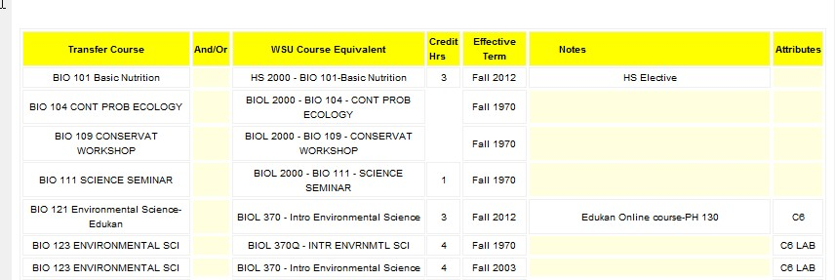
In this specific example, BIO 123, Environmental Sci, taken at a local community college is going to transfer to WSU as a course equivalent to BIOL 370 – Intro Environmental Science. We can see the Credit Hours are 4, and the Effective Term is going to be when that course became an equivalent. This course also has a corresponding Lab. There is also a notes section as well as an attributes section (at the bottom) that is imperative to review before transfer equivalency is complete. If you are having a hard time finding a class, you should be able to do a ctrl + f key and do a find to search for a particular course number.

