Athletics Task Force
CESSNA STADIUM SUB-COMMITTEE
Recommendations – May 2020

Sub-Committee Members:

WSU Staff
Emily Patterson
Misha Jacob-Warren
Todd Woolsoncroft

WSU Athletics
Brad Pittman
Steve Rainbolt

WSU Foundation
Mike Lamb
WSU Students
Jacob Tubach

Community Members
Bill Moore
Cindy Carnahan
Barry Schwan

Process:
The Cessna Stadium Sub-committee was tasked to meet to research and discuss the current condition of Cessna Stadium and work through options for repair, demolition, and potential options for construction of a new facility to house track & field, soccer, and lacrosse at Wichita State University.

Current Facility:
Cessna Stadium is a 30,000-seat facility that was constructed in 1946 (with a significant renovation in 1969) as a football and track facility and was the home of the Shocker football program until it was discontinued in 1986. The stadium serves as the venue for the annual Kansas State High School Track and Field Championship and the K.T. Woodman Track Classic. The stadium consists of a lower section of concrete seating bleachers as well as a higher section of steel seating structure and a press box on the west side. There are a series of concrete/cmu structures incorporated into the lower section of concrete bleachers and extending to the area below the upper section of steel seating structure. These structures house team locker rooms and support facilities that are being relocated to the new Student Athlete Center currently under construction adjacent to Koch Arena. There are also freestanding concrete/cmu structures under the steel seating structure serving as public restrooms and ticketing areas. The stadium is in poor condition and has outlasted the typical lifespan of exposed steel structures. A study in 2017 indicated that significant steel repair is needed – over $100,000 was invested at that time for immediate safety repairs. The facility continues to be exposed to the elements and deterioration of the steel structure will require extensive repairs and is a continuing public safety concern. In addition, the facility is not ADA compliant and past studies have indicated that significant demolition and rework are needed to bring the facility into compliance.

The stadium currently houses locker room, team room, and support areas for the Shocker Track & Field team. By August 2020, however, the coaching offices, strength and conditioning room, locker rooms, team rooms, and athletic training room will be relocated to a new building adjacent to Koch Arena. The existing facilities dedicated to track & field within the stadium will no longer be needed after the new facility is complete.

Personnel with Textron Aviation, the parent company of Cessna Aircraft Company, which was granted naming rights related to the 1969 expansion of the stadium, were contacted regarding the possible demolition of the stadium and indicated that they would have no objections.

The Kansas Board of Regents approved the demolition of Cessna Stadium in their April 2020 meeting.

Benchmarking Study:
- Appendix A shows links for facilities in the top 80-100 Division I athletic programs in the country. There are many varieties of stadium/field configurations. Most soccer stadium capacities were under 3,000. Several soccer/track combos were found, but very few of a large capacity (over 10,000). Two examples of large soccer/track facilities are in Drake and Texas.
- In our area there are some very nice soccer only facilities that have just been built: Kansas, Kansas state, Oklahoma State. Kansas also has one of the premier track facilities in the country.
- Appendix B shows the 2017 and 2018 attendance data for NCAA Men’s and Women’s soccer for reference.

Competition Requirements:
- Wichita State is scheduled to host the American Athletics Conference Track & Field Championships in 2024 or 2025.
- In order to host championships in track & field and soccer, the new facility would need to meet the following minimum requirements:

Soccer:
  - Four team locker rooms that can accommodate 22 student athletes each plus support personnel. Each locker room should have showers/toilet facilities
  - Two official’s locker rooms that can accommodate up to 6 people each, with shower/toilet facilities.
  - Visible scoreboard
  - Athletic Training facility
  - Hospitality area for administrators and coaches. (can be a tented location if needed)
  - Filming area and scouting location for teams, this is typically in the stands.
  - Video review location
  - Seating for a minimum of 1,000 people with permanent restrooms, ticket booths, concession stands.
  - 150-foot candle lighting level
  - Enclosed press box for minimum of 20 people, with two separate radio booths and a separate broadcast booth.
  - Media work room adjacent to the field.
  - Wired and wireless internet.
  - Minimum of two, 200 amp 3phase disconnects for linear TV power.

Track: (general items outside the specific nature of the actual track and throwing areas)
  - Track must be lighted
  - Seating for minimum of 1,500
  - Visible main scoreboard
  - Meeting space for 80 people close to the competition site the day before the championship
  - Hospitality space for 75 people that has a view of track for administrators and coaches.
  - Dedicated space for 75 people for officials and workers (can be tented)
  - Area for an athlete village, 20 spaces large enough for a 10 x 10 tent and also a larger tent for student-athlete hospitality. Should have a view of the track.

Lacrosse:
  - Men’s Lacrosse does not have a conference championship, but the women’s specifications are similar to soccer except the locker rooms need to be larger.

Conclusions:
- It is recommended that the university plan to demolish the existing Cessna Stadium and build a new multi-sport stadium to house track & field events as well as soccer and lacrosse. Although the soccer and lacrosse fan experience would be preferred with a facility dedicated to soccer/lacrosse, the restrictions of the site between Koch Arena (and the new Student Athlete Center) and Devlin Hall and between 21st Street and Perimeter Road does not allow for two separate facilities. The existing track will need to be reconfigured (widened) to allow for soccer and lacrosse events.
- The Sub-committee recommends that the university wait to proceed with demolition of the stadium until a plan for the new stadium is finalized and project funds are raised.
- The Sub-committee feels that the Kansas State Track meet is an important event for Wichita State University and the City of Wichita. We recommend that WSU explore partnership opportunities with the city to keep the home of the event at Wichita State University in the future. We will need to ensure that the seating capacity of any new facility is sufficient for this event (either entirely with permanent seating or supplementing the permanent seating capacity with temporary bleachers).
- If soccer and/or lacrosse events will be held at the stadium, additional team support areas (locker rooms, team rooms, coaching offices, etc) will also be required – either as part of the new facility or as an addition to the new Student Athlete Center. Planning will also be needed for additional practice fields as all three sports will not be able to use the stadium for practice at the same time and practice hours are limited due to academic schedules of the student athletes.

Recommended Next Steps:
- Engage architect specializing in athletic facilities to create a conceptual plan for a multi-sport facility to replace Cessna Stadium. The deliverable will be a plan for the phased removal of the east and west stadium stands, widening of track and playing field area to accommodate a regulation soccer and lacrosse field, a new facility to house stadium seating/press box/ticketing area/restrooms/support area/locker rooms/marching band practice and instrument storage room, as well as an anticipated project budget and timeline.
- Ensure that the existing facility can continue to be used for track & field events throughout the design/fundraising/construction process (including the ability to continue to hold the Kansas State High School Track & Field Championships)
- Maintain Cessna Stadium Sub-Committee as advisory/working group during the planning process

Appendix A:

AMERICAN
Cincinnati – Combined Track and Field/Soccer
https://gobearcats.com/sports/2017/6/11/facilities-gettler-stadium-html.aspx
separate la crosse - https://gobearcats.com/sports/2017/6/11/facilities-sheakley-html.aspx

ECU – Stand-alonetrack - https://ecupirates.com/facilities/bate-foundation-track-field-facility/2
Soccer/La Crosse - https://ecupirates.com/facilities/johnson-stadium/10

Houston – combined soccer/track - https://uhcougars.com/sports/2018/6/12/facilities-tellez-html.aspx

Memphis – combine soccer/Track - https://gotigersgo.com/facilities/?id=12&path=mtrack
https://gotigersgo.com/facilities/?id=27

SMU – combine soccer/Track - https://smumustangs.com/facilities/westcott-field/21

Temple – combined soccer/track, combines lacrosse/field hockey
https://owlsports.com/sports/2018/2/9/temple-sports-complex-wsoc.aspx?id=1439

Tulane – no comparable facility (only has track) https://en.wikipedia.org/wiki/Danny_Thiel_Track

Tulsa – combined soccer/track https://tulsahurricane.com/news/2015/6/5/POM_0605153052.aspx

UCF – Combined soccer/track https://ucfknights.com/facilities/ucf-soccer-and-track-complex/6

UCONN – Track/La Crosse https://uconnhuskies.com/facilities/george-j-sherman-family-sports-complex/6
Stand-alone soccer https://uconnhuskies.com/facilities/joseph-j-morrone-stadium/5

USF –
Stand-alone soccer - https://gousfbulls.com/sports/2012/1/4/205356020.aspx
Stand-alone track (used to host soccer) - https://gousfbulls.com/news/2005/12/12/220400

MISSOURI VALLEY
Bradley- Stand-alone soccer - https://bradleybraves.com/sports/2016/6/16/shea.aspx?id=940
Opened in 2003, renovated site of former baseball stadium and reused portions for stands for it. Attendance for 2019 was 650-1,300 people.

Drake – Football/soccer/track stadium - https://godrakebulldogs.com/facilities/?id=3
Renovated in 2005 for 15 million dollars has a capacity of 14,557 with and artificial turf field.
City of Des Moines soccer facility used as well - https://godrakebulldogs.com/facilities/?id=2

Evansville – Soccer only - https://gopurpleaces.com/sports/2007/10/22/MSOC_1022070345.aspx
2,500 seat soccer stadium that was once the site of football before it was discontinued.

Illinois State – Soccer only - https://goredbirds.com/sports/2014/4/30/Facilty_adelaide.aspx?path=facilty 1,000 seat soccer only stadium

Track and field only - https://goredbirds.com/sports/2014/5/12/Facilty_track.aspx
Little to no seating and amenities

Indiana State – women’s soccer uses football stadium - https://gosycamores.com/facilities/memorial-stadium/5 - capacity of 12,500.
Track and field only stadium - https://gosycamores.com/facilities/gibson-track-field-complex/2
4.3 million dollar facility built in 2015, minimal seating.

Loyola – Chicago – soccer at a local park - https://loyolaramblers.com/sports/2017/5/25/facilities-loyc-soccer-html.aspx
1,023 seating capacity

Missouri State – Soccer/Track - https://missouristatebears.com/sports/2016/7/21/facilities-allison-south-html.aspx
1,500 seats, completed in 2014.

Northern Iowa – Outdoor Track only - https://unipanthers.com/facilities/mark-messersmith-outdoor-track-field-complex/13
Minimal seating and amenities on site. Soccer is played off campus.

Southern Illinois – soccer/track and field - https://siusalukis.com/sports/2016/6/12/facilities-facilities-track-html.aspx
Minimal seating, 4 million dollar project completed in 2012.

Valparasio – Football/soccer/track - http://www.valpoathletics.com/facilities/default/
5,000 seat facility, last renovated in 2014.

BIG 12 CONFERENCE
Baylor – Track only - https://baylorbears.com/sports/2018/5/16/facilities-hart-html.aspx
18.1 million dollars dedicated in 2014, seats 5,000
Soccer only - https://baylorbears.com/sports/2018/5/16/facilities-loumays-html.aspx
3,000 seat soccer stadium

Iowa State – soccer/track - https://cyclones.com/facilities/cyclone-sports-complex-track-soccer-softball-/7
13 million dollar facility (also included a softball stadium), track/soccer seating for 1,500.

Kansas – Rock Chalk Park – Soccer only - https://kuathletics.com/facilities/soccer-complex/
2,500 seat stadium built in 2014
Track and field only – 7,500 seats, 9 million built in 2014. World Class facility.

Kansas State – Track only - https://www.kstatesports.com/sports/2015/6/24/_131476205052492599.aspx?id=206
3,000 seat stadium
Soccer only - https://www.kstatesports.com/news/2019/12/6/soccer-buser-family-park.aspx
Brand new 1,400 seat stadium.

Oklahoma – soccer only - https://soonersports.com/sports/2019/8/13/208803886.aspx
Capacity unknown
Track and field only - https://soonersports.com/sports/2019/8/12/208803917.aspx
Capacity unknown

Oklahoma State – Track and field only - https://okstate.com/sports/2018/8/20/track-field-complex.aspx?id=1433
9 million dollar facility built in 2013.
Soccer only - https://okstate.com/sports/2018/8/20/track-field-complex.aspx?id=1433
2,500 seat stadium, 20 million dollars built in 2018

TCU – track only- https://gofrogs.com/sports/2018/7/13/facilities-tcu-facilities-track-html.aspx
Soccer only - https://gofrogs.com/sports/2018/7/13/facilities-tcu-facilities-soccer-html.aspx
1,500 seats

Texas – soccer/track - https://texassports.com/sports/2013/7/25/facilities_0725133514.aspx
20,000 seat stadium

Texas Tech – soccer only - https://texastech.com/facilities/john-walker-soccer-complex/6
1,500 seats
Track and field only - https://texastech.com/facilities/fuller-track-field/8
Seating capacity unknown

West Virginia – Track only - https://wvusports.com/facilities/the-track-field-complex-at-mylan-park/31
1,800 seats part of 40 million dollar complex completed in 2019
Soccer only - https://wvusports.com/facilities/dick-dlesk-soccer-stadium/10
1,650 seat facility.

SEC
Alabama – Soccer only - https://rolltide.com/sports/2016/6/10/facilities-soccer-stadium-html.aspx
1,500 seat stadium
Track and field only - https://rolltide.com/sports/2016/6/10/facilities-sam-bailey-html.aspx

Arkansas - https://arkansasrazorbacks.com/facility/john-mcdonnell-field/ - Track only
7,000 seat stadium
Soccer only - https://arkansasrazorbacks.com/facility/razorback-field/
1,500 seat stadium

Auburn – Track only - https://auburntigers.com/facilities/hutsell-rosen-track/19
Soccer only – (1,500 seats) - https://auburntigers.com/facilities/auburn-soccer-complex/15

Florida – Track only (4,500 seats) - https://floridagators.com/facilities/james-g-pressly-stadium-percy-beard-track/4
La Crosse/Soccer (1500 seats) - https://floridagators.com/facilities/donald-r-dizney-stadium/8

Georgia – Track (1,100 seats) - https://georgiadogs.com/sports/2017/6/17/spec-towns.aspx
Soccer - https://georgiadogs.com/sports/2017/6/16/turner-soccer-complex.aspx

Kentucky – Track (3,000 seats) - https://ukathletics.com/sports/2015/7/31/_131461810140972035.aspx?id=475
Soccer - https://ukathletics.com/sports/2015/7/31/_131461810174973640.aspx?id=487
3,368 seats, 7.7 million dollar facility in 2014

LSU – Soccer - 2,197 capacity - https://lsusports.net/news/2018/8/10/177183.aspx
Track – (5,680 capacity) - https://lsusports.net/news/2012/2/1/177187.aspx

Mississippi – track (1,500) - https://olemisssports.com/sports/2018/7/20/facilities-ole-facilities-track-html.aspx?id=1229
Soccer – (1500) - https://olemisssports.com/sports/2018/7/20/facilities-ole-facilities-soccer-stadium-html.aspx?id=1231

Miss. State – Soccer (1,000) - https://spark.adobe.com/page/X0BdRhk63DQrH/
Track – (3,500) - https://spark.adobe.com/page/eVAwGEUm1zzSR/

Missouri – Soccer/Track (2,500) - https://mutigers.com/facilities/audrey-j-walton-soccer-stadium/10

South Carolina – Track (2,000) - https://gamecocksonline.com/feature/cregger-track
Opened in 2016, cost 10.3 million
Soccer only - https://gamecocksonline.com/feature/stone-stadium

Tennessee – Track - https://utsports.com/facilities/tom-black-track-at-laporte-stadium/21
Soccer – (3,000) - https://utsports.com/facilities/regal-soccer-stadium/16

Texas A&M – soccer (3,500) - https://12thman.com/facilities/ellis-field/9
Track – (2,000) - https://12thman.com/facilities/e-b-cushing-stadium/49
40 million dollar facility that opened in 2019

Vanderbilt – Lacrosse/Soccer - https://vucommodores.com/facilities/vanderbilt-soccer-lacrosse-complex/
Track - https://vucommodores.com/facilities/vanderbilt-track/

CONFERENCE USA
Charlotte – Track with ability to put soccer in the middle (4,000) - https://charlotte49ers.com/sports/2017/3/28/irwin-belk-track-and-field-center.aspx?id=2395
Soccer (4,000)- https://charlotte49ers.com/sports/2016/7/29/welcome-to-transamerica-field.aspx?id=2383

FIU – Soccer - https://fiusports.com/facilities/fiu-soccer-stadium/8
Track – Off Campus

FAU – Soccer (1,000) - https://fausports.com/sports/2018/5/25/facilities-fau-soccer-stadium-html.aspx
Track – Shared facility with Campus Rec http://www.fau.edu/campusrec/about_us/facility/track.php

Louisiana Tech – Soccer - (minimal seating) - https://latechsports.com/facilities/lady-techster-soccer-complex/6
Track - https://latechsports.com/facilities/jim-mize-track-and-field-complex/5

Marshall – Soccer - https://herdzone.com/facilities/hoops-family-field/6

Middle Tennessee – Track/Soccer - https://goblueraiders.com/sports/2014/7/9/WSOC_0709144223.aspx

North Texas – Track/Soccer (1,500) - https://meangreensports.com/facilities/soccer-and-track-field-stadium/19

Old Dominion – LaCrosse/Field Hockey – (1,500) - https://odusports.com/facilities/l-r-hill-sports-complex/12
Soccer – (4,000) - https://odusports.com/facilities/soccer-complex/5
They do not sponsor track

Rice – Soccer/Track and Field - https://riceowls.com/facilities/wendel-d-ley-track-holloway-field/8
1500 seating capacity

Southern miss – Soccer/Track (1,000) - https://southernmiss.com/sports/2018/6/21/_facilities_tf_soccer_complex_html.aspx?id=1223

UAB – Soccer only - https://uabsports.com/sports/2017/6/10/facilities-bbva-compass-field-html.aspx

UTEP – soccer only - https://utepminers.com/facilities/university-field/11
Track only - https://utepminers.com/facilities/kidd-field/8

UTSA – Track/Soccer – 1,000 - https://goutsa.com/sports/2007/6/1/611017.aspx

Western Kentucky – Soccer (1,00) - https://wkusports.com/facilities/wku-soccer-complex/6
Track and field - https://wkusports.com/facilities/charles-m-ruter-track-and-field-complex/7

ACC
Boston College – La Crosse/Soccer - https://bceagles.com/facilities/newton-campus-lacrosse-soccer-field/4
Field Hockey (750) - https://bceagles.com/facilities/field-hockey-complex/5

Clemson – soccer - https://clemsontigers.com/soccer-operations-complex-construction/
Under construction now

Duke – La Crosse/Soccer (4500) - https://goduke.com/sports/2014/12/1/209852526.aspx
Track (500) - https://goduke.com/sports/2015/1/16/209852313.aspx

Florida State – track - https://seminoles.com/sports/track-and-field/facilities/florida-state-track-and-field-facilities/
Soccer - https://seminoles.com/sports/soccer/facilities/the-seminole-soccer-complex/

Georgia Tech (no soccer) – track - https://ramblinwreck.com/george-c-griffin-track-field-facility/

Louisville – Soccer only (5,300) - https://gocards.com/facilities/dr-mark-cindy-lynn-stadium/10
La Crosse Stadium (1,500) - https://gocards.com/facilities/uofl-lacrosse-stadium/8
Track (can also do soccer) (2,200) - https://gocards.com/facilities/cardinal-track-stadium/15

Miami – Soccer/Track (500) - https://hurricanesports.com/facilities/cobb-stadium/4

North Carolina – Soccer/la Crosse (4200) - https://goheels.com/news/2019/6/19/general-unc-soccer-lacrosse-stadium.aspx
New Track (500) - https://ramsclub.com/campaign/facilities/track-field-complex/index.html

NC State – soccer/track - https://gopack.com/facilities/dail-soccer-field-track-complex/13

Notre Dame – soccer (3,000) - https://und.com/facilities-3/alumni-stadium/
La Crosse (2,500) - https://und.com/facilities-3/arlotta-family-lacrosse-stadium/
Track - https://und.com/facilities-3/notre-dame-outdoor-track/

Pittsbugh – soccer - https://pittsburghpanthers.com/facilities/ambrose-urbanic-field/24

Syracuse – track - https://cuse.com/facilities/skytop-track/122
Soccer (1500) - https://cuse.com/facilities/su-soccer-stadium/29
Field hockey - https://cuse.com/sports/2001/8/7/coyne.aspx

Virginia – La Crosse/Soccer - https://virginiasports.com/facilities/kl-ckner-stadium/3
3,600 seats with hillside seating for 3,500
Track (1,500) - https://virginiasports.com/facilities/lannigan-field/12
Field Hockey - https://virginiasports.com/facilities/turf-field/17

Virginia Tech – soccer/la Crosse - https://hokiesports.com/sports/2018/4/20/thompson-field.aspx?id=110
Track - https://hokiesports.com/sports/2018/4/20/johnson-miller-track-complex.aspx?id=103

Wake Forest – Soccer (3,000) - https://godeacs.com/facilities/spry-stadium/7
Field hockey/track (4,000) - https://godeacs.com/facilities/kentner-stadium/9

BIG TEN
Illinois – track/soccer – separate facilities, same complex
https://fightingillini.com/sports/2019/9/16/facilities-demirjian-park.aspx

Indiana – soccer (6500) https://iuhoosiers.com/facilities/bill-armstrong-stadium-mens-and-womens-soccer/9
Field hockey - https://iuhoosiers.com/facilities/bill-armstrong-stadium-mens-and-womens-soccer/9
Track (3,200) https://iuhoosiers.com/facilities/robert-c-haugh-complex-outdoor-track-and-field/14

Iowa – Track - https://hawkeyesports.com/sports/2016/6/13/facilities-iowa-cretzmeyer-track-html.aspx
Soccer - https://hawkeyesports.com/sports/2016/6/13/facilities-iowa-soccer-complex-html.aspx
Field Hockey – Grant Field

Maryland – Field Hockey/La Crosse (1,400) - https://umterps.com/sports/2018/6/14/field-hockey-lacrosse-complex.aspx?path=athleticfacilities
Track/Soccer (4,500) - https://umterps.com/sports/2018/6/18/kehoe-track-field-complex.aspx?path=athleticfacilities

Michigan – Field Hockey (1500) - https://mgoblue.com/sports/2017/6/16/facilities-ocker-field-html.aspx
Soccer (2,200) - https://mgoblue.com/sports/2017/6/16/facilities-soccer-complex-html.aspx
La Crosse (2000) - https://mgoblue.com/sports/2017/6/16/u-m-lacrosse-stadium.aspx
Track (2000) - https://mgoblue.com/sports/2017/6/16/facilities-south-complex.aspx

Michigan State – Soccer (2,500) - https://msuspartans.com/sports/2018/7/20/facilities-ocf-soccer-html.aspx
Field hockey/track and field (1500) - https://msuspartans.com/sports/2018/7/20/facilities-ralph-young-field-html.aspx

Minnesota – Soccer (1000) - https://gophersports.com/sports/2018/5/21/facilities-robbie-stadium-html.aspx
Track and Field (2400) - https://gophersports.com/sports/2018/9/27/facilities-uofm-track-stadium.html.aspx

Nebraska – soccer (2500) - https://huskers.com/sports/2019/2/7/208519760.aspx?path=wsoc#wilderness
Track - https://huskers.com/sports/2019/1/31/208569672.aspx?path=mtrack#ed

Northwestern – soccer/lacrosse - https://nusports.com/facilities/lanny-and-sharon-martin-stadium-soccer-lacrosse-/5
Field hockey (300) - https://nusports.com/facilities/lakeside-field-field-hockey-/6

Ohio State
Soccer/lacrosse/track -3242 - https://ohiostatebuckeyes.com/sports/m-soccer/facilities/jesse-owens-stadium/
Field hockey – 500 - https://ohiostatebuckeyes.com/sports/w-fieldh/facilities/varsity-field/

Penn State – soccer (5000) - https://gopsusports.com/sports/2018/8/8/facilities-jeffrey-field-html.aspx
Lacrosse (1300) - https://gopsusports.com/sports/2018/8/8/facilities-lacrosse-html.aspx

Purdue – soccer - https://purduesports.com/facilities/folk-field/7
Track - https://purduesports.com/facilities/rankin-track-field-complex/13

Rutgers – soccer (5000) - https://scarletknights.com/sports/2017/6/11/facilities-yurcak-html.aspx
Track/field hockey - https://scarletknights.com/facilities/bauer-track-and-field-complex/10

Wisconsin – soccer/track - https://uwbadgers.com/sports/2015/08/21/GEN_2014010137.aspx

PAC12

Arizona State – Soccer (1,050) - https://thesundevils.com/facilities/sun-devil-soccer-stadium/6
Track (5,000) - https://thesundevils.com/facilities/sun-angel-stadium-joe-selleh-track/11

Colorado – Track - https://cubuffs.com/facilities/potts-field/5
Soccer - https://cubuffs.com/facilities/prentup-field/6
La Crosse - https://cubuffs.com/facilities/kittredge-field/11
Oregon – soccer (1,000) https://goducks.com/sports/2011/6/21/205174866.aspx
Track (10,500) - https://goducks.com/sports/2011/6/21/205174795.aspx

UCLA – Track - https://uclabruins.com/facilities/drake-stadium/4
Soccer (2145) - https://uclabruins.com/facilities/wallis-annenberg-stadium/24

Arizona – Soccer - https://arizonawildcats.com/sports/2013/4/18/208232669.aspx
Track (5,000) - https://arizonawildcats.com/facilities/drachman-stadium-track-field-/2

USC – Track (3,000) - https://usctrojans.com/facilities/cromwell-field-loker-track-stadium/10
Soccer (1,000) - https://usctrojans.com/facilities/soni-mcalister-field/7

Stanford – Track (2,158) - https://gostanford.com/facilities/cobb-track-and-angell-field/7
Soccer/la crosse (2,000) - https://gostanford.com/facilities/maloney-field-at-laird-q-cagan-stadium/9
Field hockey - https://gostanford.com/facilities/varsity-field-hockey-turf/19

Utah – soccer/la crosse (900) - https://utahutes.com/facilities/ute-field/20
Track - https://utahutes.com/facilities/mccarthey-family-track-field-complex/6

Washington State – soccer (2,000) - https://wsucougars.com/facilities/lower-soccer-field/7
Track - https://wsucougars.com/facilities/mooberry-track/8

California – soccer/track (22,000) - https://calbears.com/sports/2013/4/17/208213294.aspx
La crosse (plays in football stadium) - https://calbears.com/sports/2014/8/22/209612414.aspx

Washington – soccer (2,200) - https://gohuskies.com/sports/2016/11/16/womens-soccer-husky-soccer-stadium.aspx
Track - https://gohuskies.com/sports/2013/9/19/209263717.aspx

Oregon State – soccer (1,500) - https://osubeavers.com/facilities/paul-lorenz-field/2
Track - https://osubeavers.com/facilities/whyte-track-and-field-center/6

Appendix B:

Women’s Soccer NCAA Attendance
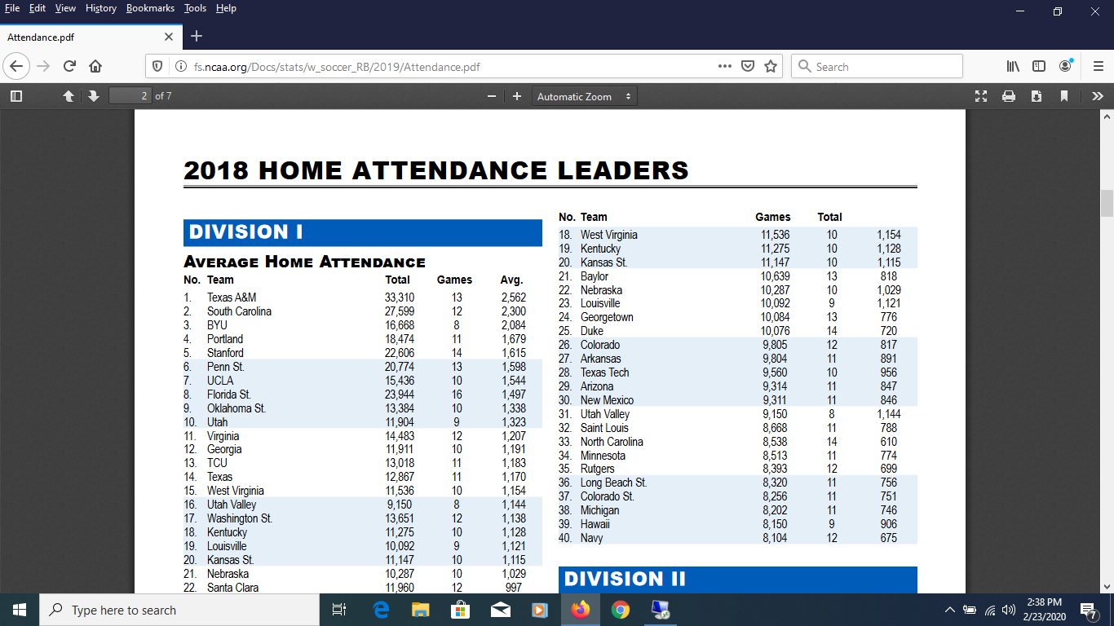

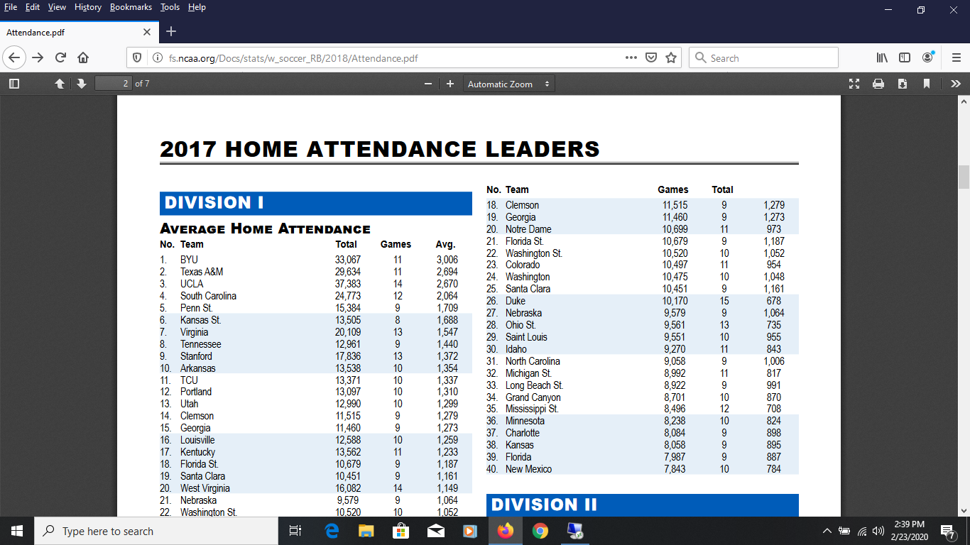

Men’s Soccer Attendance NCAA
