Equipment Guide  
Feature information on hanging system

Contents

HANGING SYSTEM 2

The Track 2

Dimensions and Finish 2

RODS v. CABLES 3

Additional Image 3

HANGERS 4

Additional Image 5

USE OF HANGERS 6

Display Solutions 7

Binder Clips 7

Poster Putty 7

PEDESTALS 7

Limitations 8

# HANGING SYSTEM

## The Track

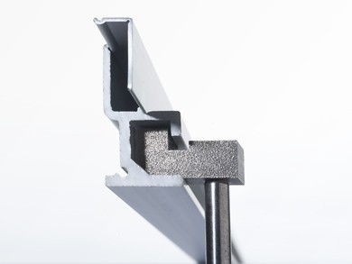**Installation:** The T-TRACK (Top Corner) is discreetly mounted at the top of the wall, where the wall meets the ceiling.

**Supplier:** Absolute Museum and Gallery Products

**Color:** Silver

**USE:** T Track is very easy to use, enabling artworks to be hung from clips inserted at any point along the track, and suspended using a choice stainless steel cable or rod.

### Dimensions and Finish

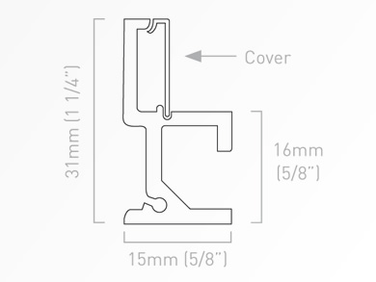T Track is an anodised aluminium extrusion that is available in either soft silver finish or white and comes in lengths of 2.5m. The track has a total vertical height of 31mm x 15mm depth. With the cover only 16mm of track is visible. The track comes pre-drilled for fixing at 300mm intervals which will suit the majority of installations. It is easy to cut to length on site if needed. Note: There is a slight widening to allow for the top blocks for the hanging sets to be inserted 100mm in from one end, the track should be trimmed from the opposite end.

# RODS v. CABLES

The Cadman Art Gallery Uses the following systems that support the flush mounted track

|  |  |
| --- | --- |
|  | **Quantity - 40**  **Stainless Steel Rod**   * Provides the most rigid installation * Available in silver * Support artworks up to 50 kgs (approx. 110 lbs) * Length 1500/2500 mm * Best used to support heavy art |
|  | **Quantity - 35**  **Stainless Steel Cable**   * Provide the strongest flexible cable system * Available in silver * Support artworks up to 35 kgs (approx. 75 lbs) * Length 1500/2500 mm * Best used to support light weight | |

## Additional Image

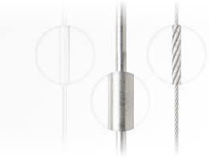

# HANGERS

The Cadman Art Gallery uses the following systems to connect the artwork to the hanging system

|  |  |
| --- | --- |
| Hanger Type | Image |
| Ryman Barrel   * Hook Barrels are compatible with Wire Hangers, Sawtooth Hangers and Adhesive Hang Tags * Choice of sizes to suit load weights up to 75lbs * Barrels available for use with Rod or Cable |  |
| Hook Barrel   * Hook Barrels are compatible with Wire Hangers, Binder Clips, Adhesive Hang Tags * Barrels available for use with Rod or Cable | C:\Users\a783y259\AppData\Local\Microsoft\Windows\INetCache\Content.MSO\913E70DD.tmp |
| Push Button Hook   * Can be used for sculptures, items with grommets, tapestries * Hook is only available for use with 2mm cable | https://encrypted-tbn0.gstatic.com/images?q=tbn:ANd9GcSMtsKyQZNafVo6tNn-ulh_l940O80xI2nnHHnihxv5xo4e6_XRmw&s |
| Push Button Security Hook   * Can be used for sculptures, items with grommets, tapestries or moveable objects * Hook is only available for use with 2mm cable | https://encrypted-tbn0.gstatic.com/images?q=tbn:ANd9GcTplJlvLRbz1AQy-Phso600Y9nmehFKJ6m6AAqufR5sIYYwM-iJfQ&s |
| Track Anchor   * The anchors are used to attach the rod and/or barrel to the track system. * The track anchor for the rod screws to the top of the rod * The track anchor for the cable, the cable slides into the hole at the top of the anchor | https://www.artdisplay.com/resize/Absolute/Hanging%20systems/flushmount-top-block-for-ca.jpg?bw=550&w=550&bh=550&h=550 |

## Additional Image

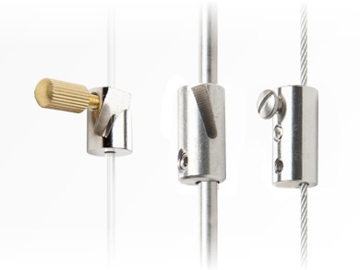

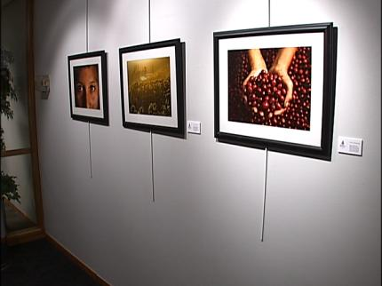

# USE OF HANGERS

|  |  |  |
| --- | --- | --- |
| Different type of hangers | Stainless Steel Wire | Stainless Steel Rod |
| **Ryman Barrel** | **No** | **Yes** |
| **Hook Barrel** | **No** | **Yes** |
| **Push Button Hook** | **Yes** | **No** |
| **Push Button Security Hook** | **Yes** | **No** |

# Display Solutions

## Binder Clips

* 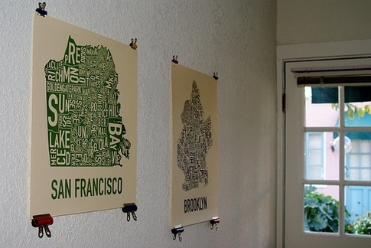Binder Clips can be used with Hanging system, nails
* Easier Installation
* Light weight solutions: mat board, foam, photos, sketch etc.,
* Not Recommended for Heavier Pieces

## Command Damage Free Hanging Strips

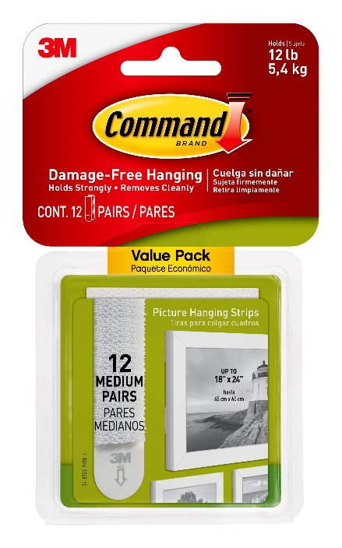

* Command Velcro Damage Free strips offer a simple solution for small framed items without hanging wires.
* Can be used in the Main Gallery and Looking Glass
* Easy installation
* Light weight solutions: mat board, foam, premade canvas
* Not recommended for heavier pieces

## 

## Poster Putty

* 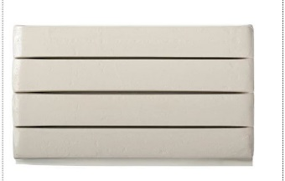Main Gallery and looking Glass
* Used to affix labels to the wall
* Not a solution for attaching artwork to the wall

## PEDESTALS

* 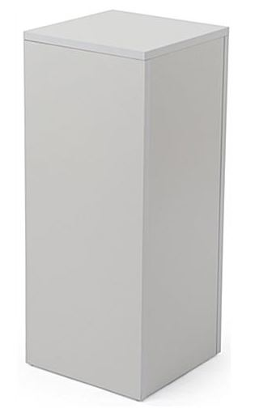3D sculptures/ ceramics should be presented for optimal viewing on a pedestal.
* Consider the placement of pedestals and how they influence the way that the audience walks through the space.
* 3D artworks can also be displayed on the floor, however artworks are unable to be hung from the ceiling in the gallery.

# Limitations

|  |  |
| --- | --- |
| No Screws | http://pngimg.com/upload/screw_PNG3033.png |
| Installations require special requests and planning, including hanging from the ceiling | http://www.artbusiness.com/1open/images/0709107.jpg |
| Shelving may be installed in the main gallery with the advisement of the gallery supervisor. No Screws. | http://cdn.instructables.com/FYG/P82U/GQ5PYNUU/FYGP82UGQ5PYNUU.MEDIUM.jpg |
| Looking Glass, must use the hanging system | Image result for absolute hanging system hook |