ClinCard by Greenphire

What is Greenphire?
  - Simple and streamlined solution for making payments to project/research participants using a WSU branded debit card

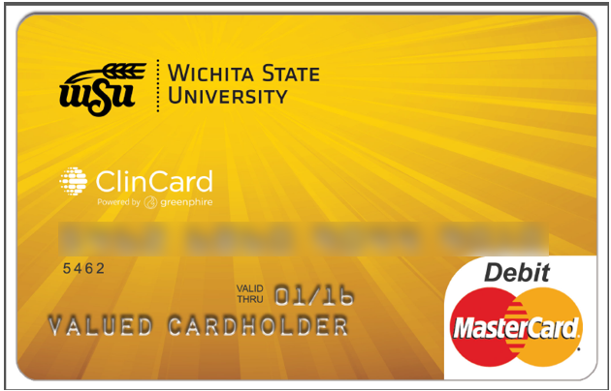

What are the benefits to using Greenphire?
  - Participant personal data controlled by the project/research group
  - Participant personal data held in a secure Greenphire database
  - Participant payments controlled by the project/research group
  - Reduction in administrative workload
  - Excellent reporting

How can I start using Greenphire?
  - Identify the project/study and funding source
  - Complete the Study Request form and email to ma.wsugreenphire@wichita.edu
  - Identify staff to have coordinator access in the Greenphire system
  - Participate in a brief orientation
  - Begin using Greenphire

How do I make a payment using Greenphire?
  - Register participant in Greenphire
  - Assign a ClinCard debit card to the participant
  - Select a payment amount to load on the debit card
  - Distribute debit card to the participant

What information do I need to collect to register a participant in Greenphire?
  - Name of participant
  - Social Security Number
  - Address/City/State/Zip/Country
  - Date of Birth (for card verification purposes)
  - Email address and cell (both optional)

How do I learn more and start using Greenphire?
  - Contact Kristie.Courtney@wichita.edu for more information!

