2020 Wichita State University Kansas SBDC
Existing Business of the Year
Connie’s Mexico Café
Owner: Carmen Rosales

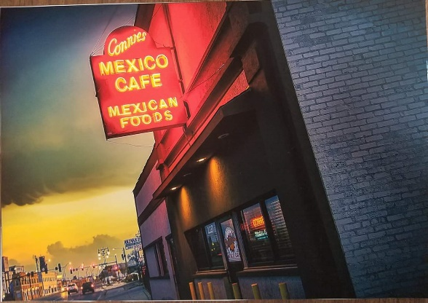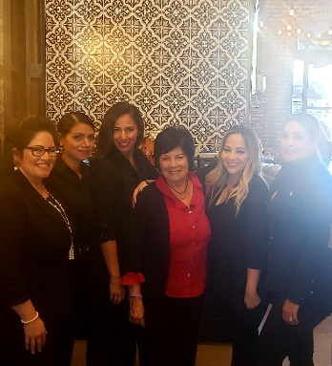

There are no shortages of restaurants to choose from when you visit Wichita, Kansas. From fast food to fine dining, you can always find something to sate your appetite. One place in particular, nestled on a side street near interstate 135, is Connie’s Mexico Café.

Carmen Rosales is the proprietor of the oldest Mexican café in Wichita. Connie’s, having been in business approximately 60 years, serves the Wichita area with delicious dishes ranging from quesadillas and enchiladas to their famous king-sized burritos. Connie’s is not just well-known for their food, but being a family business, they also bring to the table respect for their customers, dedication, and family values.
They have always and continue to be a portal from the main stream community to the Latino community in Wichita. Connie’s is an icon of credibility and social responsibility, allowing many young people to enter the labor force by providing a good place to work and close mentorship from the owners to the employees.
Though Connie’s is well-received from locals, a lot has changed over the last six decades, and Rosales felt it was time to adapt. Rosales is nearing retirement, and with her daughters, Adele, Carla, and Carmen now taking the reins, they were eager to bring in new and exciting changes to the business while providing their mother the support she needs to successfully transition the ownership of Connie’s to her children.

“​We needed another point of view, someone to guide and direct and assist us in finding new and innovative ideas,” said Adele Jordan, daughter of Rosales. “Our restaurant has been in business since the 1960’s and things have changed since then. Changes such as digital marketing, food trucks, and food delivery services. We needed an advisor to give structure and provide resources and tools to improve.”
The Rosales family reached out to the Kansas Small Business Development Center for assistance in strategic and succession planning. Frank Choriego, Kansas SBDC advisor at Wichita State University, worked with Connie’s to create a SWOT analysis to look at the current state of the business and what opportunities were available for growth.
Choriego also brought in Kansas SBDC advisor Will Katz to assist in business valuation for Connie’s. In collaboration with the Kansas SBDC, Adele, Carla, and Carmen worked to further develop Connie’s catering department, and manage their costs and pricing efforts to increase profits. The Rosales family participated in a business transitions conference in 2018 and attended several Kansas SBDC workshops that helped the team become more motivated than ever.
“​In our strategic planning, we took a step back to analyze our expenses and discovered ways to save money and increase our revenue. Since then, our cost of goods has decreased, thus saving us money. We now have a total of 4 delivery services,” said Jordan. “[Frank] really made us take a step back to look at how the business is run as well as pushed us out of our comfort zone in expanding the business with new and innovative ideas. We now have bigger goals to reach for, such as opening a second location. Most importantly, we gained a friend that we trust with business ideas.”
You can visit Connie’s Mexico Café at 2227 N Broadway Ave in Wichita, Kansas. You can also follow Connie’s on Facebook and Instagram or call (316) 832-9636.
The Kansas SBDC at Wichita State University serves the following counties: Sedgewick, Sumner, Harvey, McPherson, Rice, Reno, Kingman, Harper, Barber, Pratt, and Stafford. You can contact the team at ksbdc@wichita.edu or call (316) 978-3193.
Kansas SBDC Advisors:
Frank Choriego
Will Katz

