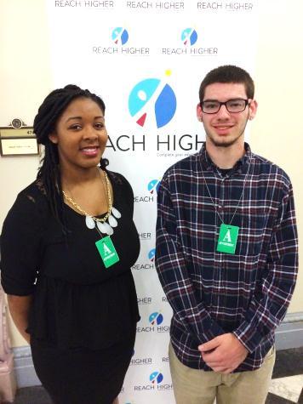
TRIO’s Upward Bound Math Science in Washington, DC
Rising college freshmen, Nikki Allums and Charles Sayer from the Upward Bound Math Science Class of 2015 traveled to Washington, DC to participate in the White House’s 2015 Beating the Odds Summit, hosted by First Lady Michelle Obama on Thursday, July 23. They were alongside 140 students that were selected nationwide to attend the gathering. Nikki and Charles took part in resource-rich panels and discussions that were designed to prepare them for the next level of their academic journey. Part of the First Lady’s Reach Higher initiative, the Summit represented a mix of youth who have overcome obstacles in high school to make it to college.
Nikki & Charles take part in the Reach Higher initiative.
Added bonus to the summit was an unexpected visit from
President Barack Obama, who addressed those in attendance at the summit.
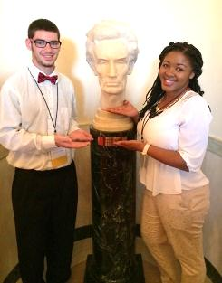
Nikki Allums, a graduate of Sumner Academy in Kansas City, KS was one of those that asked Mrs. Obama a question directly. Nikki plans to attend Kansas State University in Manhattan, KS in the fall. Charles Sayer, a graduate of Hutchinson High School in Hutchinson, KS plans to attend Wichita State University fall of 2015.
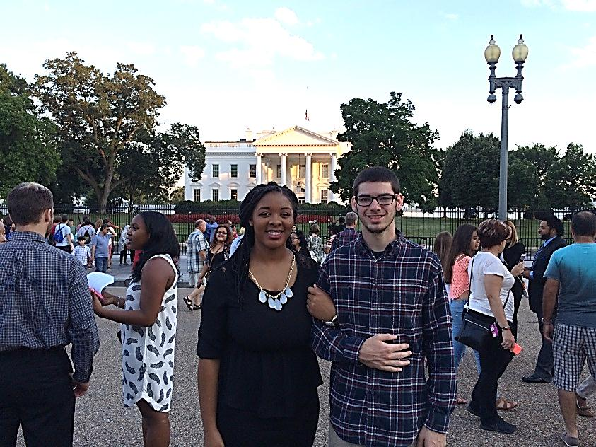
Nikki & Charles tour the White House.
TRIO Upward Bound Math Science program representatives from Wichita State University attended the 2015 Beating the Odds Summit on July 23, 2015. Upward Bound Math Science Nikki Allums, and Charles Sayer.
About TRIO Upward Bound Math Science at Wichita State University
The TRIO Upward Bound Math-Science Center is federally funded and hosted by Wichita State University (WSU) in Wichita, Kansas. With the support of WSU and the cooperation of schools throughout Kansas the program is designed to serve seventy-four disadvantaged high school students, who have and interest in Medicine, Science, Technology, Engineering and Math (M-STEM) and also have the potential to be the first in their family to attend college and earn a four-year degree. UBMS provides and academic-year program and a summer program for high school freshmen through seniors. Students are expected to participate in both components from freshman through high school graduation.

The purpose of the Upward Bound Math Science Center is to stimulate and advance interest in medicine, mathematics, science, engineering and technology, challenge students to perform to the best of their ability, provide a unique residential, academic, exploratory, hands-on experience, and encourage high school students to realistically consider the attainment of a post-secondary degree in mathematics or the sciences.”

The Center also benefits from a College Access Challenge Grant from the Kansas Board of Regents (KBOR). Many of the science projects were underwritten with the KBOR funding.

More information can be found at www.wichita.edu/ubms or contact the main office at (316) 978-3316.

