Vendor Totals by Period Guide
In Reporting Services select Vendor Totals by Period (linked)
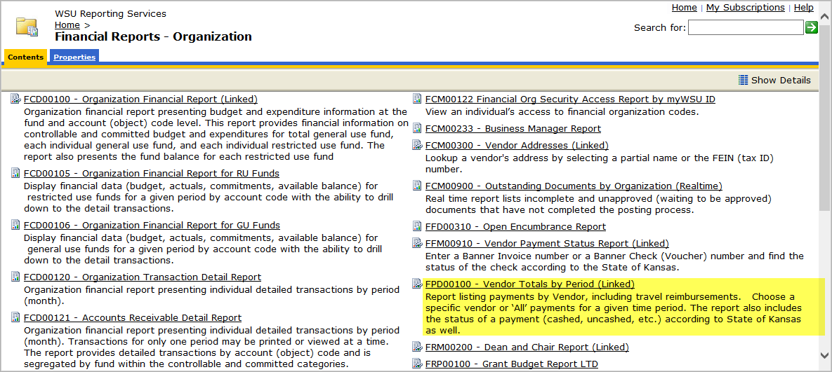
- Select a Start Date, example use the date the ICD was created
- Select an End Date, example use today’s date
- Select No for Subtotal by Vendor
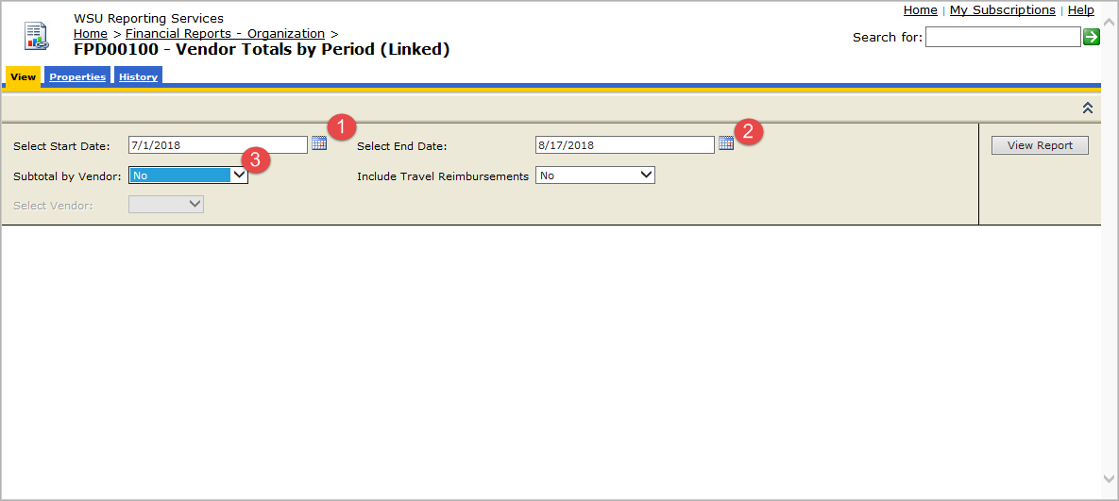
Once you have done that the Select Vendor field will no longer be grayed out (this will take a second to update) and you can search for your Vendor.
- Select Vendor
- Click View Report
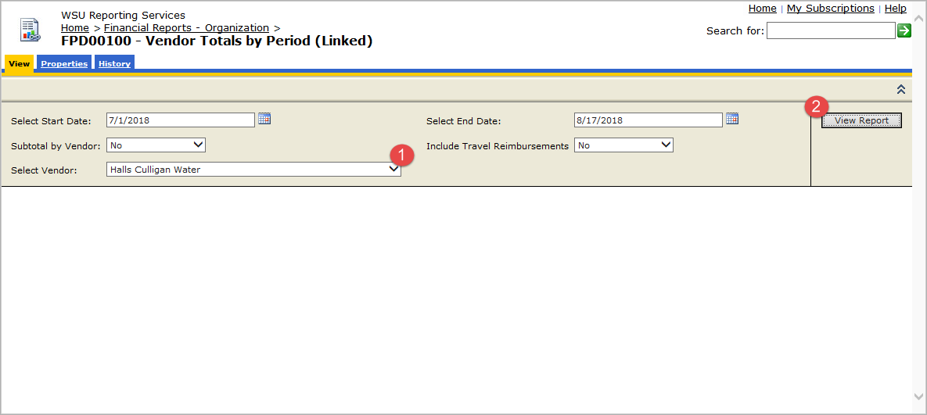
The completed report will show the State of KS check number and if the check has been cashed, below it is called Check/Recon Date.

