Finance Self-service banner 9 Handbook

Contents
Introduction 1
Access Self-Service Banner 2
Accessing the Test Site 2
Accessing the Live Site 2
My Finance Query Overview 3
Create a New Query 4
Creating a Budget Quick Query 5
Creating a Budget Status by Account 7
Reviewing Query Options 9
Approve Documents 10
View Document 13

Introduction
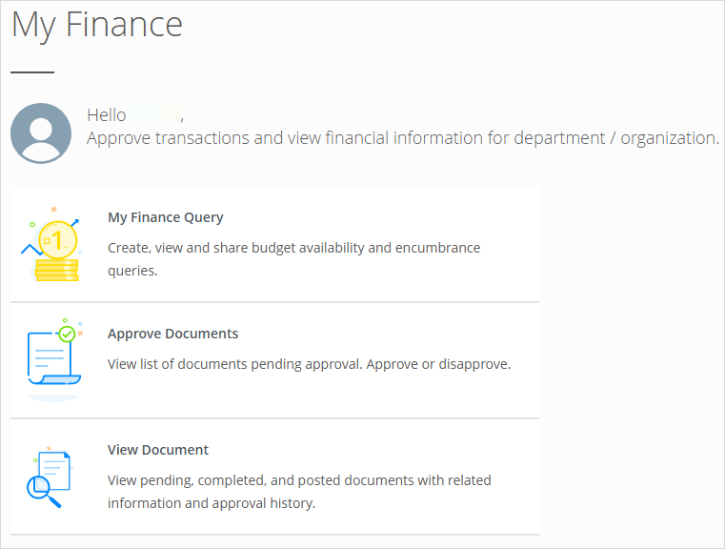
In Finance Self-Service Banner 9 (SSB9), there are three helpful modules: My Finance Query, Approve Documents, and View Document. Users can utilize these modules to create queries to view and compare budget information, as well as view, approve, or disapprove documents.

Access Self-Service Banner
There are two environments for SSB9: TEST and LIVE environments. The TEST environment is used in training sessions and by support staff. The LIVE environment should be used by all other employees for daily business operations.

Accessing the Test Site
Employees working remotely must use the university VPN to access the application. Follow the steps below to log into the test site:
- Navigate to the Admin Links page on the WSU|ITS Resources SharePoint site.
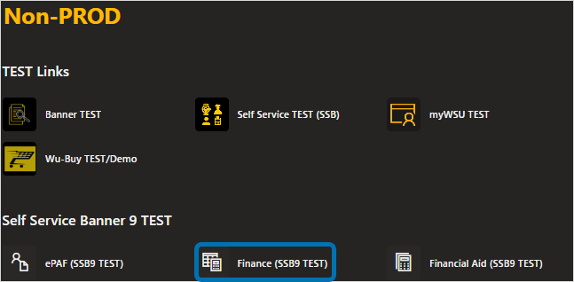
- Select Finance (SSB9 TEST) in the Non-PROD—Self Service Banner 9 TEST section.
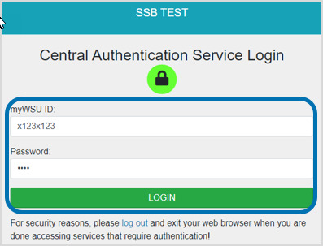
The Central Authentication Service Login pop-up screen appears.
- Enter your myWSU ID and Password, then click LOGIN.

Accessing the Live Site
Employees working remotely must use the university VPN to access the application. Follow the steps below to log into the live site:
- Navigate to the Admin Links page on the WSU|ITS Resources SharePoint site.
- Select Finance (SSB) in the Production—Self Service Banner 9 PROD section.
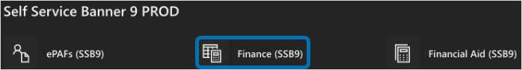
The Central Authentication Service Login pop-up screen appears.
- Enter your myWSU ID and Password, then click LOGIN.

My finance query Overview
The My Finance Query module enables users to view documents or create and share queries regarding budget availability and encumbrance.

- Click on My Finance Query from the home screen to access the query.

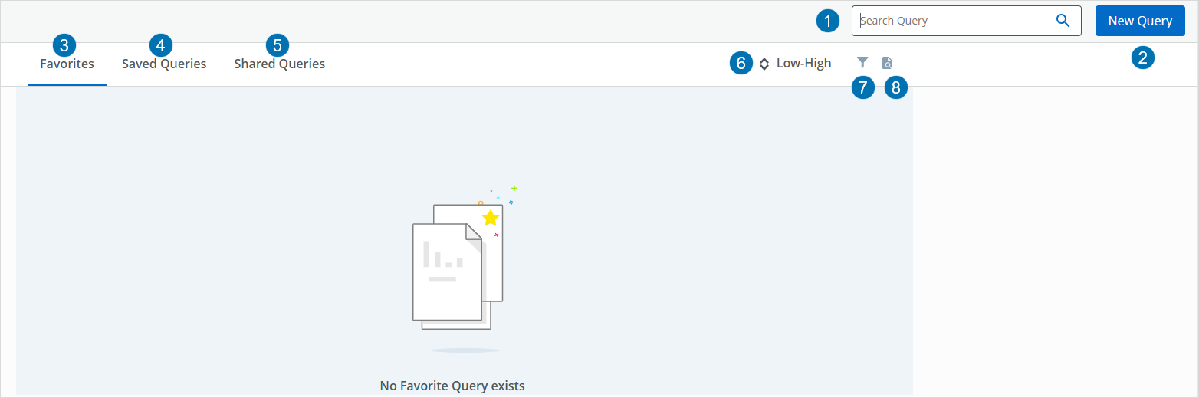
The My Finance Query screen displays Favorites, Saved Queries, Shared Queries, the New Query option and other features.

Search Query Functions
- Search Query: Search by key terms for a query.
- New Query: Create queries based on desired criteria.
- Favorites: Displays a list of queries that are used regularly.
- Saved Queries: Displays a list of all queries that have been saved.
- Shared Queries: Displays a list of queries that have been shared with users by other users within the university.
- Low-High Filter: Use the Low-High/High-Low arrows to filter queries based on budget size.
- Funnel Icon: Filter queries by Budget, Encumbrance, and Multi Year.
- Document Icon: Search for specific document(s). Provides the same functionality as the View Documents module.

create a new query
The New Query feature enables users to create budget reports based on specific criteria, allowing them to review budget information at a high level or drill down to account-level details. Follow the steps below to access the New Query function:
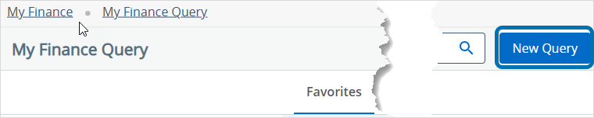
- Select New Query from the My Finance Query screen.
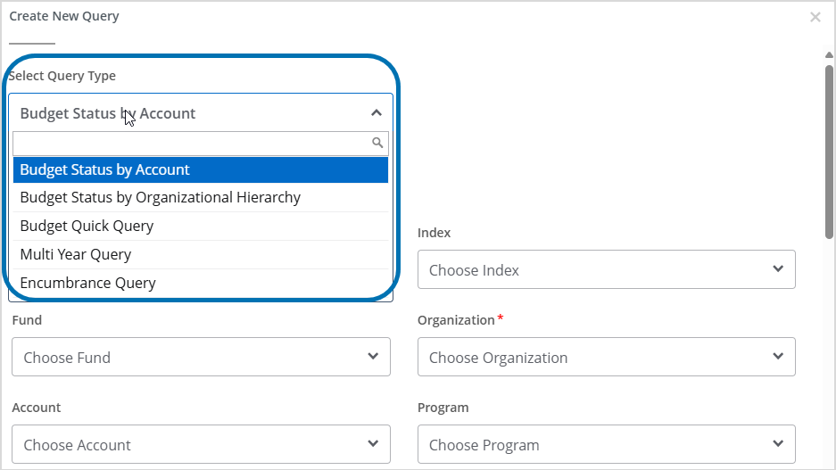
The Create New Query screen displays.
Types of Query Reports
- Budget Status by Account: Narrow search results into each account to view individual accounts (FOAPAL/values, Single Organization, Fund Type, Account Type, Revenue Accounts, and Wild-card filters supported for FOAPAL).
- Budget Status by Organizational Hierarchy: View budget information for organizations by hierarchical structure, specific funds (high-level organizations, accounts, and programs), Fund Type, Account Type, Revenue Accounts, and Wild-card filters supported for FOAPAL.
- Budget Quick Query: View current budget status. Be aware of the following:
  - Only one parameter page displays for this query. Ledger fields include Adjusted Balance, Year to Date, Net Commitments, and Available Balance.
  - Wild-card filters supported for FOAPAL.
  - Can enter the fiscal year. Data displayed is through period 14.

- Multi Year Query: View the current budget status by Grant, which displays information like the Grant Inception to Date (FRIGITD) in the Admin application. It provides a comparison of different date ranges varying across multiple fiscal years. Wild-card filters are supported for the FOAPAL.
- Encumbrance Query: View encumbrance information for the Commitment Type (all, committed, or uncommitted), Encumbrance Status, and Fiscal Year and Period.
- Select the type of query you want to run from the drop-down menu.
- Select (or enter) the values in each drop-down list in the remaining fields.

Required fields have a red asterisk * by the value title. Required fields depend on the type of query and include Chart, Organization, and Fiscal Year.



To delete a value, click the x by the drop-down menu.

- Scroll to the bottom of the query form and click SUBMIT to run the query report.

Creating a Budget Quick Query
The Budget Quick Query is a commonly used report that allows for easy viewing of budget information. Follow the steps below to view a Budget Quick Query report:
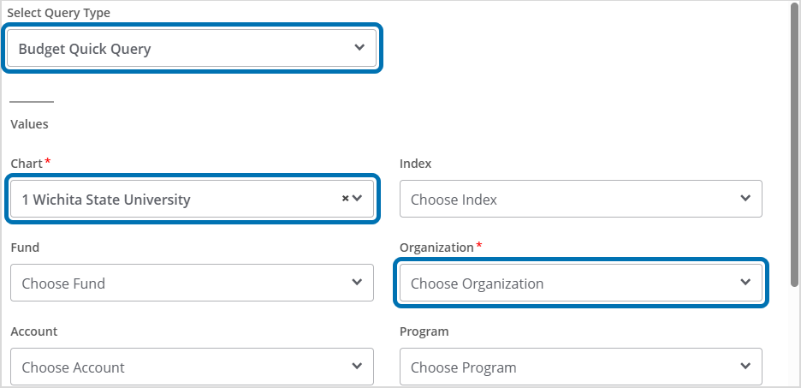
- Select Budget Quick Query from the Select Query Type drop-down menu.
The Chart value automatically populates to 1 Wichita State University, but a different option can be selected in the drop-down list.
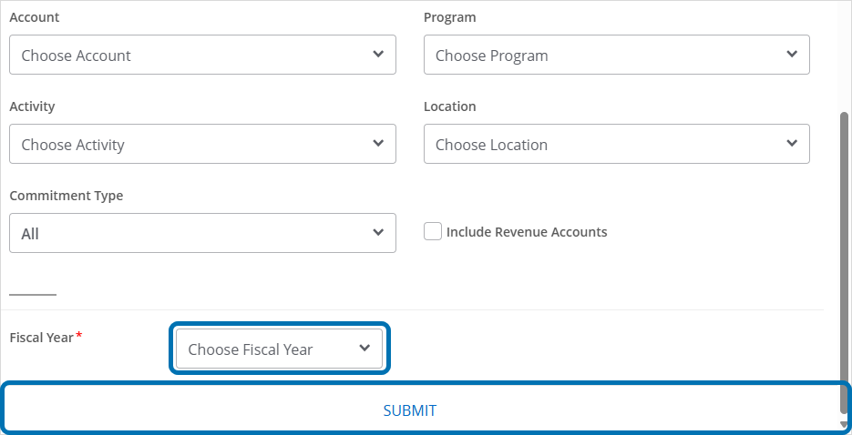
- Select (or enter) the Organization number from the drop-down list.
- Choose the Fiscal Year from the drop-down list and click SUBMIT to run the query report.
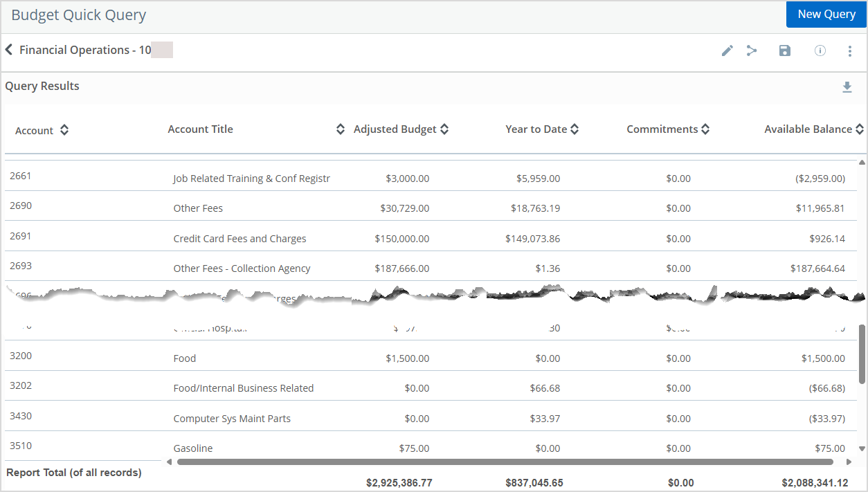
The Budget Quick Query report displays.

Creating a Budget Status by Account
The Budget Status by Account is a common report. It is used to narrow search results into each account to view individual accounts. Follow the steps below to create a report:
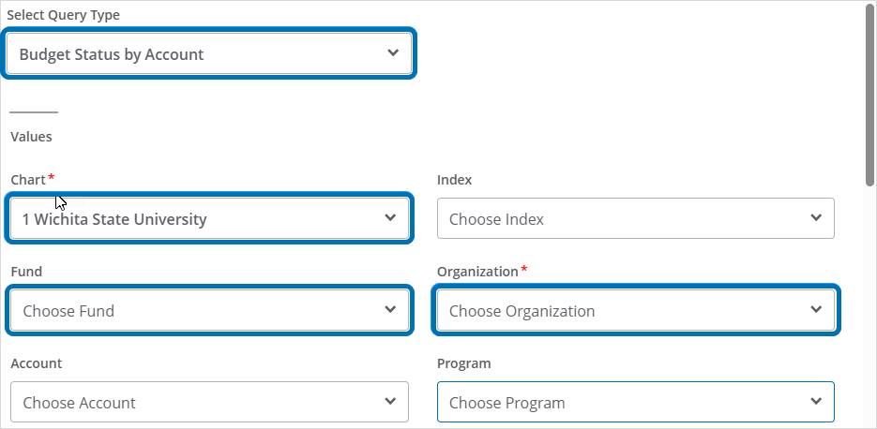
- Select Budget Status by Account from the Select Query Type drop-down menu.
The Chart value automatically populates to 1 Wichita State University, but a different option can be selected in the drop-down list.
- Select (or enter) the Organization number from the drop-down list.
- Select (or enter) the Fund type from the drop-down list.
Leave the Fund field blank to view all Fund types within the organization.
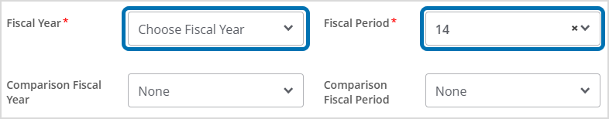
- Select the Fiscal Year from the drop-down list.
- Select the Fiscal Period from the drop-down list.
The Fiscal Period 14 is year to date (YTD).

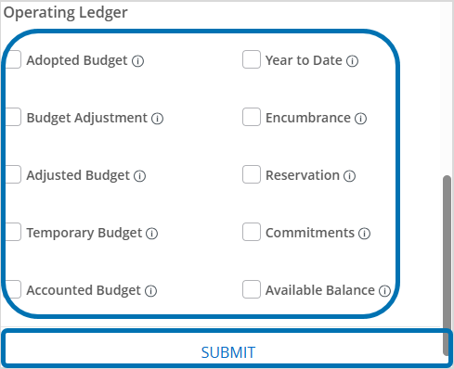
- Select Operating Ledger options to add to the query report. Each option displays as a column in the report.
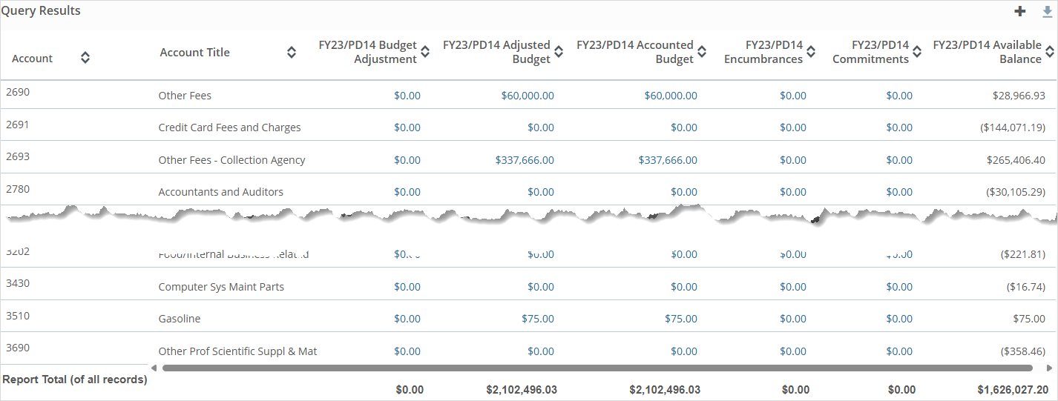
The Budget Status by Account report displays.

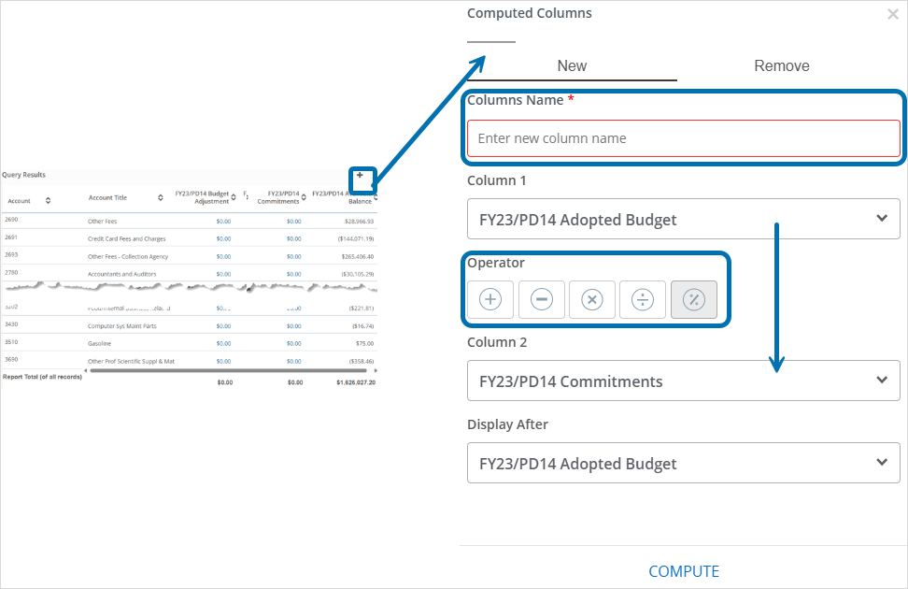
Select the + symbol at the top of the report to create a computed column that displays a comparison between existing columns.

- Click the amount hyperlink to view detailed information.

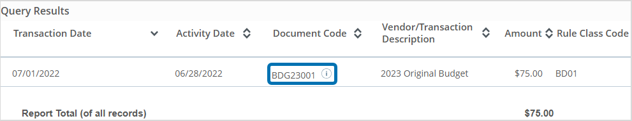
The Query Results page displays.
- Click the Document Code to view document details (i.e., invoice, journal entry, etc.) about the transaction.

Reviewing Query Options
In the Query Results screen, there are several features available that allow users to save the query, create a new query, share the query, etc. Review the features below:
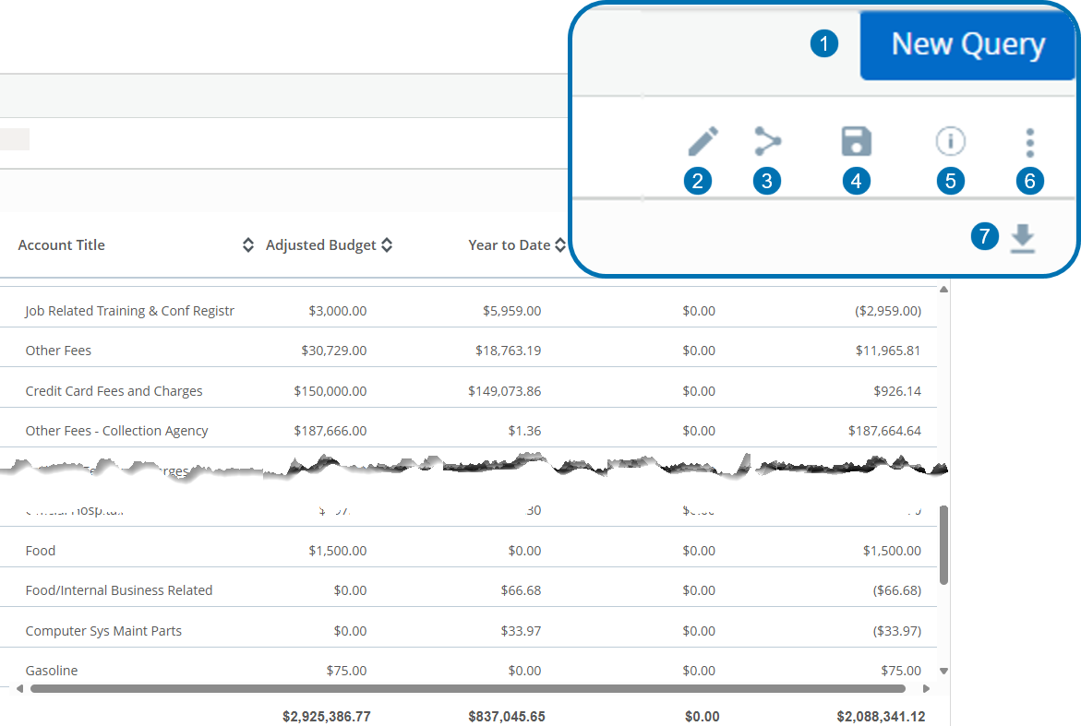
- New Query: Select to create a new query.
- Edit Icon: Select to make edits to the parameters of a query.
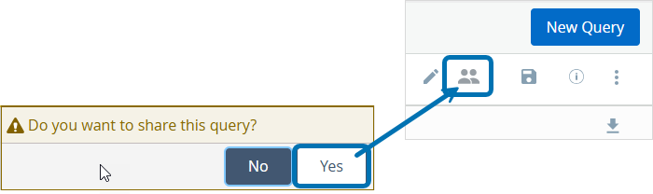
- Share Icon: Select to share a query with other university employees. The Share Icon will change to the Person Icon once the query is shared. Select to stop sharing.
Note: Be sure to name and save the query before sharing.
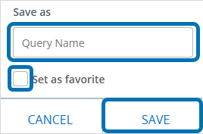
- Save Icon: Select to save a query and add to Favorite queries.
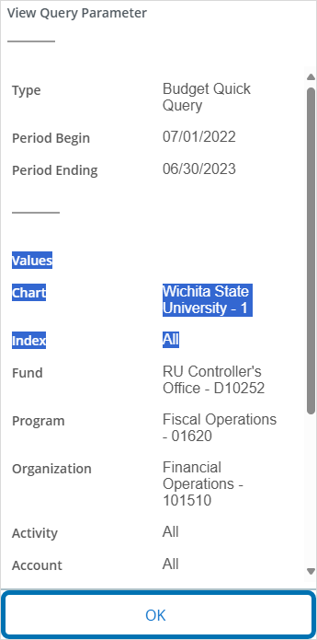
- Information Icon: Select for an at-a-glance view of the query parameters. Select OK to close.
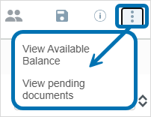
- Ellipses Icon: Select to view Available Balance & Pending Documents.
- Download Icon: Select to download the query report as an Excel file.

approve documents
The Approve Documents module enables users to view, approve, or disapprove documents.
Only documents that are pending approval are available to view in the Approve Documents module. View previously approved documents in the View Document module.

Follow the steps below to view, approve, or disapprove documents:

- Select Approve Documents from the My Finance home screen.
The Approve Documents screen displays. The User ID automatically populates.
- Enter the Document Number and click Submit.
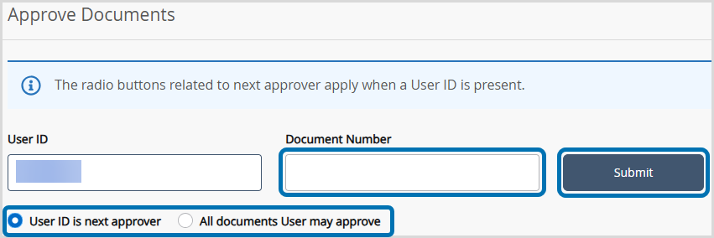
View all documents in your approval queue by leaving the Document Number field blank and select Submit.

Or
- Select the User ID is next approver to view all documents that are waiting in queue for the specified user’s approval before they can be moved to the next approval queue.
- Select the All documents User may approve to view all documents the specified user can approve even if they are not the next approver.
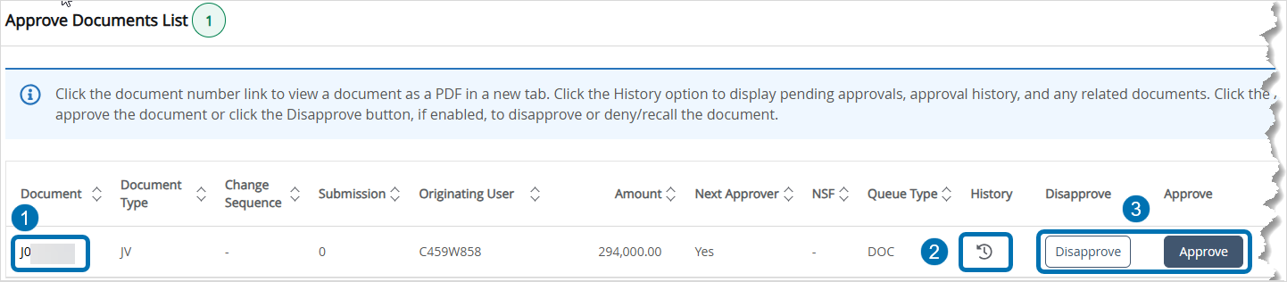
The Approve Documents List screen displays.
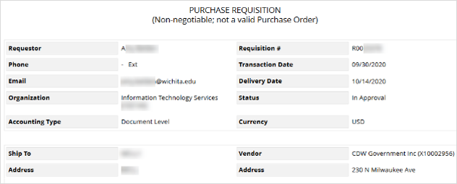
- Document Number: Select the hyperlink to review the document paying attention to vendor, commodity unit price, quantity, FOAPAL string (funding), etc.
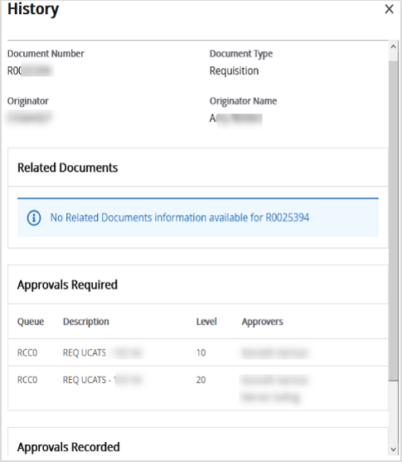
- History Icon: Select the History icon to view approval history, the number of approvals required, and any related documents.
- Disapprove or Approve Button: Select Disapprove to return the document for correction.
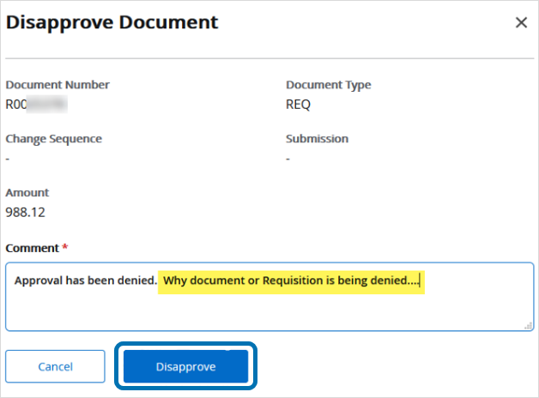
Enter a Comment on why the document is being returned and select Disapprove.
Documents can be recalled by the creator of the document. Select the Disapprove button on the approval screen to recall a document.

view document
The View Document module enables users to easily view documents, including those with pending, completed, and posted statuses, along with related information and approval history.
Table 1. Document Type Codes
Document Type Code | Document Type Description
REQ | Banner Requisition
PO | Purchase Order
INV | Invoice
JV | Journal Document
ENC | Encumbrance
CHK | Check Disbursement
DCR | Direct Cash Receipts
Follow the steps below to view documents:

- Select View Document from the My Finance home screen.
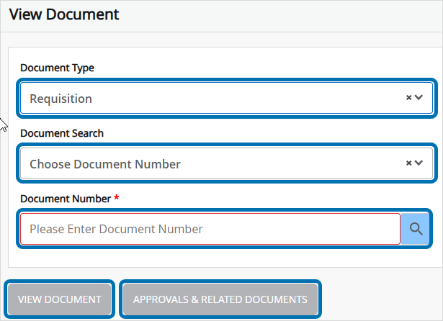
The View Document screen displays.
- Select the Document Type from the drop-down list.
Document Types: Purchase Order, Invoice, Journal Voucher, Encumbrance, Direct Cash Receipt, and Document Posting History.
- Enter the document number (or search in the drop-down list) in the Document Search field.
Or
- Enter the document number in the Document Number field.
- Select VIEW DOCUMENT or APPROVALS & RELATED DOCUMENTS depending upon the need.

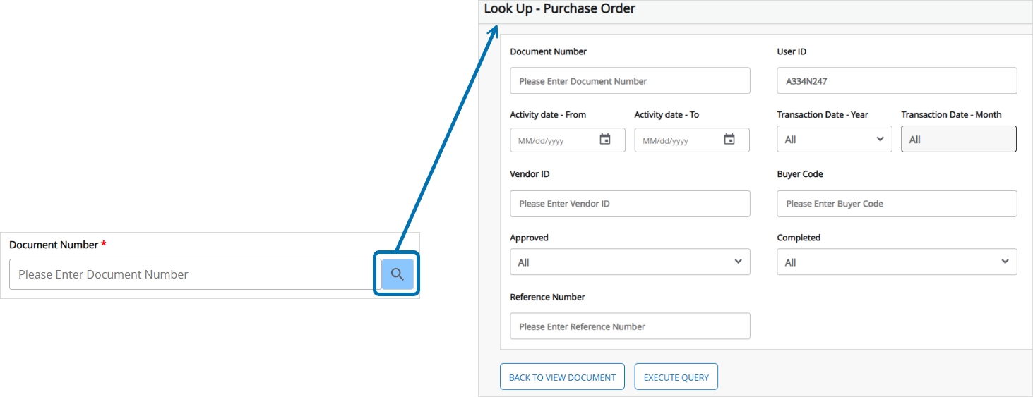
If unaware of the Document Number, leave the field blank and select the magnifying glass icon to add additional search criteria.


For assistance or questions with SSB9, please contact:
Kristie Courtney, Executive Director, Business Services: kristie.courtney@wichita.edu

Date (mm/dd/yyyy) | Modified By | Subject Matter Expert(s) | Approver(s) | Revision Description
11/20/2025 | Briana Duke | Trey Bowman | Trey Bowman & Kristie Courtney | Redid old doc. Updated screenshots and added the View Document section.
12/11/2025 | Briana Duke | Kristie Courtney | Kristie Courtney | Added a note about the additional search criteria function in the Document Number field and the list of document codes.

