
Getting Started in myWSU

What is myWSU?
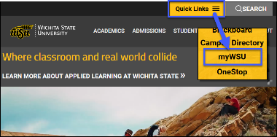
myWSU is WSU’s portal, single point of entry to web based services at Wichita State.
To login, go to http://www.wichita.edu click Quick Links, select myWSU

In the myWSU Login
- Enter your myWSU ID and password.
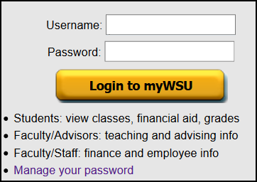
- Click the Login button.

The Faculty/Staff tab houses a variety of options for WSU faculty and staff. For example:
- Employee Dashboard: All Employees: View benefits, leave balances, pay stubs, exempt employee Leave Reports and more
- myTraining: Sign up for trainings available to WSU Employees.
- myPerformance: Complete staff performance evaluations.
- Outlook Web Mail: View WSU email online

Access Email Online
- Go to mail.wichita.edu or click on Outlook Web Apps Mail in the Employee Toolbox channel in myWSU.
- Domain: enter ad\(your mywsuID): e.g. ad\A123Z987.
- Password: your established password.
- Private Computer: uncheck this box if you are using a public computer.
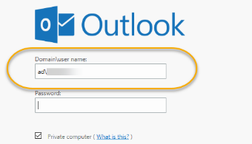

To Change your Password
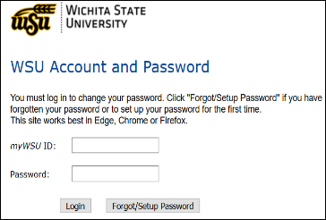
Go to http://mywsu.wichita.edu:
- Select Manage your password
- Enter your myWSU ID and current password. Click Submit.
  - Forgot Password? Leave the password box blank.
    - Click Forgot/Setup Password, Complete information requested.
- Enter New Password
- Click Change Password.
(DO NOT check the lock my password account box.)
- You will receive a message that your password was changed. Click “Close Window”.
- Exit Manage your Password.

Password Tips
- cannot be reused or shared and must include upper and lower case letters, a number, or a special character
- expires every 180 days. You will receive an email 10 days prior to the date your password expires reminding you to change it.
- On mobile devices, you will need to re-enter your password on accounts that use your myWSU ID with your new password, for example: WSU email & WSU Secure wifi.
- IT Security Awareness (ITSA) must be current before changing your password.

Having problems accessing myWSU or password management?
HELP is just a phone call away. Contact the Technology Help Desk at (316) 978-HELP, option 1, or helpdesk@wichita.edu

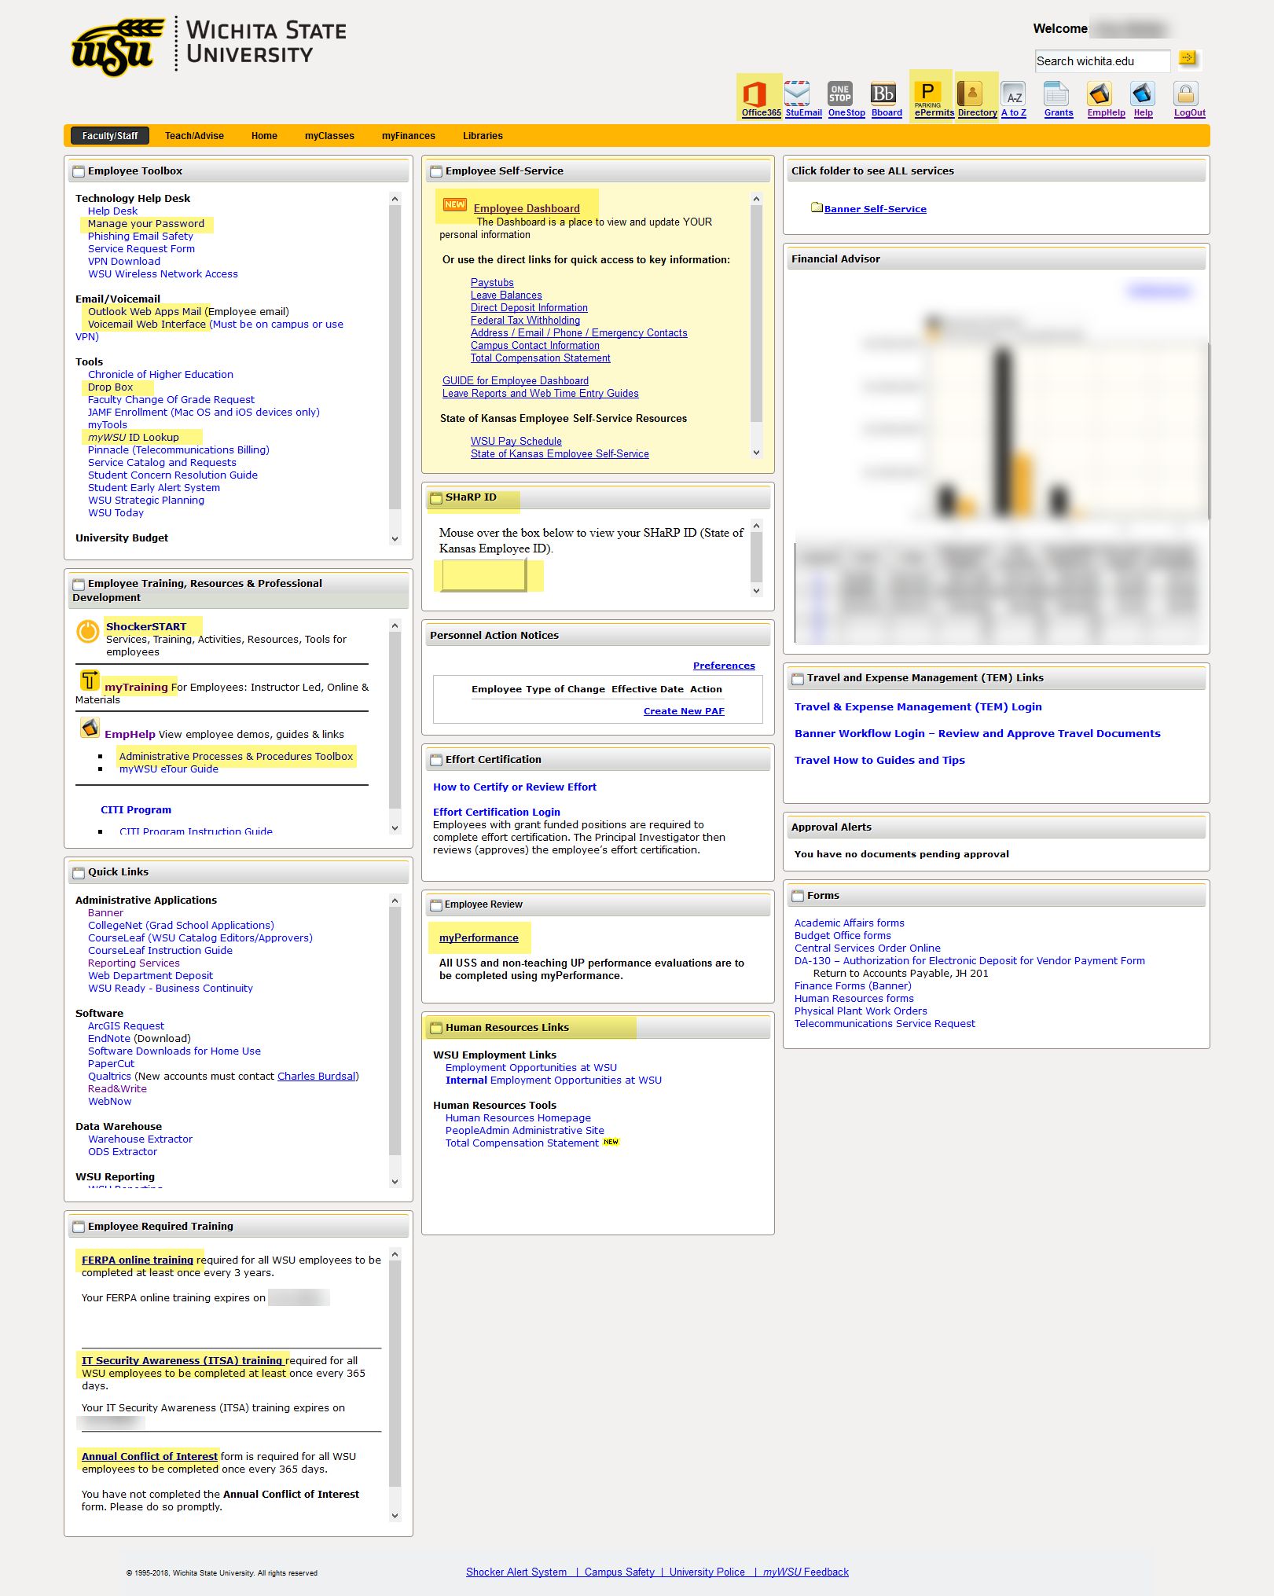
Technology Help Desk Located in Jabara Hall, room 120
316-978-HELP, Option 1 or email: helpdesk@wichita.edu
Website: http://wichita.edu/helpdesk
Check website for details and hours.

ITS Applications Training
Contact Information: 316-978-5800
Email: training@wichita.edu

Microsoft Office 365: for Home Use

About Office 365
Office 365 for WSU Faculty and Staff can be downloaded onto personal devices. For WSU owned devices, contact the Help Desk at 978 4357, option 1, for assistance.

Microsoft Office 365 contains:
- Excel
- Word
- PowerPoint
- OneNote
- OneDrive storage
- And more!

Up to five (5) installations of Office 365 are allowed on PCs, Macs, tablets or smart phones. WSU does not recommend storing FERPA protected information on OneDrive.

How to Access Office 365 Online

To access Office 365:
- Go to o365.wichita.edu
- Log in:
  - Username: your myWSUID@wichita.edu (e.g. A123Z987@wichita.edu)
  - Your myWSU ID Password

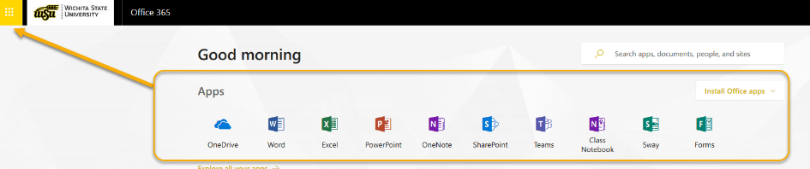
At the top of the screen, note the ability to access various Microsoft Applications online, without downloading them. These can be accessed under “Apps” at the top of the screen, or by selecting the launcher grid in the upper left.
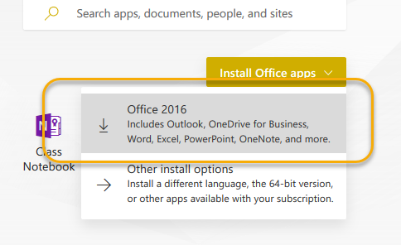
- To download desktop applications, select Install Office Apps in the upper right, and select the first option with the down arrow.
- Users may be asked to enter login credentials again upon installation.
- At any point, check the number of active installations by clicking on your initials in upper right and selecting My Account.
  - A total of five (5) installations of Office 365 are allowed on PCs, Macs, tablets or smart phones.

myWSU
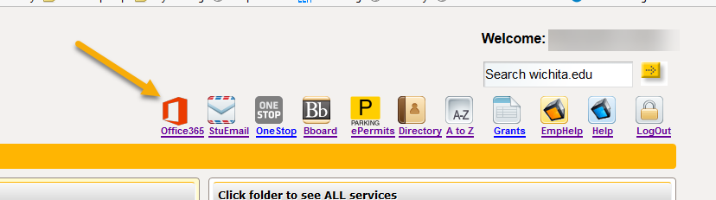
Users may also access the 365 subscription by logging in to myWSU and selecting the Office 365 icon in the upper right.

