Web Time Entry Guide
Web time entry if for those employees who enter hourly time using the self-service application in myWSU and is accessed through the Employee Dashboard

How to Enter Web Time Entry
To enter hourly time:
- In myWSU, select Employee Dashboard, located:
  - On the myFinances page for student employees, or
  - On the Faculty/Staff page for staff
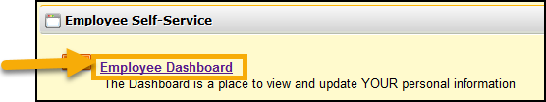
- Click Enter Time under My Activities on the Employee Dashboard
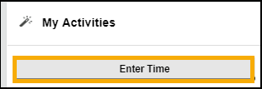
- Click Start Timesheet on the position to enter time
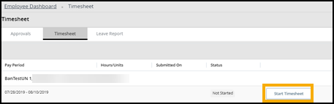
- Select the date for time entry
- Select the earn code from the drop down list
- Enter the number of hours for that date
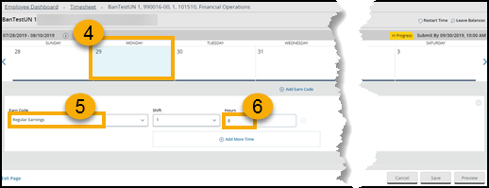
- Select the next date for time entry and repeat the process.
  - Time can be split per day by adding an earn code
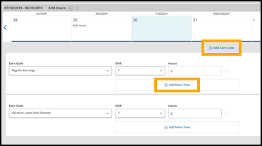
- To add additional hours from previous time periods, enter hours on the first Sunday of the pay period. Entering comments are required.
  - Use the Earn Code ‘Additional Straight Time’
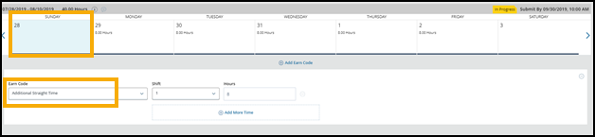
- Enter comments then click save
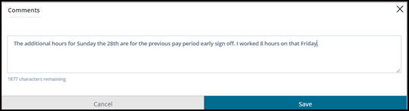
  - Comment indicator will show once comments are entered
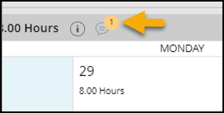
- Click Preview to view to finalize time entry
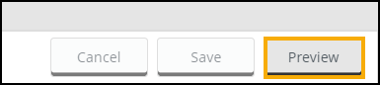
- Review time entry, Click Submit to complete time entry
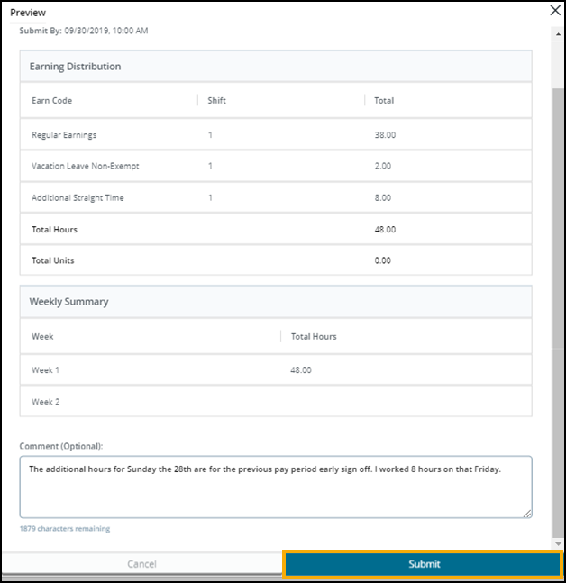
- Notification Message will indicate that timesheet has been submitted
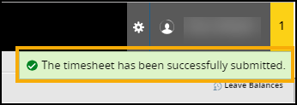

- To make corrections to timesheet or enter additional time after submitting:
  - Click Recall Timesheet
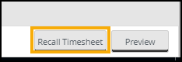
    - Notification will indicate that the timesheet has been recalled
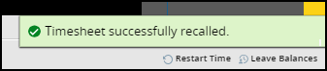
    - Comments will automatically be added to indicate recalled timesheet
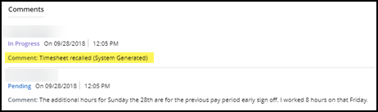
  - Make corrections or enter additional time
  - Click Preview and Submit to complete timesheet after correction are completed
Back to Top

Contact Information
- Web Time Entry Questions: Timekeeping: (316) 978-3074 or timkeeping@wichita.edu
- Application Training: ITS Applications Training: (316) 978-5800 or training@wichita.edu
- Password Assistance: Technology Help Desk: (316) 978-HELP or helpdesk@wichita.edu

Back to Top

