IT Portfolio Management with Executive Council Oversight

1. Overview
The purpose of the IT Portfolio Management policy will bring about greater:
  - Communication
  - Transparency
  - Accessibility for all stakeholders
  - Governance, all can know how the process works

The IT Portfolio Management Executive Council reviews and approves the ITS planned projects each Quarter to help achieve the University’s Mission and Strategies. They receive input from the Divisions’ Top Five and ITS who does the original prioritization and confirmed from “ITS Advisory” which will be comprised of key stakeholders and IT professionals from across the university. Greater communication with all stakeholders on Governance will also insure compliance with State of Kansas regulator changes from the Kansas Information Technology Office (KITO) on IT Projects.

2. Executive Council and Standing ITS Advisory Council:

Executive Council is comprised of individuals that have substantial functional leads related to ITS. The Executive Council has the authority to create sub-committees for the purpose of research, recommendations, and execution of directives defined and authorized by the Executive Council. It also serves as an appeal body for projects that have been denied or given lower priority, or in cases where a sub-committee cannot reach agreement on a submitted project.

Executive Council’s Responsibilities:
Ensuring IT remains aligned with the University’s Strategic Plan and Mission, including support of the Innovation Campus
Validation of the prioritized IT projects
Give new projects and recommendations to ITS
Oversight

Executive Council Membership:
Chief Information Officer, Co-Chair
Chief Data Officer, Co-Chair
Chief Information System Officer
Executive VP and Provost
Vice President for Finance and Administration

ITS Advisory Council advises on the following components of ITS projects:
- Management and customization of enterprise data systems and application development projects;
- Infrastructure technology, including servers, networking, data operations center, and the data recovery center;
- Technology and information security, including compliance to industry and governmental standards (e.g., FERPA, HIPAA, PCI);
- Technology services and customer support to campus and community partners, including support services for desktop/mobile, networking and telephone, and training support;
- Technology and services related to instructional use within classroom space and virtual instruction, security procedures and guidelines;
- Development and standards related to mobile devices and web applications; and
- Research computing technology and services related to faculty, student and community partner research.
In addition to responding to requests from ITS and the Executive Council, the group is responsible for updating their project recommendations, advising on emerging technology and best practice operations. The ITS Advisory council may suggest new technologies to be allocated in research projects.

This council is a standing committee and has a CIO selected membership, viewable on the ITS Advisory Committee website page, links from Wichita.edu/pmo.

Divisions
The Divisions of WSU play in important part in reviewing project requests before they are submitted into the process, monitoring existing in process projects, prioritizing within their many departments the Top 5 Projects to submit to ITS each quarter. ITS may select all or none of one division’s Top 5 to be included in the next quarter ITS roadmap of IT projects. The Divisions may be present and present why their projects need to be working in any given quarter to either the ITS Advisory or Executive Counsel.

Divisions are responsible to provide needed resources, funding, testing and change management to ITS projects. Examples of the Divisions are Academic Affairs, Finance and Operations, Research, Student Affairs, etc.

3. Project Submission and Workflow:

Projects must have approval from their divisional supervisor and include scope of work; articulation of importance, as it relates to the university’s strategic plan; when the project is needed to be completed and in production; and estimated cost, including budgeted source funds. If the project includes outside vendors and/or contracts, Purchasing, General Counsel and IT security review are required.

Project submissions are routed to the university’s Project Management Officer (PMO), who, in consultation with IT directors, assigns a Project Manager and Technical Lead. The PMO may change the routing of the project proposal if it is decided that it does not qualify as a project and can be executed through the IT ticket systems for immediate action. Requestor or ITS have the right to request that other personnel be in attendance when project requests are reviewed.

The ITS Advisory Council receive from ITS the project proposal list containing meta data on assessing the project’s scope, needed resources, services, staff, alignment with the university’s strategy plan, estimated timeline for implementation, and priority. ITS Advisory Council has the right to return proposals for additional content or revisions. Once the ITS Advisory completes its review, ITS will finalize recommended quarterly projects and the reports will be sent to the Executive Council. Thereafter the Division is updated on their project(s) placement.

4. Project Prioritization:

In general, the IT Portfolio will be prioritize for the university each quarter, selected from the Divisions’ top 5 projects with the IT Advisory’s input. This work will be done by the ITS Directors and CIO. Project work may still be delayed if the incidents listed below occur during the quarter:
- System malfunctions that affect campus operations
- Federal, State, Industry, or Accreditation Compliance rules change
- Executive order
- System malfunction that affects a specific unit’s operations
- New or system changes that strategically transform business practices
ITS Advisory Council, in review of submitted proposals, assign an initial project prioritization addressing any approved projects currently in implementation or waiting for implementation in the next several quarters. An additional key input will be the Divisions’ Top 5 projects, gathered quarterly. Prioritization for any project can change at any time, allowing for the criticality to system performance—including temporarily stopping implementation of current projects, based on business need. The subjective decision of the Executive Council will prevail in final selection of the next quarter’s projects. Dependent on future State of Kansas laws and the latitude given to KITO, all ITS projects may need to be reviewed by KITO before IT funds may be spent. Many projects will be in process at any given time, based on resources available. Project will be clearly typed as either Research/ Forming or Implementation or both.

Prioritization Cycle:
Week 1-10 Division submits a Project Request, identifying priority projects asap
Week 1-11 ITS gives input on fit, refines scope/cost/timelines and adds resource availability
Week 1-11 ITS Advisory group recommends, defers or returns projects
Week 11 Divisions select their top five projects for the following quarter
Week 12 Executive Committee validates projects for the following quarter

A large project may remain on the roadmap for several quarters. At any time, an emergency project may be added, which may or may not change the priorities; all changes will be communicated.

5. Project Portfolio Visibility:

The process will be accessible to WSU Faculty and Staff who are interested or who need to use it. Projects will be submitted by Divisions in a Project Request Form, which starts the process. All Requests can be viewed as they progress through the approval process; this includes Tickets by IT Managers or Directors.
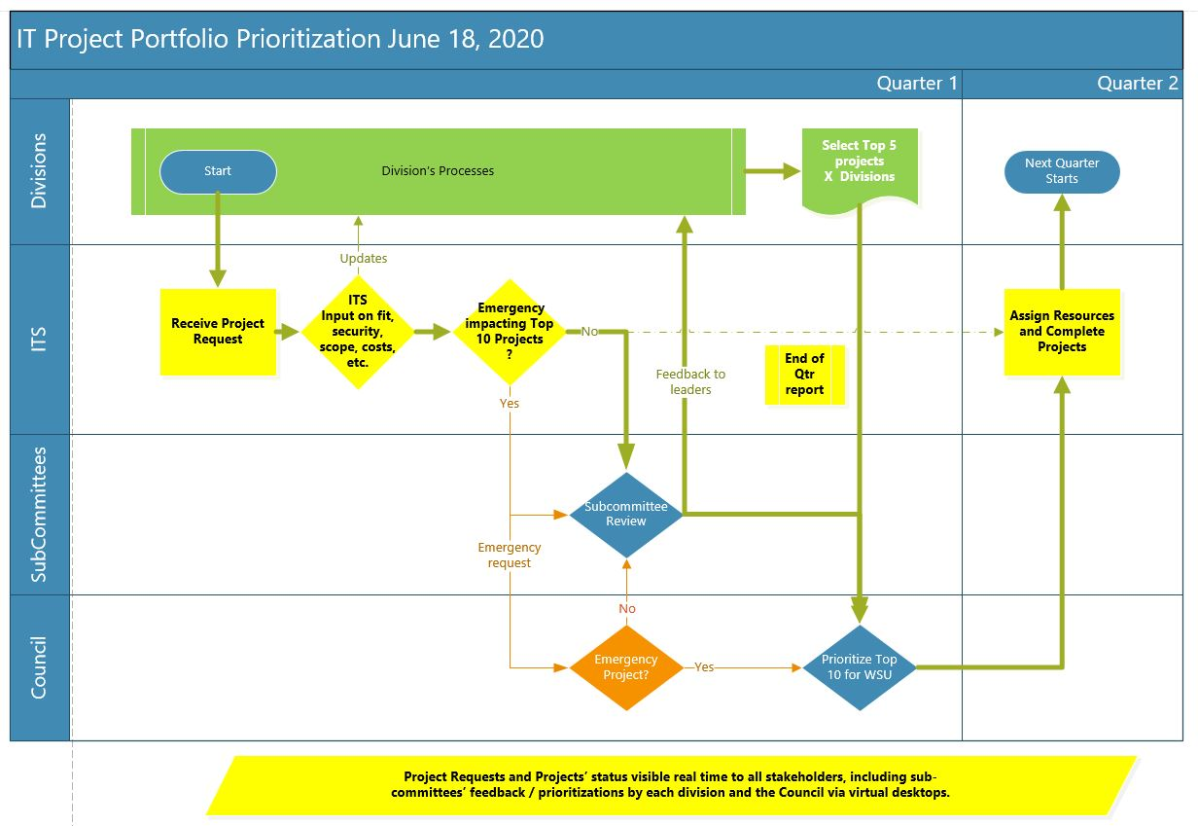

Projects will show the current implementation stage, preferably in a Kanban visual format for all projects but especially development projects. A Development Project pipeline will be updated each quarter by ITS. Summary Desktop Views of all “work in progress” projects will be shown on a graphical timeline and indicate a health of Green (good), Yellow (minor issues) or Red (show-stopper issues), signifying the likelihood of finishing on time, specification, and budget. PMO / ITS Directors will be available for each ITS Advisory meeting and for reporting needs as requested.

