How to: Withdraw from a training

Document links may not work in Firefox. Scroll down to view guide information.
Guide Contents
Logging in to myTraining 1
How to Withdraw 1
Withdraw Registration 2
Contact Information 2

Logging in to myTraining
- Start by logging in to myTraining through myWSU.
- MyTraining is in the Employee Training, Resources, Tools Professional Development section.

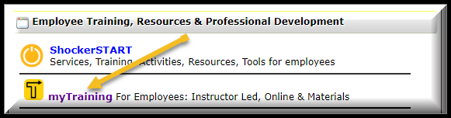

How to Withdraw
- Once logged in, hold your mouse over the myTraining Options section.
- Select myTraining Transcript

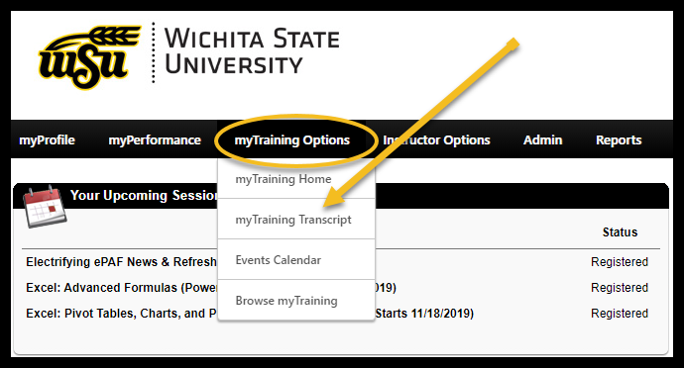

- When your myTraining Transcript with Upcoming Sessions appears, go to the training that you want to withdraw from.
- You will see on the right of your screen next to the class you want to withdraw from a black box that says View Training Details.
- Click on the down arrow in the View Training Details box.
- Select Withdraw

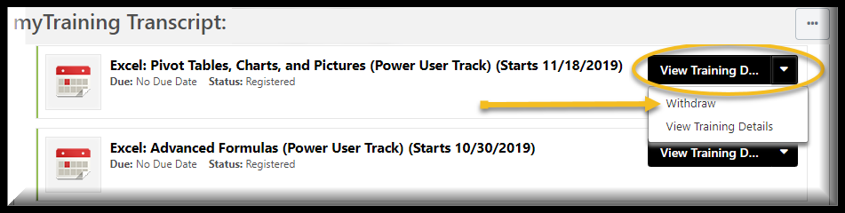

Withdraw Registration
- Verify that you are withdrawing from the correct session by reviewing the information in the Session Details section.

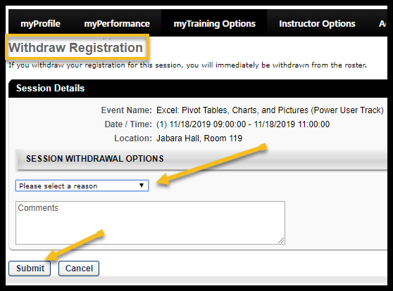

- In the Session Withdrawal Options section select the appropriate reason for withdrawing from the session in the drop-down menu.
- Leaving a comment is optional but helpful for the instructor.
- Click the Submit button to complete the withdraw process.
- Click the Cancel button if you do not wish to continue withdrawing from a session.
Back to Top

Contact Information
- myTraining Questions: myTraining@wichita.edu
- myWSU Password Assistance: Technology Help Desk: (316) 978-HELP or helpdesk@wichita.edu

