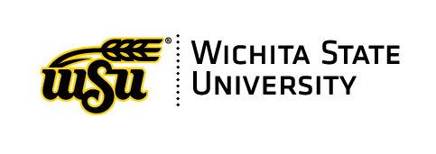
Summer 2022

Dear Instructor,

As you may have already heard, SPTEs will be retiring at the end of Spring 2023. We are in the process of switching to the Watermark Course Evaluation & Survey (CES) platform. We will be piloting CES in Fall 2022 and Spring 2023. There will be communication about the process in the coming semesters.
We encourage you to continue requesting SPTES until we make the final switch. SPTEs will still be needed to satisfy the requirements regarding the annual Faculty Annual Report (FAR), Tenure & Promotion or post-tenure review.
Here are some benefits that come with CES:
- Evaluations will be integrated into Blackboard.
- Easy to use for both faculty and students.
- Results will be accessed online. Paper results will no longer be offered.
- Once CES is fully implemented and has been in use for several semesters, the previous CES results will be accessible. SPTE results will not be integrated into the platform.
- Instructors will have access to training and a dedicated website that will provide additional details about the platform and the changes made with course evaluation procedures. Both are in the development phase.
- Response rates should increase from those received with the electronic versions of SPTEs.
A couple of notable changes:
- Evaluation requests will need to adhere to the specified deadlines. Late requests will not be accepted.
- CES Results will only be available at the end of the complete semester. This keeps WSU in compliance with the KBOR policy regarding the use of a norm-based instrument.
As with all new platforms, policies and procedures may change. We will continue to keep you informed. Please note that this process will take a few years to fully implement. If you have any questions, please contact David Wright or Sandra Ranney.

Sandra Ranney
Sandra Ranney
CES Administrator

