How to record hours worked on the holiday and earn Comp Time?

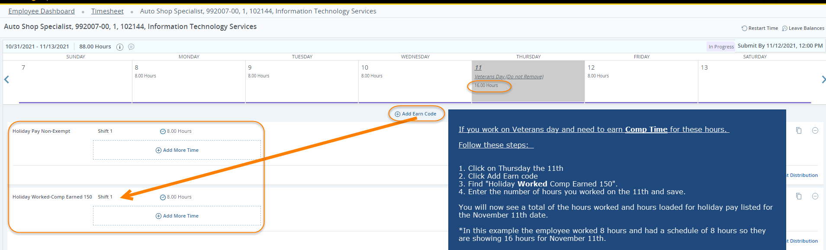

How to record hours worked on the holiday and earn Overtime?

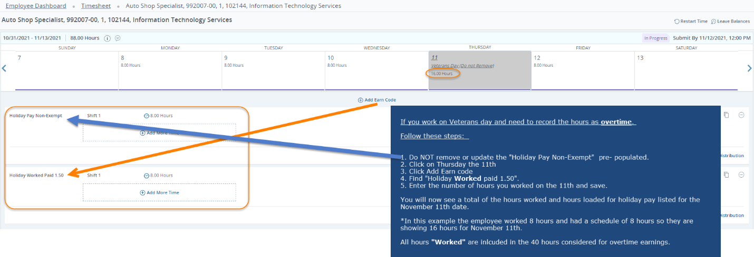

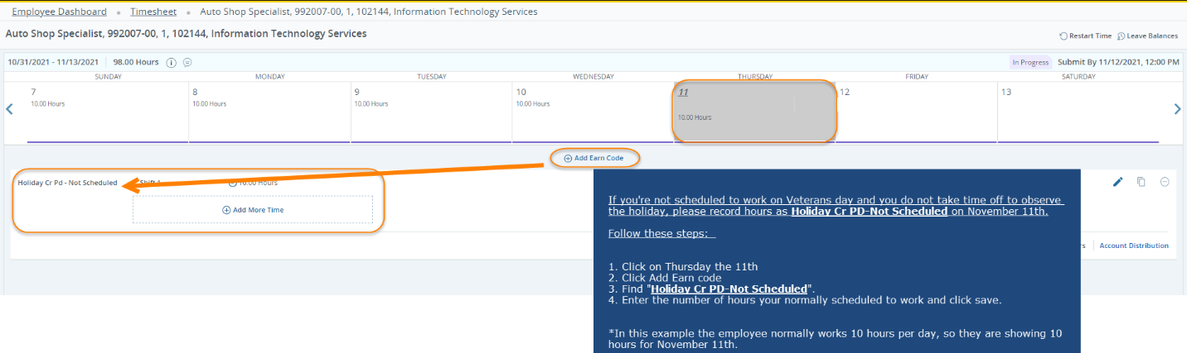
How do I earn time for the holiday if I am not scheduled to work on the holiday?

