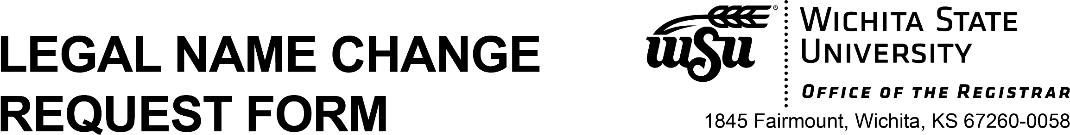

Legal name changes must be initiated by the person in question, who must complete this form and submit it with listed documentation.

Submission of this form in person requires the original documents listed below.

If submitting this form by U.S. Mail, a notary public must copy each document listed below and notarize each copy.

Requests must be accompanied by original documentation of a legal name change (certified by the court) as specified below:

* marriage license showing date of marriage and signed by minister/judge; ***or***
* divorce decree, dated and signed; ***or***
* **court order, dated and signed**

**(other documents may be accepted, but in all cases, we must be able to document the connection between both the old and new names)** *Notarized certified copies of court certified documents are acceptable.*

* **ALWAYS provide** current government-issued photo identification with new name.

The middle name of record may be changed to maiden name or previous last name if we have that name on record.

Legal name changes will not be made without proper documentation. Legal name changes will be reflected on your Student Academic Record. The above policies do not apply to minor spelling corrections.

**Complete all the information below and attach documentation:**

LEGAL NAME NOW

ON WSU RECORDS

First Middle Last

***MyWSU* ID #** Date of Birth

Mo/Day/Year

|  |  |  |  |
| --- | --- | --- | --- |
| CHANGE NAME TO: |  |  |  |
|  | First | Middle | Last |

**Have you submitted an AFD (Application for Diploma)?** Yes No

**If not, are you planning to order a replacement diploma?** Yes No

**I want my Wichita State email address CHANGED to reflect my new name.**

I affirm that the above information is correct, and that the change requested is for myself:

Signature Date

Phone# Email Address:

10/16/2025