Approving Changes in CLSS Workflow

1. **You will receive an email from CLSS when changes are submitted to workflow that require your approval:**

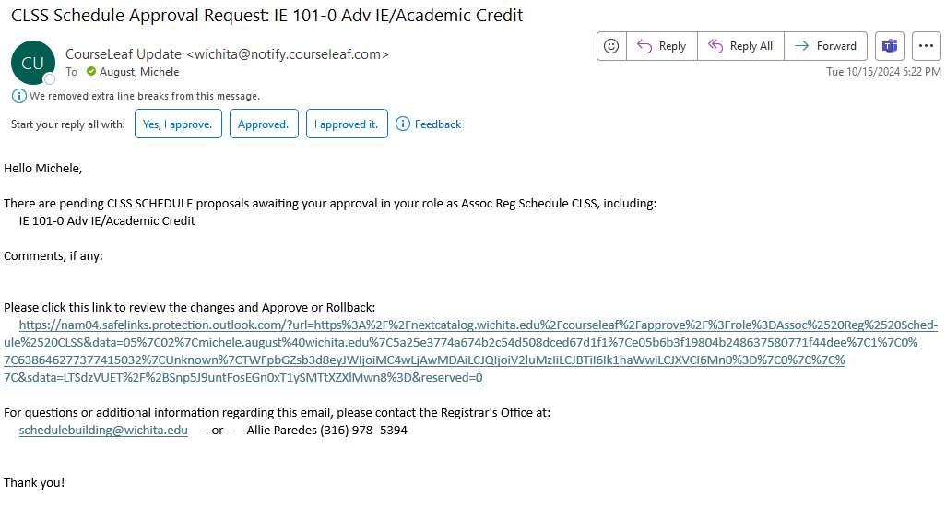

1. **Click the link to go to the CLSS Approval page:**

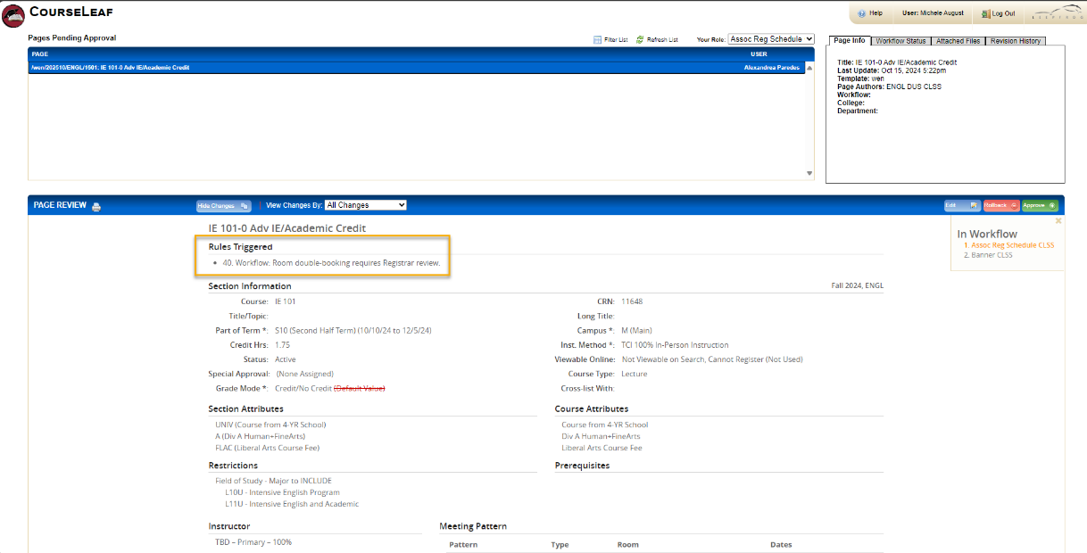

This page shows you what changes have been made that are awaiting your approval. Pay particular attention to the Rules Triggered list at the top of the page and any red or green markup within the document. Items underlined in green are new while those crossed through in red are what was changed.

1. **You can either approve, rollback, or edit:**

**A screenshot of the three buttons labeled edit, rollback and approve.**

1. **Approve**

Click the green Approve button to Approve. This will send the approval to the next step in the workflow.

1. **Rollback**

Click the red Rollback button to roll the changes back to a previous approval step or to the initiator. Choose the role you want to send back to. You will need to enter a comment in the Comment/Reason box to continue. **Be very specific in your reasoning for rolling back in this comment section.** Make sure to be as specific in the comment as possible. Include your name or initials.

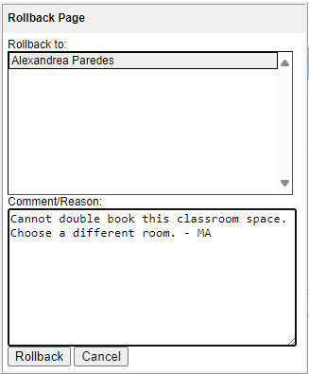

1. **Edit**

Click the blue Edit button to make changes to the section. This will open the Section Editor where you can make changes directly to the section and save. You can approve after making your changes.

**Workflow Steps**

Workflow steps are listed under the approval buttons. This shows what steps are required in the workflow. The current step is in orange, previous steps are in green, and future steps are in gray.

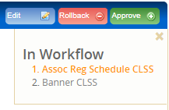

Once the request has gone through all the steps in the workflow, the initiator (department schedule builder) will receive an email notifying them that the changes have been approved and have been made.