University Staff Senate
  - September 20, 2022 | 3:30pm-5:00pm | Zoom

Attendance: Denise Gimlin, Kennedy Rogers, Naquela Pack, Rachel Tuck, Jason Bosch, Katie Austin, Amy Belden, Erin Shields, Pamela O’Neal, JaNeshia Wilson, Jennifer Nicholson, Kendra Nguyen, Angela Aubrey, Amy McClintock, Matt Houston, Ali Levine, Marissa Kouns, Johny Buchanan-Spachek, Sara Rue, Vicki Forbes, Stacy Salters, Cheryl Miller, Teresa Moore, Jessica Pierpoint, Anne Marie Brown, Lisa Clancy
Not in Attendance: William Fulls, Carrie Henderson, Randy Sessions, Jeswin Chankaramangalam, Gabriel Fonseca
Guests: Rick Muma, Zach Gearhart, Susan Martin, Vicki Whisenhant, Susan McCoy, Lauren Wilson, Lyndsay Pletcher, Allison Campbell, Mikayla Irish, Lana Anthis, Joseph Dempewolf, Francine Angell, Jerri Rogers, Bethany Uhler
- Call to Order
  - Minutes approval process – Electronic
  - Committee Reports/Updates – Submitted in Advance
- New business
  - Dr. Rick Muma, University President
    - Growing the university means we haven’t had to look at closing programs or eliminate services
    - Reminder of Strategic Plans and Goals – primary drivers of the University
    - Enrollment should be up; official numbers will be released at the end of the month
    - Slide Presentation is available: Fall 2022 Staff Senate
      - DEI Plan
        - HR will be working on a plan for staff and faculty diversity
        - 45% of our student body are People of Color; our workforce does not match that; increasing this percentage for the workforce is a major priority; for the university we should all engage around this and provide feedback about ways to improve. Review the DEI plan, get to know what is included.
      - National Institute for Student Success
          - Student retention is a challenge; retention numbers may decline a little this year, in part due to last year’s largest ever incoming freshman class.
          - Have to provide more support to our students so they stay here and complete their degrees
          - Focus is on underserved students and retention to decrease equity gaps.
          - Moral imperative to be focused around this; don’t want students to leave the university without a degree, and with a large debt. We need to help them to be successful
      - Immediate Future projects on campus:
        - Renovation of Clinton Hall to become Student Success Center for Students
          - Will move over 17 different student departments into 1 location
          - Construction delayed by several months due to need for asbestos removal
        - University Stadium
          - The stadium is very old and difficult/expensive to maintain.
          - Student athletes and visitors need and deserve a better venue
          - Potential plan to use for sports (soccer, track, area football games), activities, and entertainment.
          - Funding will come from private fundraising; may bond part of the cost. Still working on determining the full funding.
        - Addition to Marcus Welcome Center
          - Addition to the center will be paid for by private funding
          - Career Development and Shocker Career Accelerator will move to Marcus Welcome Center to show incoming students the life cycle of a student. Fits in with the applied learning focus of the university.
        - National Institute for Aviation Research
          - $51 million grant to advance research and education mission around advanced and smart manufacturing and related research; $26 million of that to be used to build the facility. Location will be east of Woosley Hall. Construction to begin next Spring.
      - Near future proposed projects:
        - A developer already has options to build on area from behind the new WSU sign down to the crash lab.
          - Determined prior to Dr. Muma’s appointment as president
          - Include potential businesses such as Jersey Mikes, a gourmet corn dog restaurant, other restaurants, an electric bicycle shop, retail area.
          - Need more people living there to support those new businesses
            - Proposal to build apartments that can be leased by students or public.
        - Additional mixed-use space to be used for conferences, eSports, campus programming, etc.
          - A place for meetings for over 1,000 people to gather in round tables
          - Interest among the developers to work with us on this
          - Would be on the water, next to the hotel.
        - P3A – ATF R&D for gun crime intelligence - will take over the building temporarily used by NetApp, plus build an additional building to the west at their cost
        - P11 – another spec building to allow for additional interest
      - Much further out projects
        - Apartments, restaurants
        - Additional areas for development interest
        - Possible interest for additional wings to the Flats if needed as enrollment numbers grow
        - Area around University Village – find people interested in being a part of this area
      - Intensive English moved to Linquist Hall
      - Wichita Biomedical Campus – working with KU on this for 4 – 5 years
        - Create a downtown health corridor
        - Transformational not just for the university but for the community
      - Shared data regarding Applied Learning earning, Research Grant award, I-35 Corridor Enrollment
    - Could we re-structure the budget to allow for a yearly/annual cost of living raise
      - Yes we could do that – but that means that if we don’t have budget increases or have cuts from the state, we would have to cut from other areas to ensure guaranteed yearly increases/cost of living raises
      - KBOR – just approved last week an additional inflationary adjustment. However, this still needs to be approved by Legislature
      - Cost of living is important but would prefer to continue investing in market pay, (as CoL does not address salary compression), and he also wants to focus on Merit based increases.
      - Don’t really have a lot of time between when we find out what money we will be getting from the legislature in June to plan before we have to have the budget in place for the new fiscal year (usually a matter of days)
        - Due to timing issues with budget, the possibility of doing mid-year raises is being discussed and then annualize them in the yearly budget.
    - Could we use centralized shrinkage to pay additional comp or bonuses for those working extra due to shortages
      - Centralized shrinkage – used it to make adjustments
        - Less shrinkage in the last several years due to less vacancies
        - Took our bonuses this last year out of this money
        - It is a challenge in that we can’t always know what we will have – if we budget 5 mil but only have 3 then the difference has to come from somewhere else, which could mean cuts from somewhere else.
    - Flexible work schedules
        - University supports this option for staff
        - Remote work or flexible schedule opportunities have to be driven at the department level
        - Unfortunately, not everyone is hearing the same information in the same way, so there is some confusion in this.
        - The president is committed to this – but recognizes that it may be a challenge in some departments, but in areas that it makes sense, it should be encouraged. New HR ED will be working on that.
    - Questions for President Muma
        - Parking at Hillside / 17th for Wilner once University Village is built.
          - Yes, this is still available – not sure how much - maybe parking garage facility or using the current parking garage or other existing parking in the area.
          - There is parking but not where we want it or know about it
        - Move in date for Shocker Success Center
          - Was estimated for Spring 2024??
          - Found Asbestos in Clinton Hall which will delay gutting the building by a couple of months – new date would be Summer 2024
        - Establishing a campus wide minimum wage for student workers?
          - Example $10 / hour
          - The new HR director will help work through this
          - Comes down to funding – University may have to make some kind of investment so that it happens
  - Susan Martin, Human Resources
    - Introduction of Vicki Whisenhant -
      - WSU Grad – class of ‘93
      - Excited for all the changes, been really great to re-connect, meet students, and looking forward to get to know everyone and excited to be working at WSU and working with the staff to address their concerns and make an already great place better
      - Shared a slide with a little of her background
      - 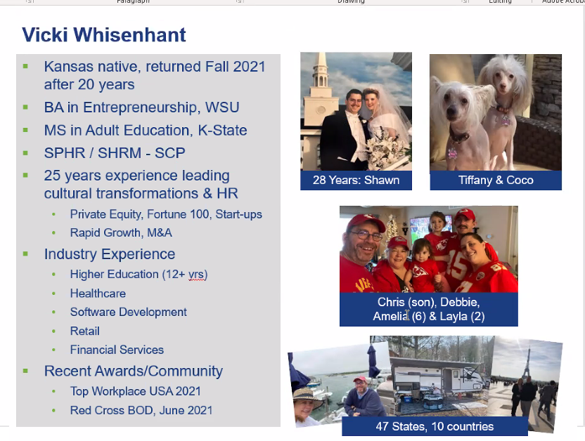
      - Majority of her focus has been in Organizational Development
      - Transformed her prior university workplace during the pandemic into one voted as a Best Place to Work
      - Style is very collaborative. She is excited to work with us on our needs, issues, and questions.
    - Will answer questions as needed and will introduce our new Executive Director of Human Resources
      - Susan updated us on MBC
        - Just about ready to close out the first annual pay adjustment cycle – just finalizing them
        - Have done a pretty big ‘road show’ on lessons learned
          - Have gotten really good, useful feedback
          - Organizing the feedback into themes and input from key stakeholders before the next cycle of MBC goes into effect
            - Work through the lessons learned and sharing once it is organized
          - Timeline
            - Cycle – so short between the timing of when we know what our budget was and when it went into effect
            - Were asked to model several ‘what ifs’ depending upon funding from the state, so that administration could see what the dollars were which may have caused some confusion
            - Already talked to Rick regarding the cycle so that they can have better input from the leaders - exploring several options
      - Flexible work schedule confusion
        - Confusion on what it is and what it really meant for the organization
        - Had some training early on but may revisit it
        - Do not hesitate to reach out to HR Business partner to help facilitate department leaders navigating between options
  - Jessica Walles resignation; new Policy Review Committee Chair
    - Jennifer Nicholson has generously agreed to take on chair of that committee
  - Appointment of a senator to replace Jessica
    - Lisa Clancy agreed to replace Jessica
      - Denise motioned and Rachel seconded to have Lisa Clancy finish out Jessica Walles’ term through June 2023
      - Vote by chat – was fully approved
      - Lisa will be on the Policy Review committee
  - Stock the Shocker Support Locker Challenge
    - Naquela
      - Have 8 locations confirmed for food donations
      - Working on one last location in the RSC then will share
      - From 9/26 to 10/14 – you can donate, there will be round colored dots to place on donations that will designate if the donation is from faculty or staff.
      - Staff Senate are the ones who do the leg work on getting this challenge up and running – so let’s go STAFF!!
  - Docking Institute Survey data release delayed until November 1
    - Docking Institute release of results has been pushed back to November 1st
      - KBOR schools will all publish at the same time - some were not ready so the date was pushed back
    - A lot of comments – gathering them together into themes
    - Hoping to pull in the individual who created a qualitative analysis of the comments last time to have her do it again if needed – Dr. Muma is talking with her.
    - Reiterated that Dr. Muma is truly listening to Staff concerns – hope to have recommendations from the Survey results to share as well after the results are released
  - Tour of Woolsey Hall
    - Friday, October 28 at 1:30 pm
    - Have an RSVP form in Qualtrics that Denise will send out to Senators
      - May limit to Senators and a few others depending on interest to limit size as needed
  - Microsoft Teams for Senate business
    - Thanks to a suggestion from Jason and hard work from Ali who set up the Staff Senate Team - Information is now stored in the Teams file
    - Denise added all the Senators to the Staff Senate team last week
    - Can do chats, save files, etc..
    - What you would normally save on the Shared drive – save in Teams now
    - Where we go to approve minutes – still Qualtrics but embedded in the Team
    - Plan is to continue to use Teams for the foreseeable future
  - Any additional questions to what Dr. Muma shared – none shared
  - Questions for Town Hall
    - Town hall is next Thursday, September 29th at 3:30 pm
    - Town hall will also include a presentation from Dr. Muma & Dr. Lefever
    - Susan Castro (Faculty Senate President) and Denise will host – and will try to have a limited script so that there is plenty of time for questions from the chat.
    - Denise & Susan did send standard questions:
      - MBC and will staff received increases in the next Fiscal Year based on the 2nd round of the study
      - Flexible work schedules
      - Holiday closedown – will administrative leave days be granted?
      - How are staff (and faculty) expected to support the increased number of students on campus, when many have taken on additional responsibilities of staff who left the U and whose positions were not (or have not yet been) filled? They are feeling overwhelmed already.
      - Faculty – concern about what happened at Emporia State University – tenured faculty especially is very concerned…
      - Free speech in relation to pronoun policies
      - Technology related questions
      - Vote counts in the upcoming election – voting for people who support High Ed is a good idea
        - NOT to influence anyone’s vote
    - Email Denise any additional questions that you may have

- Committee Updates - provided in advance
  - Senate Committees
    - Awards and Recognition
      - No updates at this time; will set up first meeting soon
    - Communication and Website
      - The Communications Committee met on 9/7. Thanks to the hard work of the committee members, the Senate website has been updated with new senators and committee lists, meeting minutes have been posted in both English and Vietnamese, and notifications placed in Strategic Communications regarding upcoming meetings. Senators will be hearing from Kendra with future meeting summary communications for constituents.
    - Elections
      - No updates at this time
    - Policy Review
      - Legal shared a policy update for Policy 2.11 – Deactivation of Courses. Though it wasn’t specifically for our review (just informational), we provided feedback that will be incorporated.
    - Professional Development and Service
      - Stock the Shocker Support Locker challenge with Faculty Senate – September 26 - October 14.
  - Campus/University Business Meeting Updates – provided in advance
    - AOC (Academic Operations Council)
      - No updates at this time; meetings not scheduled yet for fall
    - Budget Advisory Committee
      - No updates at this time
    - Human Resources Meeting
      - No updates at this time – meeting not held this month.
    - KBOR Briefing
      - Our proposed peer institutions and aspirational peer institutions have been approved.
      - Woodman Alumni center will be remodeled to accommodate the merger with Foundation; Foundation funds will pay for remodeling
      - Approval for award of an honorary doctorate was granted (we must ask permission from KBOR each time we wish to award an honorary doctorate)
      - Approval granted to begin work on renovating Cessna stadium
      - Mill Levy approved
    - Legislative Update
      - No updates at this time
    - President One-on-One
      - Continued discussion of the importance of funding staff increases based both on market and cost of living, merit increases, filling vacant positions.
      - Relayed concerns staff have expressed over university growth resulting in more work in overtaxed employees
      - Discussed the need for a policy that clearly outlines how leaders can work with employees on developing flexible work schedules & remote work opportunities, and have administration support leaders choosing to allow their staff to work a flexible schedule
    - RSC Board of Directors
      - No update at this time; they meet quarterly
    - Traffic and Parking Appeals
      - The committee has processed 450 parking appeals in the first month of the semester. (!!!)
    - UPS/USS President’s Council (KBOR)
      - No update at this time; no meeting yet this month.
    - VP of Finance & Administration One-on-One
      - First meeting was mostly to get to know each other and outline our expectations for the meetings going forward. We did discuss the importance of funding staff increases, both based on market and on cost of living, and of filling vacant positions.

- As May Arise

- Upcoming Meetings/Events
  - University Town Hall – Thursday September 29, 3:30 pm – Virtual
  - Stock the Shocker Support Locker Challenge – Sept 26 – Oct 14
  - Next Senate meeting – Tuesday October 18
    - Featured Speaker will be Kevin Saal, Athletic Director
  - Check the Events Calendar for upcoming events on campus
  - Kansas Board of Regents will be visiting WSU campus October 19 – 20.
    - Susan and Denise will be having dinner with them
  - Employee Service Recognition (5-20 yrs) - October 26
    - Public event
  - Employee Service Recognition – (25+), Bender of Twigs, Retirees - October 27
    - Still an invitation only event
  - Senate Tour of Woolsey Hall – October 28th, 1:30 pm start

