University Staff Senate
  - October 21, 2025 | 3:30pm-5:00pm | RSC 142 – Harvest Room

Senators in Attendance – In Person
Krissy Archambeau, Angela Blackerby, Zachary Brown, Anne Marie Brown, Whitney Crager, Kevin Duffy, Gabriel Fonseca, Kimberly Gutierrez, Courtney Henry, Nathan Johnson, John Keckeisen, Christopher Leonard, Daniel Ludlow, Sara Mata, Sarah Mathews, Susan McCoy, Jacob Mendez, Kendra Nguyen, Jessica Pierpoint, Margaret Rees, Sadi Roberts, Stacy Salters, Kelley Smetak

Senators in Attendance – Virtual
Corby Redington, Kennedy Rogers

Senators Not In Attendance
Trang Bui, Angie Linder, Lyndsay Pletcher, Aaron Coffey, Chukwunenye Nweke, Monica Bergkamp, Jennifer Eastham

Guests
Katherine Johns, Roberta Swanson, Autumn Bennett, Abigail Burgess, Traci Taylor, Amanda Rose, Amy McClintock, Lisa Clancy, Melanie Tidball

- Call to Order
  - Approval of Minutes – Electronic
    - Motion to approve, Gabriel Fonseca, Daniel Ludlow seconded. Motion passed.
  - Announcements
    - First Gen Week is November 3rd-22nd
      - Faculty/Staff Social at WSU Connect
    - Don’t forget to do your open enrollment, due October 31st
    - Service Recognition events – looking for volunteers
    - WSU CEI Open House on 10/23 from 3:30 – 6pm

- Old Business
  - Update on Staff Senate Logo Update – Communications Committee
    - The communications committee has been working with Strat Comms for a logo design
    - They are in the process of getting templates and style guides created and will be available to the senate once they are available
    - Plan on having on the new STRIVE tshirts.
- New Business
  - Finance and Administration Update and Presentation – VP David Miller
    - Wichita State is an affordable research institution, we are the lowest cost research institute compared to other research institutions.
    - Student Retention – we’ve made some strong strides in student retention.
    - Applied Learning – we are really seeing that come to life
    - Research – the university is emerging as a research powerhouse
    - Healthcare – Wichita biomedical center will be a prominent fixture in the community
    - A growing campus – we continue to grow as an institution with private-public partnerships.
    - Challenges
      - State Operating Support – has been frozen the last several years.
      - Compensation – SGF Fund represents 13% of our budget, increases for all other positions must be covered through cuts & reallocations/tuition & fee charges or research/grant growth
      - Tuition rates – competitive pressure to keep rates slow
      - Enrollment – declines in international student enrollment
      - State & National funding support – experiencing broad changes in federal and state funding support for higher education
      - Campus challenges – Financial issues that may arise
    - Questions
      - With all the building changes (renovations, etc) how is that impacting finances (example Grace Wilke). – overall there is not enough space for on campus staff, so a space like Grace Wilke is a great staging location for construction projects, etc.
      - What is being done to be sure that we won’t have to cover the financial issues that may arise? – Provost is focused on ensuring that all colleges are managing budgets accordingly to ensure that there aren’t any issues that may arise that previously would need to be covered by the university. Having more detailed discussions than we have had in the past.
      - What is something you are optimistic about? – Truly believe that Wichita State is coming into its own, we offer a lot of things that are unique compared to other institutions.
  - Awards Committee Proposal
    - The committee has been working on putting processes down on paper and ensuring they are listed in the Senate’s governing documents.
    - Updates
      - President’s Distinguished Service Award
        - Wanted to define who is eligible/ineligible for the President’s Distinguished Award.
        - Clarifying whether an individual can win an award multiple times (timespan of when they can renominated or win again)
        - Wayne Carlisle can only be won once.
        - *Question on “permanent employee” classification and whether they would be eligible. Wording in the proposal was pulled from previous information, can look at updating to current categories.
        - *Question on rubric, are there definitions for the 1-5 ratings. Yes, there are some definitions, can add accordingly.
      - Staff Excellence Award
        - The committee would like to add two additional award categories: Applied Learning Staff and Administrative Support Staff
        - *Question – there was a rubric outlined for the President’s Distinguished Awards and the Staff Excellence Award doesn’t not have a rubric. The committee felt consistency would be important for the President’s Distinguished Awards. The Staff Excellence Award was staff senate created so felt that it was okay to have it more flexible
        - *Question – the staff excellence & engagement award, has there been any concerns with the current environment from the state perspective. The committee has checked on this and there are no concerns.
    - Motion to approve, Jessica Pierpoint, Seconded Anne Marie Brown. Motion Passed.
  - Docking Results Discussion Activity – Staff senate participated in a discussion activity to provide opportunities to provide input from the results received from the Docking Survey.
    - Appreciation
    - Work Morale
    - Wages
    - Incentives
    - Different Job/Budget Limitations
  - Open / As Arises
- Senate Committee Updates
  - Awards and Recognition
    - The award process will be starting sooner with information coming out prior to the winter break and will be implementing changes from the proposal submitted by the awards committee.
  - Communications and Website
    - The committee is working on finalizing the logo and will be working on creating a toolkit with new logos for future marketing and use.
    - 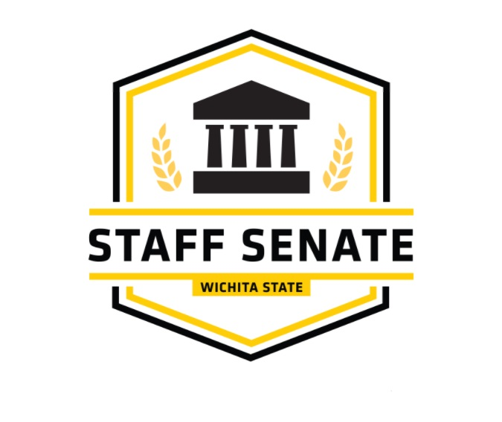
  - Elections – no updates
  - Policy Review
    - 3.15 / Internal Dispute Resolution Process: This policy is being updated to align with current practices and to clarify the requirements and limitations of the University’s Internal Dispute Resolution Process for non-faculty employees.
    - 3.20 / Recruitment, Hiring and Onboarding: This policy is being updated to clarify the University’s current practices in recruitment, hiring and onboarding, to strengthen consistency in the hiring process, and address changes resulting from the University’s transition to Applicant Tracking System software in the hiring process.
    - 5.06 / Attendance (Currently 3.55 / Attendance): This is an update to current Policy 3.55 / Attendance. The coversheet, however, indicates that this is a new policy. This is because along with the present updates, Policy 3.55 is being moved over to Chapter 5 of the WSU Policies and Procedures and will be renumbered as 5.06, as part of an ongoing project to consolidate information and policies addressing time, pay, and leave under Chapter 5. The current updates are being made to clarify the University’s attendance expectations for employees.
    - 3.41 / Separation of Employment: This policy is being revised for the limited purpose of clarifying that a representative from Human Resources must be present at an employee’s meeting with leadership for separation of employment that is initiated by leadership. This revision is necessary to ensure policies and process are followed, maintain consistency, and provide support to both leadership and the separating employee.
    - 3.46 / Veterans Preference in the Application Process: This policy is being revised to ensure compliance with recent changes in state law that govern hiring preferences for veterans and individuals with a disability. This is a compliance policy.
  - Professional Development and Service
    - History Walking Tour with Jay Price coming soon; more details will be announced once finalized.
  - STRIVE Conference
    - Feedback survey will be sent out after Winter break to start gathering ideas for training sessions at Strive.
  - Scholarships
    - We have received six applications, 4 WSU dependents and 2 staff members.
    - From Founders’ Day we received $829 for our scholarships.
  - Chair Policy and Procedures Ad Hoc Committee
    - The committee reviewed the town hall and upcoming policy revisions; while the electorate changes are expected to pass, they do not include updates to staff voting eligibility, which may warrant further discussion

- Campus/University Business Updates & Discussions
  - Academic Forum – no updates
  - Advisory Budget Committee – no updates
  - Human Resources (Joint with Faculty Senate)
    - Open Enrollment through Oct 31
    - Service Recognition in November; invitations have been sent out.
    - Tuition Assistance applications are open for Spring ‘26
    - Vicki will be presenting to Staff Senate in November with annual HR update.
  - Legislative Update + KBOR Briefing – no updates
  - Parking Appeals + Traffic Appeals
    - The parking office is rolling out new software for citations and appeals, which will make it easier for drivers to appear and will include the quiz as an option. Of the 198 citations appealed between 9/16 and 10/7, 79 have been denied and 119 have been upheld.
  - President’s Meetings
    - President approved the purchase of additional docking survey. Will be available by 2nd week of November.
  - RSC Board of Directors – no updates
  - Admins Coming Together – no updates
  - UPS/USS Presidents Council (KBOR)
    - Discussed the Docking Survey on 10/14 and started making plans for Docking presentations in December.

- Adjourn/Upcoming Meetings and Events/Shoutouts
  - September Senate Meeting: Tuesday, November 18, 2025 | 3:30pm-5:00pm | RSC 142 Harvest Room
  - Check the Events Calendar for upcoming events on campus

