Fall 2019 WSUE 102A First Year Seminar: Intro to Technology & Innovation (3 credit hours)
Classroom: John Bardo Center (Experiential Engineering) Room 338 3rd floor
Lab: Project Innovation Hub. John Bardo Center Room 105 1st floor
 |  | TR 9:30-10:45 | Hadley CRN 14386
MW 11:00-12:15 | Corcoran CRN 13838 | TR 12:30-1:45 | Wyant CRN 14388
MW 12:30-1:45 | Wyant CRN 14387 | TR 2:00-3:15 | Hadley CRN 14390

Instructors: | Samantha (Sam) Corcoran | Jennifer Hadley | Nathan Smith | Chris Wyant
Title | Engineering Educator | Engineering Educator | Lab Manager | Clinical Educator
Department | Engineering Technology | Engineering Technology | Engineering Technology | College of Applied Studies, School of Education
Office | P2 128 | Wallace Hall 305 | John Bardo Center 105 | Corbin Education Building 165
Email | Samantha.corcoran@wichita.edu | Jennifer.hadley@wichita.edu | nathan.smith@wichita.edu | chris.wyant@wichita.edu
Office hours | By appointment | By appointment | By appointment | By appointment

Course Content
WSUE 102, Introduction to Technology and Innovation, uses hands-on projects and in-lab training to guide first year students through the design thinking process in order to develop innovative and creative problem-solving skills. Teams will compete in the Koch Innovation Challenge by entering a project that addresses a specific, student-identified need in the community, third world country, or society at large. Students will demonstrate skills and knowledge gained throughout the course by working in a collaborative team, building a working prototype of their design, assessing economic and societal impact, and communicating with local industry professionals.
Student Success Content: FYS Student Success Topics will contribute to your overall achievement in this course and throughout your college career. Lessons and activities on these topics will be graded. Student Success Topics include: Study Skills, Learning Styles, Campus Resources, Campus Involvement, Information Literacy & Library Skills, Peer Coach Meetings, Career Development, Student Organizations. Campus Read Convocation, Volunteer Projects.

Definition of a Credit Hour
Success in this 3 credit hour course is based on the expectation that students will spend, for each unit of credit, a minimum of 45 hours over the length of the course (normally 3 hours per unit per week with 1 of the hours used for lecture) for instruction and preparation/studying or course related activities for a total of 135 hours.
TRANSLATION: for each class session you will be expected to spend 3 hours of your own time on coursework for this class.

Required Texts/Readings Textbook
Text: How We Got to Now: Six Innovations that Made the Modern World by Steven Johnson ISBN 9781594633935
Supplies: Bound Notebook such as a composition book
All other course materials including videos are from free online sources, which will be provided in Blackboard.
- Various outside reading will be required, including the Common Read: Designing Your Life, by Burnett & Evans
- The PBS video series How We Got to Now will be watched in its entirety, six one-hour documentaries. They are free to students with a myWSUid and password.
- The main source on Design Thinking will be Stanford’s d.school free online curriculum, found at http://dschool.stanford.edu/use-our-methods/ and also at http://futureofstuffchallenge.org/.

Required events:
- Academic Convocation 9/12, 9:30am, Wilner Auditorium (can watch online www.wichita.edu/about/convocation)
- Wu’s Big Event: Saturday, 10/5/19, 9:00am (must pre-register online www.wichita.edu/bigevent)
- Koch Innovation Challenge,12/6/19 All Morning

Class Protocol
PREPARE: Before attending each class meeting students are expected to review content on blackboard and complete a HW quiz.
CLASS ATTENDANCE: Class meetings require active participation from students. Due to the hands-on nature of the class, in-class content and activities cannot be made up and excessive (>4) unexcused absences could result in failure of the course. If extenuating circumstances arise, contact your instructor for approval PRIOR to your absence.
INVENTORS NOTEBOOK & CALENDAR: Students are required to maintain a bound notebook and a calendar for the class. These will be turned in as an assignment each week on Fridays.
OUTSIDE MEETINGS: Students are expected to attend meetings outside of class for multiple reasons: Customer Interviews, Instructor Office Visits, Project Team Meetings, Campus Involvement activities, and Peer coach meetings (3x semester).

How to use this syllabus
This syllabus provides you with information specific to this course, and it also provides information about important university policies. This document should be viewed as a course overview; it is not a contract and is subject to change as the semester evolves. The instructor reserves and retains the right to alter the course requirements and/or assignments based on new materials, class discussions, current events or other legitimate pedagogical objectives. When changes need to be made the instructor will make an announcement inside Blackboard and email it to all students. For more detail on how to use a syllabus, see http://webs.wichita.edu/?u=ofdss&p=/students/syllabusinformation/
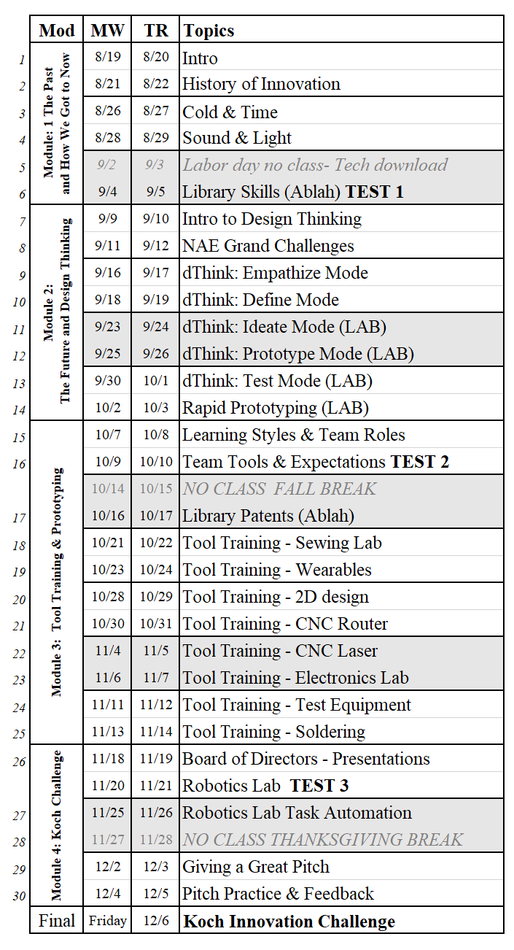
Assignments
Weekly Assignments 30%
Student Success 25%
HW Quizzes 15%
Tests 15%
Final Portfolio 15%

Extra Credit
Extra Credit may be available for attending Campus Events beyond the required number.

Late Assignments

In general, late assignments are unacceptable. Please talk directly with your instructor if you know that you are in danger of missing an assignment. Each instructor has their own policy

Missed Assignments and Exams
Anyone missing an exam, quiz, presentation without notifying the instructor in advance will NOT be allowed to make up the missed exam, quiz or presentation. Documentation of reason for missing may be required by instructor.

Important Academic Dates
For Fall semester 2019
Classes begin Aug 19, 2018
Classes end Dec 5, 2018.
Study Day Dec 6, 2018.

The last date to drop a class and receive a W (withdrawn) instead of F (failed) is Oct 29, 2018.

The final exam period is
Tuesday Dec 10, 2018 – There will be no written exam.
Your final portfolio will be due on this day.

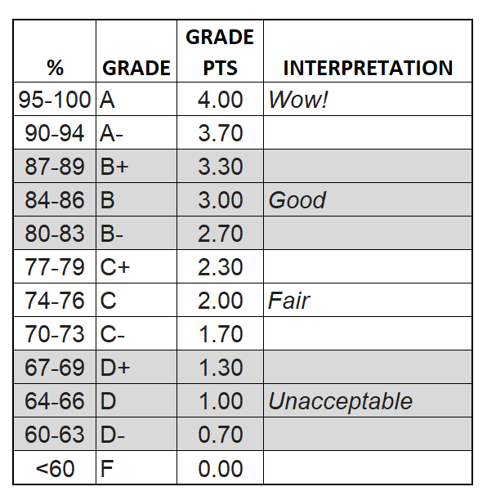
Weather Cancellations –
Call 978-6633 (select 2) to obtain information on class cancellations.

Grading Scale
The grading in the class will include assignments, written papers, and the final project. Use the scoring rubrics provided in Blackboard (within the assignment) to ensure the highest grade possible. The evaluation of your work is the professional judgment of your instructor and is not subject to negotiation.
WSU uses a +/- grading scale for final grades and to calculate grade point averages. In this class, grades are assigned according to the chart. (Other classes might assign grades differently: Be sure to understand the different grading scales in all of your classes.)

Koch Innovation Challenge
The Koch Innovation Challenge will be an annual competition that will support the College of Engineering in fostering a culture of creativity, innovation, entrepreneurship, and teamwork among WSU students. Cross-disciplinary teams of First Year and transfer students studying engineering, art and design, business, and other disciplines will compete for funding and scholarships to invent products and technologies. The grand champions of the competition will compete nationally at a collegiate entrepreneurs’ conference. The goal is to immediately begin preparing students the moment they join WSU to become real world-ready graduates with an entrepreneurial mindset.

The annual Koch Innovation Challenge will emphasize teamwork and entrepreneurship. In addition to a technically feasible and potentially profitable prototype, competing cross-disciplinary teams will submit a basic business plan or opportunity statement to determine market size, profitability, and potential for commercialization.

Winning entries will have:
- Demonstrated utility and technical feasibility
- Met technical, economic, legal, and regulatory requirements
- Featured a novel and practical design
- Demonstrated potential for commercialization including a market assessment, and proposed regulatory and intellectual property strategies

The College of Engineering will organize the Koch Innovation Challenge from its WSUE 102A Introduction to Technology & Innovation course that includes access to a project innovation laboratory. Lectures, lab assignments, and team building activities supporting the ideals of the competition will be provided to all cross-disciplinary student team members.

All students in WSUE 102A will participate in the fall pitch competition with their class team. Students on the five winning teams will receive a scholarship and seed money to continue working on their project. Winning teams will be REQUIRED to take a course in the spring semester to help them further develop their prototype and business plan before the spring Koch Innovation Challenge Grand Championship competition; the Grand Champion team will go on to compete at a national pitch competition in the following fall.

First Year Seminar Overview, Mission & Goal
This general education seminar course will be an integral part of your general education at Wichita State University. You will explore a broad topic from a variety of different disciplinary perspectives. In this course you will become part of the community of academic learners whose responsibility it is to ask questions, explore and exchange ideas, and become effective critical thinkers. Additionally, you will have the opportunity to engage with your fellow students and WSU faculty and staff by participating in activities aimed to further connect you to WSU.
General Education Mission
The mission of general education is to provide a well-rounded education that enables you to live the fullest most meaningful life possible regardless of your particular career preparation. Embedded throughout this course and furthered in the major are the skills that enable graduates to contribute productively to society and the on-going culture.
General Education Goal
The goal of general education is to enable you to live a rich, meaningful life by developing an informed appreciation of the arts, humanities, and natural and social sciences; an ability to intelligently follow and participate in current events, and a sensitive and tutored appreciation of diverse cultures and ways of living.
General Education Outcomes (GEO)
Upon completion of this course, you will have started on your journey to:
1. Acquire knowledge in the arts, humanities, and/or natural and social sciences
2. Demonstrate the ability to think critically and independently
3. Effectively write and speak
4. Employ analytical reasoning and problem-solving techniques
5. Develop fundamentals of information literacy and library research
6. Develop an appreciation for diversity
Course Learner Outcomes (CLO)
Upon completion of this course, you will:
1. Describe the design thinking process
2. Demonstrate an entrepreneurial mindset using design thinking
3. Effectively write and orally communication to a variety of audiences
4. Apply the design thinking process to create a technically feasible prototype based on user need and feedback
5. Compare and contrast the value of specific technological innovations and their impact to society
6. Participate in a multi-disciplinary team and incorporate diverse points of view
Student Success Outcomes (SSO)
During this course, you will have the opportunity to:
1. Connect to faculty and other students to develop an appreciation for others and respect for diversity of thought.
2. Develop more effective study and life skills in areas including information literacy, time management, note taking, test taking, personal finance, and learning styles.
3. Immerse yourself into the Wichita State community to understand resources, campus traditions and culture and the value of student involvement.

UNIVERSITY POLICIES

Inclusive Excellence
Wichita State University is committed to achieving “Inclusive Excellence” and institutional strength through curricula, co-curricula, and other practices, which promote and encourage the intermingling of its students, faculty, and staff from different backgrounds, in a challenging intellectual and multicultural climate that is marked by respect and appreciation for the spectrum of human diversity. The University is also committed to an “all-inclusive” diversity and does not discriminate on the basis of race, ethnicity, gender, gender identity/expression, sexual orientation, age, socioeconomic status, disability, religion, national origin, or military status.

Academic Honesty
Students are responsible for knowing and following the Student Code of Conduct http://webs.wichita.edu/inaudit/ch8_05.htm and the Student Academic Honesty policy http://webs.wichita.edu/inaudit/ch2_17.htm.

CARE Team
Wichita State University is committed to the safety and success of and cares about all members of the University community. If you or someone you know needs support, is distressed, or exhibits concerning behavior that is interfering with their own or others’ academic or personal success or the safety of members of our community, resources and assistance are available. As your Faculty, I may seek support for you. If you or another member of our campus community is in need of help, please submit a concern at www.wichita.edu/ubit or call any CARE team member listed on that webpage. In case of emergency, please call the University Police Department at (316) 978-3450 or 911.

Concealed Carry Policy
The Kansas Legislature has legalized concealed carry on public university campuses. Guns must be out of view, concealed either on the body of the carrier, or backpack, purse or bag that remains under the immediate control of the carrier. Gun owners must familiarize themselves with WSU’s Concealed Carry Policy at http://webs.wichita.edu/?u=wsunews&p=/weapons_policy_documents and the Kansas Board of Regent’s policy at http://www.kansasregents.org/about/policies-by-laws-missions/board_policy_manual_2/chapter_ii_governance_state_universities_2/chapter_ii_full_text#weapons.

Under the Concealed Carry Policy, a backpack or other bag used to carry a handgun must be within the immediate control of the individual. This course requires students to leave belongings such as backpacks or other bags out of reach and unattended for the duration of class time. Students who choose to carry a concealed handgun in a backpack or other bag must plan each day accordingly,and are responsible for making alternate arrangements as necessary. Wichita State does not provide publicly available secure storage for concealed handguns. If you believe that there has been a violation of this policy, please contact the University Police Department at 316 978-3450.

Counseling & Testing
The WSU Counseling & Testing Center provides professional counseling services to students, faculty and staff; administers tests and offers test preparation workshops; and presents programs on topics promoting personal and professional growth. Services are low cost and confidential. They are located in room 320 of Grace Wilkie Hall, and their phone number is (316) 978-3440. The Counseling & Testing Center is open on all days that the University is officially open. If you have a mental health emergency during the times that the Counseling & Testing Center is not open, please call COMCARE Crisis Services at (316) 660-7500.

Diversity and Inclusion
Wichita State University is committed to being an inclusive campus that reflects the evolving diversity of society. To further that goal, Wichita State University does not discriminate in its employment practices, educational programs or activities on the basis of age (40 years or older), ancestry, color, disability, gender, gender expression, gender identity, genetic information, marital status, national origin, political affiliation, pregnancy, race, religion, sex, sexual orientation, or status as a veteran. Retaliation against an individual filing or cooperating in a complaint process is also prohibited. Complaints or concerns related to alleged discrimination may be directed to the Office of Institutional Equity and Compliance, Wichita State University, 1845 Fairmount, Wichita, KS 67260, telephone 316-978-3187.

Disabilities
If you have a physical, psychiatric/emotional, or learning disability that may impact on your ability to carry out assigned course work, I encourage you to contact the Office of Disability Services (DS). The office is located in Grace Wilkie, room 203, (316) 978-3309 (voice/tty) (316-854-3032 videophone). DS will review your concerns and determine, with you, what academic accommodations are necessary and appropriate for you. All information and documentation of your disability is confidential and will not be released by DS without your written permission.

The Heskett Center and Campus Recreation
Whether you are wanting to be active on campus, relieve the stress from classes or take care of your body, Wichita State Campus Recreation is the place for you. Campus Recreation, located inside the Heskett Center, contributes to the health, education, and development of Wichita State University students, faculty, staff, alumni, and community members by offering quality programs and services. With many programs and facilities which are free to all students and members, Campus Recreation offers its members limitless opportunities. For more information about our services see www.wichita.edu/heskett.

Intellectual Property
Wichita State University students are subject to Board of Regents and University policies (see http://webs.wichita.edu/inaudit/ch9_10.htm) regarding intellectual property rights. Any questions regarding these rights and any disputes that arise under these policies will be resolved by the President of the University, or the President’s designee, and such decision will constitute the final decision.

Names and Pronouns
Everyone has the right to be addressed as and referred to by the name and pronouns (including non-binary pronouns) that they choose and that correspond to their gender identity. Class rosters have a student’s legal name and do not include pronouns, therefore, all students will be asked in class to indicate the names and pronouns they use for themselves. A student’s chosen name and pronouns are to be respected at all times in the classroom.

Shocker Alert System
Get the emergency information you need instantly and effortlessly! With the Shocker Alert System, we will contact you by email the moment there is an emergency or weather alert that affects the campus. Sign up at www.wichita.edu/alert.

Student Health Services
WSU’s Student Health clinic is located in 209 Ahlberg Hall. Hours are 8:00am to 7:00pm (8:00 am to 5:00 pm on Fridays), though the clinic may be closed occasionally on Wednesdays from noon to 1:30pm. The telephone number is (316) 978-3620. In addition to outpatient and preventive care (including immunizations, a prescription service, and testing/counseling for sexually transmitted infections), Student Health can handle minor injuries. All services are confidential. For more information see www.wichita.edu/studenthealth.

Title IX
Title IX of the Educational Amendments of 1972 prohibits discrimination based on sex in any educational institution that receives federal funding. Wichita State University does not tolerate sex discrimination of any kind including: sexual misconduct; sexual harassment; relationship/sexual violence and stalking. These incidents may interfere with or limit an individual’s ability to benefit from or participate in the University’s educational programs or activities. Students are asked to immediately report incidents to the University Police Department, (316) 978- 3450 or the Title IX Coordinator (316) 978-5177. Students may also report incidents to an instructor, faculty or staff member, who are required by law to notify the Title IX Coordinator. If a student wishes to keep the information confidential, the student may speak with staff members of the Counseling and Testing Center (316) 978-3440 or Student Health Services (316)978-3620. For more information about Title IX, go to: http://www.wichita.edu/thisis/home/?u=titleix.
Additionally, WSU provides training that can be accessed through your myWSU portal.

Video and Audio Recording
Course materials prepared by the instructor, together with the content of all lectures presented by the instructor, are the property of the instructor. Video and audio recording of lectures and review sessions without the consent of the instructor is prohibited. Unless explicit permission is obtained from the instructor, recordings of lectures may not be modified and must not be transferred or transmitted to any other person, whether that individual is enrolled in the course.

