12th Annual Shocker T-Shirt Design Competition

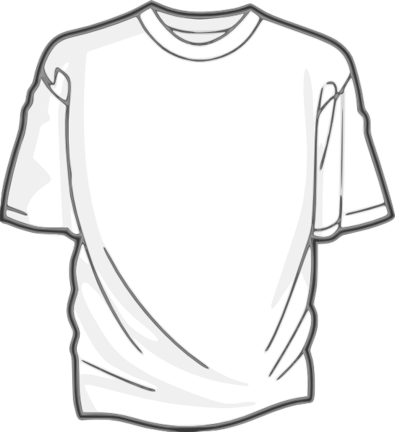


Rules & Regulations Informational Packet
Basic Competition Logistics

What is the Shocker Shirt?
The Shocker Shirt is a t-shirt design contest promoting Shocker pride. In association with Hippodrome, this year’s theme is Innovation! Don’t be afraid to get creative!

Awards
First place winner’s design will be printed and sold in the University Bookstore following Hippodrome, while supplies last.
First, second and third place designers will receive WSU gift baskets!

Announcements
The three (3) finalists will be announced during three Student Involvement events.
The First place winner will be announced during Hippodrome on Saturday, April 15, at the CAC Theatre. Hippodrome begins at 3 p.m., various competition winners will be announced throughout the show.

Eligibility
Entrants must be current WSU students.

Number of Entries
Up to three (3) designs may be entered per person.
Only one (1) design per contestant may win a prize.

Deadline
T-shirt designs must be submitted with the entry/permission form to Student Involvement, RSC 216, by 5 p.m. Wednesday, March 15, 2017. No entries will be received after the specified time and date.

For Further Information
Call Student Involvement at (316) 978-3022 or visit www.wichita.edu/sac
Competition Rules

Design Guidelines
Designs must encompass the theme of “Huxley’s Great Invention” or “Innovation at WSU”.
Designers need to make sure that the design meets brand standards for the University and that the final design in is a PDF, EPS, AI etc. file. No word documents, paint or screenshots from an online t-shirt design website will be accepted.
Entries must be designed for one side only, should not include design on the sleeves.
Design must be created with a black background in mind. The winning design will be printed on a black t-shirt.
All entries must be original and the student’s own creation.
Artwork must not be fashioned after or appear similar to trademarked or copyrighted material.
Designs must be appropriate in nature and not have any vulgar content. Any entry that is deemed inappropriate will be automatically disqualified.
No design materials will be provided by the sponsors.

***Designs which include WuShock or WSU logo must use original design. WuShock or the WSU logo cannot be modified in any way. ***

Judging Criteria
When selecting the finalists’ designs, judges will consider the creativity, originality, neatness of
presentation, wear ability (transferable to a t-shirt), and use of WSU school spirit and design guidelines.
All decisions of the judges are final.
The judges selected by the sponsors will select the top three designs.
The top three designs will then be posted online and the public will then determine the winning design that will be printed and sold in the University Bookstore while supplies last.

Finalists
Finalists may only have one (1) eligible design.
No more than three (3) designs will be chosen as our final designs.
All finalists must submit an electronic copy of their winning design and a photo of their self.

Liability
By submitting an entry, you grant and transfer to the Student Involvement, the Rhatigan Student Center, and Wichita State University all rights, including copyright, trademark rights, rights of publicity or privacy, and any other rights, in and to the design in the entry, including the right to reproduce, edit, and distribute the design without further permission or compensation, and authorize the RSC to use your name in conjunction with advertising or promotional materials related to the Shocker T-Shirt design contest.
Employees of Student Involvement, the RSC, and WSU will exercise every possible precaution in handling the entries, but they cannot assume responsibility for damage to the original design or loss of pieces.

Design Submissions
All designs should be emailed to sac@wichita.edu with a subject header “T-SHIRT DESIGN COMPETITION”. The email should include the final design attached in the appropriate format, as well as the Entry and Permissions form (found on the next page). These must both be attached to the same email!

Entry & Permission Form
Deadline for Submission: Wednesday, March 15, at 5 P.M., RSC 216
Please hand in your hard copy prints to RSC 216.
Please email digital designs to sac@wichita.edu with a subject heading, “T-Shirt Design Competition”.

Name: ________________________________________

Address: ___________________________________________

(City)_______________ (State) _______ (Zip) __________

Telephone: (Primary) _____________________ (Alternate) _____________________

Email: _____________________________________________

Student Shocker ID#:____________________________

The undersigned hereby grants permission to Student Involvement, the Rhatigan Student Center, and Wichita State University to use the following artwork in the WSU Shocker T-shirt Design Competition. Student Involvement, the RSC, and WSU retain the right to make any necessary alterations to the said artwork (in color, size, etc.) for reprint and retain the right to not produce a prize winning entry. Additionally, the undersigned grants and transfers to Student Involvement, the RSC, and WSU all rights and designs, including the right to reproduce, edit, and distribute the design without further permission or compensation, and authorizes the RSC to use their name in conjunction with advertising or promotional materials related to the Shocker T-Shirt Design Competition.

Winning designs will have to be approved by the WSU Athletic Association.

One copy of this permission form shall be emailed to sac@wichita.edu, and one copy shall be retained by the undersigned. Please print legibly.

Artist Signature: ___________________________________________________________

Today’s Date: _____________________________________________________________

